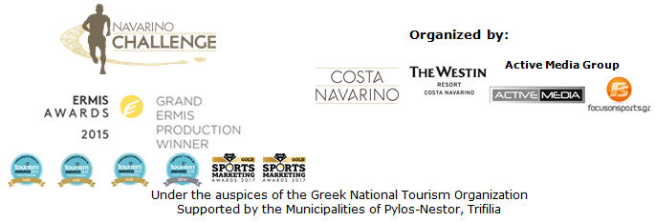

PRESS RELEASE

“Navarino Challenge 2017”
A program full of activities is announced

All sports for all people

Athens, September 7th 2017 – “Navarino Challenge” invites people of all ages to participate at the 3-day sports event taking place 13-15 October in Costa Navarino and Messinia. The multi-awarded event aims to promote the Olympic Spirit and Ideal, and “Fair Play” through the participation of role-model athletes, joining 17 activities in total.

On Saturday October 14th, participants will join a non-competitive open water swimming race (10:00am) at the Bay of Navarino. Starting from the picturesque port of Pylos, participants will cover a 1-mile (1.6 km) swimming route, designed by the Federal Technical Coach of Swimming, Nikos Gemelos. At 10:30am, Kids’ Athletics will take place at the Pylos town square, joined by the event ambassador Periklis Iakovakis, Olympic & World Champion at 400m hurdles. Kids’ Athletics has been developed and set in place by a special panel of scientists from IAAF (International Association of Athletics Federation) and is organized in Greece by the Hellenic Athletics Federation (SEGAS) in cooperation with the Ministry of Education. For the second consecutive year, focus will switch to the Stand Up Paddling demonstration race by BIC® Sport (at 11:30am at Pylos port), with the support of Surf Salad, water sports at Costa Navarino. The day will conclude with a demonstration of Optimist and Laser boats (at 12:30pm) from the Maritime Athletic Pylos Association “Nestor” with the assistance of the Sailing Club of Kalamata “Poseidon” and the Sailing Club of Kalamata “Eolos” with the assistance of the Municipality Pylos-Nestor, the Port Authority of Pylos, Pylos Association of Enterprises for Tourism Development and Explore Messinia.

On Sunday October 15th, participants will join the half-marathon (21.1km), 10km (joint start time at 08:15am), and 5km (running and dynamic walking - start time 08:30am) routes, while the 1km running route for children (9:30am) will also take place. The race will be timed for all runners.

The event will be supported for the first time by official sponsor Sportingbet, one of the world’s leading online gaming companies. On behalf of Sportingbet, Mr. Giannis Kapodistrias, stated: “We are very pleased to support such a great sport event such as Navarino Challenge, which is taking place all accross Messinia! Sportingbet is distinguished for its dynamism, energy to achieve goals, passion for sport, which are also found at Navarino Challenge. We are very proud of the fact that Navarino Challenge promotes the benefits of exercise and balanced nutrition and raise awareness regarding childhood obesity”.

The gala dinner “A Night to Remember by Qatar Airways” will be held on Saturday October 14th, for the guests and participants staying at The Westin Resort Costa Navarino. The event will also honor athletes who have been distinguished for their ethics and contribution to sport. The distinct gifts and awards of the Gala are created once again by Apia store in Costa Navarino.

For those wishing to stay at The Westin Resort Costa Navarino, a full program of events is included in their stay, with activities such as taekwondo (by the twice silver Olympic medalist Alexandros Nikolaidis), Kids’ Athletics (with the Olympic and World Champion Periklis Iakovakis), boccia (with the Gold Paralympic athlete Grigoris Polychronidis), climbing and bike ride at Voidokilia beach (supported by Navarino Outdoors), pilates (with the PE instructor specialized in pilates Mandy Persaki), basketball, golf (supported by the Navarino Golf Academy) kick boxing (with the champion Alexandros Nikolaidis), baby swimming and aqua aerobic (supported by Swim Academy), tennis cross training (supported by Navarino Racquet Academy) and boxing (supported by Vizantinos target sport club).

More information about the available accommodation packages at The Westin Resort Costa Navarino are available here.

Samsung will join the event for the first time as the official technology partner, with the eco-system of Samsung Galaxy devices. Samsung Galaxy S8 and S8+, combined with the camera Gear 360 and Gear VR, will enrich the experience of participants and spectators alike, with unique 360° content.

The pasta brand Melissa also joins this year’s event, promoting the message about the benefits of the Mediterranean nutrition and the balanced Mediterranean diet, as the official nutrition supporter.

“Navarino Challenge” will be held under the Auspices of the Greek National Tourism Organization with the co-organization of Costa Navarino, The Westin Resort Costa Navarino and Active Media Group and the support of the Municipalities of Pylos-Nestor and Trifilia.

Registrations for “Navarino Challenge” are still open, for your registration please complete the form here.

Official Airline Partner: Qatar Airways
Official Technology Partner: Samsung
Official Sponsors: Sportingbet, “Vikos” Natural Mineral Water, Ford Motor Hellas
Official Nutrition Supporter: Melissa
Official Supporters: BIC®, BIC® Sport, Wyndham Grand Athens, Poseidonia, Surf Salad
Assisted by: Inbi, Navarino Outdoors, Swim Academy, Navarino Racquet Academy, Apia, Health Runners Club of Messinia, Pylos Association of Enterprises for Tourism Development, Maritime Athletic Pylos Association “Nestor”, Explore Messinia, Navarino Golf Academy, Hellenic Athletics Federation (SEGAS), IAAF Kids Athletics, Vizantinos target sport club
Strategic Partner: National Geographic

Under the auspices of the Greek National Tourism Organization

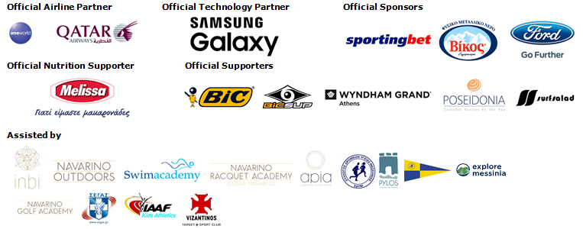

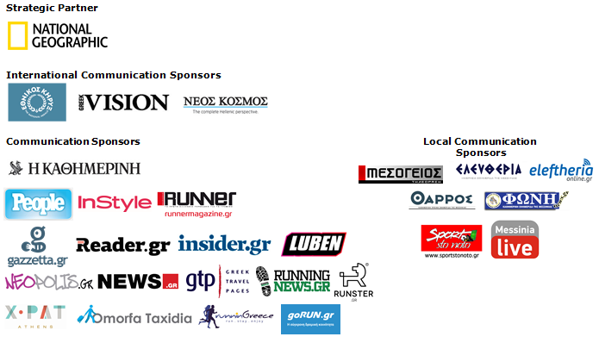

Website: www.navarinochallenge.com
Facebook Page: www.facebook.com/Navarinochallenge
Twitter Account: https://twitter.com/NavarinoC
YouTube Channel: http://www.youtube.com/user/NavarinoChallenge
Instagram Page: http://instagram.com/navarinochallenge
Hashtags: #navarinochallenge #costanavarino #eatwell #runwell #livewell

Costa Navarino:
Costa Navarino is the prime, sustainable destination in the Mediterranean, located in the Greek region of Messinia in the southwest Peloponnese. One of the most unspoiled and breathtaking seaside Mediterranean landscapes, this area has been shaped by 4,500 years of history. Its philosophy is driven by a genuine desire to promote Messinia, while protecting and preserving its natural beauty and heritage. It will comprise a number of distinct sites featuring 5-star deluxe hotels, luxury residences, conference facilities, spa and thalassotherapy centres, signature golf courses, as well as a wide range of unique year-round activities for adults and children. Navarino Dunes, the first area, is home to two luxury 5-star hotels, The Romanos, a Luxury Collection Resort and The Westin Resort Costa Navarino; The Dunes Course – the first signature golf course in Greece- Anazoe Spa, a 4,000sq.m. spa & thalassotherapy centre; the state-of-the-art conference centre House of Events; specially designed facilities for children; as well as a variety of gastronomy venues, sports, outdoor and cultural activities. Navarino Bay, the second area is home to the signature golf course, The Bay Course.
High resolution photos can be accessed through the following link, by using the password nestor.

About The Westin Resort Costa Navarino:
The Westin Resort Costa Navarino is one of the two luxury 5-star properties at Navarino Dunes, the first resort area in Costa Navarino, the prime destination in the Mediterranean. Overlooking the Ionian Sea coastline of the Dunes Beach, The Westin Resort Costa Navarino 445 rooms and suites, inspired by old Messinian mansions, spring from nature and create an ambiance of genuine hospitality. Voted as the “Best Family Destination” in the Mediterranean amongst Europe’s Starwood Hotels & Resorts, The Westin Resort Costa Navarino is the ideal destination for family getaways as it proposes a plethora of children activities such as a wonderful aqua park with water slides, playground and recreational center as well as two specially designed hubs for children, Cocoon and SandCastle. At Navarino Dunes there is also The Romanos, a Luxury Collection Resort, the 18-hole signature golf course The Dunes Course the 4,000 sq.m Anazoe Spa, a state-of-the-art conference center, as well as a variety of culinary venues, sports, outdoor and cultural activities. Navarino Bay, the second area in Costa Navarino, features the second 18-hole signature golf course, The Bay Course. For more information on The Westin Resort Costa Navarino, please visit www.westincostanavarino.com, or follow us on Twitter.

