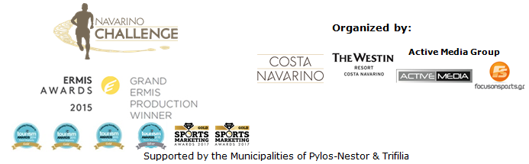

PRESS RELEASE

“Navarino Challenge” continues impressively in 2018

Registration is open!

Athens, April 17 2018 – Registration is open for the 6th “Navarino Challenge”, the established sports tourism event and standard choice in the calendar of the fans, since 2013!
This year’s event will take place on 12-14 October 2018, in Messinia and Costa Navarino, anticipating hundreds of professional and amateur athletes, who will take part in its numerous activities.

The multi-awarded sports tourism event, that promotes sports and fair play as its main goal, will be, once again, full of activities for all ages. “Navarino Challenge”, with the most Olympic athletes ever participating as ambassadors in a sports event, returns again to Messinia, including more than 10 Olympic sports! Running, swimming, SUP, as well as the successful recipe of Tae Kwon Do (with two-times silver Olympic medalist, Alexandros Nikolaidis) and Boccia (with four-time Paralympic medalist, Grigoris Polychronidis), being examples of the sports featured.

Running routes
Participants will be able to choose between the Half-Marathon (21.1km), 10km and 5km (running and dynamic walking). Starting from Navarino Dunes of Costa Navarino, professional and amateur athletes will run along the coast to Pylos crossing the beautiful Voidokilia beach in the unique trail run that combines soil, sand and street parts. At the same day, respectively, the 1km kids running race will be held. Start and finish of each race will be the same, while the participation fee for running will be 20€ (kids’ race is free of charge). The routes are designed by ex-marathon runner, holder of the best classic route record in Greece, trainer and director of All About Running, Nikos Polias. All participants will be timed.

Open water swimming race
The fans of open water swimming will compete and be timed for the first time ever at the beautiful Navarino Bay, at the port of Pylos, covering the 1 mile (1.6km) special swimming route, designed by the Federal Swimming Coach, Nikos Gemelos. The cost will be 20€.

Stand Up Paddling race
Right after swimming and for the third consecutive year, the Stand Up Paddling by BIC® Sport relay race will be held. At the port of Pylos, “Navarino Challenge” presents the innovative sport of Stand Up Paddling (SUP), that has become highly popular around the world. The participation cost will be 15€. The race is supported by the surf club, Surf Salad!

The registration for the multi-awarded sports tourism event is open and those interested can participate, filling the special form, available in the following link: http://activemedia.com.gr/product/navarino-challenge-2018/. At the same time, pre-sale has begun online via www.viva.gr, via telephone on 11876 as well as via the Viva network pre-sale points. Registration ends on August 31 2018.

Please, be informed that participants who book their accommodation package at The Westin Resort Costa Navarino and choose the standard activities (running, swimming, SUP) will be able to enjoy free of charge the event’s full activities schedule. More information about the special accommodation packages will be announced in the following weeks.

“Navarino Challenge” in its continuous effort for innovation and in order to become even more attractive, increases the Wellness Activities for the participants. Besides pilates (by instructor Mandy Persaki), CrossFit by Dimitris Moros, strengthening and wellness via weight-lifting, will be integrated. Dimitris Moros has graduated from the National and Kapodistrian University of Athens and owns Fitness Art gym. He won several Greek championships from 1997 to 2001 and was member of Judo National Team. Since 2007 he is involved in personal training. You can participate in crossift by sending an email in the following address: booking@navarinochallenge.com

The renewed program includes activities for the whole family at The Westin Resort Costa Navarino: tae kwon do, boccia, indoor climbing, and bike ride in Voidokilia (with the support of Navarino Outdoors), pilates, basketball, golf (with the support of Navarino Golf Academy), kick boxing (with the champion Alexandros Nikolaidis), baby swimming and aqua aerobic (supported by Swim Academy), kids’ athletics, beach volley, tennis cross training (supported by Navarino Racquet Academy), crossfit, beach yoga, Optimist boat exhibition race (from Maritime Athletic Pylos Association “Nestor”) and boxing (with the support of Vizantinos target sport club).

“Navarino Challenge”, in its five year successful course, has been awarded with Ermis Awards, Tourism Awards and Sports Marketing Awards, setting new booking records for The Westin Resort Costa Navarino.

Official sponsors are, once again, Natural Mineral Water “Vikos” and Ford Motor Hellas. Official supporters are Poseidonia, BIC® and BIC® Sport.

“Navarino Challenge” will be held with the co-organization of Costa Navarino, The Westin Resort Costa Navarino and Active Media Group and the support of the Municipalities of Pylos-Nestor and Trifilia.

Official Sponsors: Natural Mineral Water “Vikos”, Ford Motor Hellas
Official Supporters: Poseidonia, BIC®, BIC® Sport
Assisted by: Navarino Racquet Academy, Pylos Association of Enterprises for Tourism Development, Maritime Athletic Pylos Association “Nestor”, Explore Messinia, Navarino Golf Academy, Vizantinos target sport club, Target Security

Hashtags: #navarinochallenge #costanavarino #eatwell #runwell #livewell

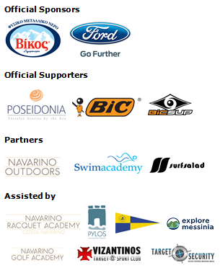

Website: www.navarinochallenge.com
Facebook Page: www.facebook.com/Navarinochallenge
Twitter Account: https://twitter.com/NavarinoC
YouTube Channel: http://www.youtube.com/user/NavarinoChallenge
Instagram Page: http://instagram.com/navarinochallenge
Hashtags: #navarinochallenge #costanavarino #eatwell #runwell #livewell

Costa Navarino
Costa Navarino is located in Messinia in the southwest Peloponnese, in one of the most unspoiled and breathtaking landscapes in the Mediterranean. Its philosophy is driven by a genuine desire to promote Messinia, while protecting and preserving not only its natural beauty but also a remarkable cultural heritage spanning 4,500 years. Costa Navarino is home to two 5-star deluxe hotels, The Romanos, a Luxury Collection Resort and The Westin Resort, Costa Navarino, Anazoe Spa, a 4,000m2. spa & thalassotherapy center, two signature golf courses, over 20 fine dining venues, a wide range of sports, outdoor and cultural activities, plus an array of 5-star services.
www.costanavarino.com

The Westin Resort Costa Navarino
The Westin Resort has been voted one of the best resorts in Greece and one of the foremost holiday destinations in Europe. In 2017 The Westin Resort Costa Navarino has been voted among the Best Resorts in Europe in Condé Nast Traveler Reader’s Choice Awards. It features an amazing selection of deluxe rooms, family rooms and suites in a privileged seaside location on a verdant hillside that affords an alluring mix of golf, sea and pool views. Voted “Best Family Destination” in the Mediterranean among Starwood Hotels & Resorts, this exceptional 5-star family resort in Greece allows children to choose from an enormous variety of supervised fun activities, tailored specifically for them, at the Cocoon and the SandCastle, giving parents plenty of time to indulge in their own favorite sports or simply unwind. At the Cocoon crèche, infants and toddlers from just 4 months to 3 years old are creatively engaged and encouraged to develop their skills under the supervision of qualified baby nurses and trained staff. Whilst the SandCastle, which offers both recreational and educational activities as well as overnight stay options, is aimed at children aged 4 to 7 and 8 to 12, with specially devised programs for each age group. For more information on The Westin Resort Costa Navarino, please visit www.westincostanavarino.com or follow us on Twitter.

