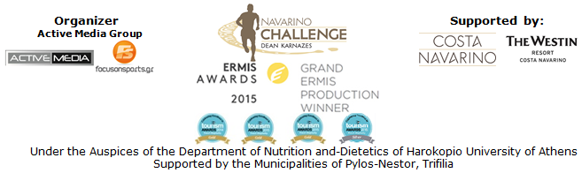

PRESS RELEASE

Water is the “leading element" of this year's “Navarino Challenge”!

Swimming, SUP, Baby Swimming, Aqua Aerobic, Scuba Diving & Sailing in Pylos & Costa Navarino!

Athens, June 09, 2016 - Messinia could be an island, as it is embraced by the Ionian Sea on the one side and the Messinian Gulf on the other, and it possesses 140 km. of coast.
The leading sport tourism event “Navarino Challenge” highlights the unique natural beauty of the area in which it takes place, by showcasing water as the dominant element of this year’s event!

Unique swimming activities will take place –within each and every day of the duration (9-11/9) of “Navarino Challenge” - in Costa Navarino and at the outstanding facilities of The Westin Resort Costa Navarino.
With the assistance of the Swim Academy, of the federal technical coach of swimming and holder of countless Olympic and World distinctions in open water swimming Nikos Gemelos, and the Olympic and World Champion in open water swimming Spyros Gianniotis, the activity of baby swimming will be presented this year for the first time (for babies from 3 months and children up to 3 years old).
In the hands of their parents, babies come in contact with the water element, get familiar with it and accept all the calming effect under the instructions of qualified personnel by Swim Academy.
Adults and children will also have the opportunity to participate for the first time in the aqua aerobic program. The most popular aerobic exercise comes in “Navarino Challenge” to help you burn calories, keep your body in shape and tone your cardiorespiratory system.

“Navarino Challenge” offers water sports’ lovers the opportunity to enjoy exciting moments under the warm Messinian sun. According to the values ​​of Costa Navarino for sustainable development and our commitment to protect the environment, all water sports are non–motorized, with a wide range available to choose from and enjoy the mild climate of Messinia all seasons with safety above all!

For the third consecutive year “Navarino Challenge” will be supported by Allianz Greece within the general effort to ensure the safety of the event. The company is sensitive to issues related to health care and supports reinforcing the message of protection of health and the adoption of a healthier lifestyle through exercise and proper nutrition. Principles and values ​​that are inextricably linked with those of the organization.

Besides the premises of Costa Navarino, water activities will be hosted in the municipality of Pylos-Nestor, whose name comes from the legendary king and mythical hero of ancient Pylos, Nestor, the wisest of the leaders of the Trojan War, as recorded in the Homeric years.
On Saturday, September 10, 2016, sea lovers will have the opportunity to swim without competition, in the beautiful Navarino bay at the picturesque port of Pylos, covering the unique swimming route of one mile (1.6 km.) designed by Nikos Gemelos.

On the same day (Saturday 10/9), the lights will also turn in the Stand Up Paddling race by BIC® Sport!
For the first time, “Navarino Challenge” will present at the port of Pylos an innovative sport like Stand Up Paddling (SUP), which quickly became popular worldwide. It is an easy and ideal sport for someone to enjoy in an area surrounded by some of the best beaches in Greece. The entertaining routes for beginners or experts are the best choices for those who wish to experience the peacefulness of the Ionian Sea. One of the most recognized brands in the world, BIC® company with presence in the field of water sports with BIC® Sport since 1979, is supporting this activity. It was created by Baron Bich, a man passionate with the sea and sailing. The company was established very quickly in manufacturing Windsurf, SUP, Surf and kayak boards, maintaining credibility, simplicity, ingenuity and an affordable profile. All athletes participating will have the opportunity to test the credibility of the SUP BIC® boards.

For the first time, sea lovers will discover the underwater secrets on the pirates island, Proti, with the assistance of the Aqua Divers Club and Scuba Hellas.
The most skilled in the activity of scuba diving will have the opportunity to explore the underwater life in the blue waters of Messinia and to follow the steps of the famous pirate Katoulas in the island, in search of the lost treasure on the Ionian Sea. Respectively, in the facilities of The Westin Resort Costa Navarino beginners will have the opportunity to make their first acquaintance with diving and special prices will apply to all who follow this activity.

Saturday sea-day, will conclude with a demonstration race with Optimist and Laser boats from Maritime Athletic Pylos Association “Nestor” with the assistance of the Municipality Pylos-Nestor, the Port Authority of Pylos, Pylos Association of Enterprises for Tourism Development and Explore Messinia.

“Navarino Challenge” will be held for the 4th consecutive year in Messinia and Costa Navarino on 9-11 September 2016, with more than 18 activities!
Registrations are open and anyone can take part in activities of running, swimming and SUP by filling the special form available at the following link:
http://activemedia.com.gr/product/navarino-challenge/

For those wishing to stay at The Westin Resort Costa Navarino and enjoy the full schedule of “Navarino Challenge” privileged accommodation packages are available until 30 June 2016. For further information please contact the event’s official travel agent Vita N Travel. Telephone: +30 210 3249070 or visit: http://navarinochallenge.com/event_accommodation_in_2016_en.html

The event will be held for one more year, under the Auspices of the Department of Nutrition and-Dietetics of Harokopio University of Athens with the support of Costa Navarino and The Westin Resort Costa Navarino, as well as the Municipalities of Pylos-Nestor and Trifilia.

For more information about the event, you may contact us through the following special form: http://www.navarinochallenge.com/contact.html

Official Sponsors: Allianz Greece, Natural Mineral Water “Vikos”
Official Supporters: BIC®, Navarino Icons, BIC® Sport, Village Cinemas
Assisted by: Health Runners Club of Messinia, Pylos Association of Enterprises for Tourism Development, Maritime Athletic Pylos Association “Nestor”, Explore Messinia, Navarino Outdoors, Swim Academy, Aqua Divers Club, Scuba Hellas, Navarino Golf Academy, Restaurant Posidonia Restaurant ThaMa, Alpha (Athlima SA)
Official Travel Agent: Vita N Travel
Official Broadcaster: OTE TV
TV Communication Partner: National Geographic Channel
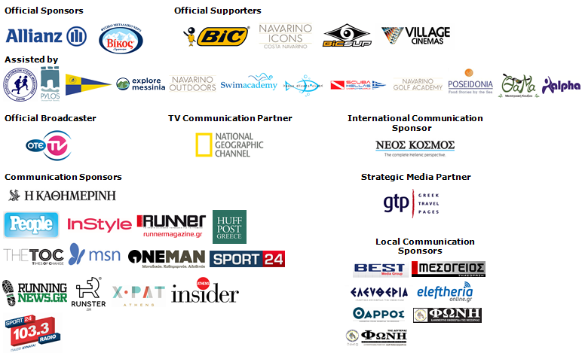
Website: www.navarinochallenge.com
Facebook Page: www.facebook.com/Navarinochallenge
Facebook Event: https://www.facebook.com/events/1575864132703599/
Twitter Account: https://twitter.com/NavarinoC
YouTube Channel: http://www.youtube.com/user/NavarinoChallenge
Google + Account: https://plus.google.com/115165548850159469774/posts
Instagram Page: http://instagram.com/navarinochallenge
Hashtags: #navarinochallenge #costanavarino #eatwell #runwell #livewell

Costa Navarino:
Costa Navarino is the prime, sustainable destination in the Mediterranean, located in the Greek region of Messinia in the southwest Peloponnese. One of the most unspoiled and breathtaking seaside Mediterranean landscapes, this area has been shaped by 4,500 years of history. Its philosophy is driven by a genuine desire to promote Messinia, while protecting and preserving its natural beauty and heritage. It will comprise a number of distinct sites featuring 5-star deluxe hotels, luxury residences, conference facilities, spa and thalassotherapy centres, signature golf courses, as well as a wide range of unique year-round activities for adults and children. Navarino Dunes, the first area, is home to two luxury 5-star hotels, The Romanos, a Luxury Collection Resort and The Westin Resort Costa Navarino; The Dunes Course – the first signature golf course in Greece- Anazoe Spa, a 4,000sq.m. spa & thalassotherapy centre; the state-of-the-art conference centre House of Events; specially designed facilities for children; as well as a variety of gastronomy venues, sports, outdoor and cultural activities. Navarino Bay, the second area is home to the signature golf course, The Bay Course.
High resolution photos can be accessed through the following link, by using the password nestor.

About The Westin Resort Costa Navarino:
The Westin Resort Costa Navarino is one of the two luxury 5-star properties at Navarino Dunes, the first resort area in Costa Navarino, the prime destination in the Mediterranean. Overlooking the Ionian Sea coastline of the Dunes Beach, The Westin Resort Costa Navarino 445 rooms and suites, inspired by old Messinian mansions, spring from nature and create an ambiance of genuine hospitality. Voted as the “Best Family Destination” in the Mediterranean amongst Europe’s Starwood Hotels & Resorts, The Westin Resort Costa Navarino is the ideal destination for family getaways as it proposes a plethora of children activities such as a wonderful aqua park with water slides, playground and recreational center as well as two specially designed hubs for children, Cocoon and SandCastle. At Navarino Dunes there is also The Romanos, a Luxury Collection Resort, the 18-hole signature golf course The Dunes Course the 4,000 sq.m Anazoe Spa, a state-of-the-art conference center, as well as a variety of culinary venues, sports, outdoor and cultural activities. Navarino Bay, the second area in Costa Navarino, features the second 18-hole signature golf course, The Bay Course. For more information on The Westin Resort Costa Navarino, please visit www.westincostanavarino.com, or follow us on Twitter.

