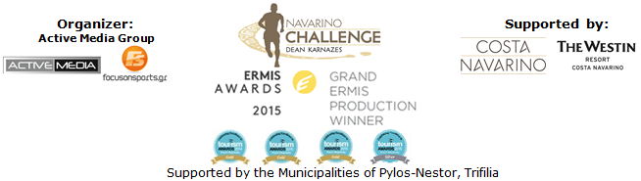

PRESS RELEASE

International promotion of the event in New York

Special prices for international flights though Qatar Airways

Athens, May 29, 2017 - "Navarino Challenge", which will take place between the 13th and 15th of October 2017, in Messinia and Costa Navarino, as part of its overseas promotional strategy, renews the cooperation with Qatar Airways.
Qatar Airways, the national carrier of the State of Qatar, is proud to be “Going Places Together” with travelers across its more than 150 business and leisure destinations. A multiple award-winning airline, Qatar Airways has been awarded World’s Best Airline, World's Best Business Class, Best Business Class Airline Lounge and Best Airline Staff Service in the Middle East by international air transport rating organisation Skytrax.
Qatar Airways proudly supports a range of exciting international and local initiatives dedicated to enriching the global community that it serves. Qatar Airways sponsors world-leading sports events, like “Navarino Challenge” reflecting the values of sports as a means of bringing people together, something at the core of the airline’s own brand message “Going Places Together”.
Please use the promo code ATHNAVCH to book an exclusive offer for roundtrip tickets to Athens from over 150 places, via the following link:
http://www.qatarairways.com/gr/el/cugs/navarinochallenge.page
Offer valid from 3 to 15 October 2017 included (Outbound) and (Inbound) to be completed on or before 25 October 2017. This offer refers to roundtrip tickets to Athens from more than 150 destinations, including New York, USA.
A short while ago, in New York, the 1st Greek Panorama exhibition took place with great success, aiming to promote Greece to the US market. Thousands of New Yorkers, as well as tourists from around the world, visited the expo at the most central station in Manhattan, the Grand Central terminal.
"Navarino Challenge" stated its participation in the expo by having its own stand combined with the presence of the Greek American ultramarathon runner Konstantinos (Dean) Karnazes, who signed autographs, represented and promoted the land of Messinia in the best possible way. True to the spirit other great personalities attended the event such as the Gold Olympic Medalist and World Champion in women's wrestling, Greek-American Helen Maroulis, the Greek-American former NFL player and twice Super Bowl finalist Niko Koutouvides and the 3 times European champion with Panathinaikos, veteran basketball player and assistant coach for the Charlotte Hornets, Mike Batiste.

The “Navarino Challenge” will take place for another year with the support of Costa Navarino and The Westin Resort Costa Navarino as well as the Municipalities of Pylos-Nestor and Trifilia.
More information will be announced in the next few weeks.

Official Airline Partner: Qatar Airways
Official Sponsor: “Vikos” natural mineral water
Official Supporters: BIC®, BIC® Sport, Wyndham Grand Athens, Poseidonia, Surf Salad
Assisted by: Navarino Outdoors, Swim Academy, Navarino Racquet Academy, Apia
Strategic TV Partner: National Geographic

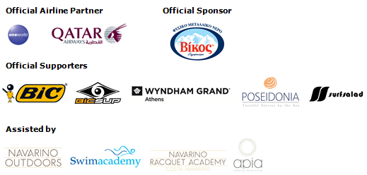
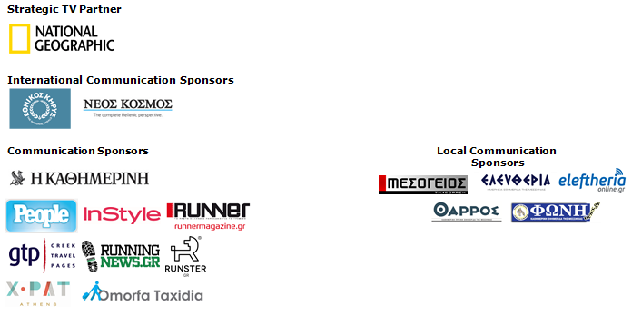

Website: www.navarinochallenge.com
Facebook Page: www.facebook.com/Navarinochallenge
Twitter Account: https://twitter.com/NavarinoC
YouTube Channel: http://www.youtube.com/user/NavarinoChallenge
Instagram Page: http://instagram.com/navarinochallenge
Hashtags: #navarinochallenge #costanavarino #eatwell #runwell #livewell

Costa Navarino:
Costa Navarino is the prime, sustainable destination in the Mediterranean, located in the Greek region of Messinia in the southwest Peloponnese. One of the most unspoiled and breathtaking seaside Mediterranean landscapes, this area has been shaped by 4,500 years of history. Its philosophy is driven by a genuine desire to promote Messinia, while protecting and preserving its natural beauty and heritage. It will comprise a number of distinct sites featuring 5-star deluxe hotels, luxury residences, conference facilities, spa and thalassotherapy centres, signature golf courses, as well as a wide range of unique year-round activities for adults and children. Navarino Dunes, the first area, is home to two luxury 5-star hotels, The Romanos, a Luxury Collection Resort and The Westin Resort Costa Navarino; The Dunes Course – the first signature golf course in Greece- Anazoe Spa, a 4,000sq.m. spa & thalassotherapy centre; the state-of-the-art conference centre House of Events; specially designed facilities for children; as well as a variety of gastronomy venues, sports, outdoor and cultural activities. Navarino Bay, the second area is home to the signature golf course, The Bay Course.
High resolution photos can be accessed through the following link, by using the password nestor.

About The Westin Resort Costa Navarino:
The Westin Resort Costa Navarino is one of the two luxury 5-star properties at Navarino Dunes, the first resort area in Costa Navarino, the prime destination in the Mediterranean. Overlooking the Ionian Sea coastline of the Dunes Beach, The Westin Resort Costa Navarino 445 rooms and suites, inspired by old Messinian mansions, spring from nature and create an ambiance of genuine hospitality. Voted as the “Best Family Destination” in the Mediterranean amongst Europe’s Starwood Hotels & Resorts, The Westin Resort Costa Navarino is the ideal destination for family getaways as it proposes a plethora of children activities such as a wonderful aqua park with water slides, playground and recreational center as well as two specially designed hubs for children, Cocoon and SandCastle. At Navarino Dunes there is also The Romanos, a Luxury Collection Resort, the 18-hole signature golf course The Dunes Course the 4,000 sq.m Anazoe Spa, a state-of-the-art conference center, as well as a variety of culinary venues, sports, outdoor and cultural activities. Navarino Bay, the second area in Costa Navarino, features the second 18-hole signature golf course, The Bay Course. For more information on The Westin Resort Costa Navarino, please visit www.westincostanavarino.com, or follow us on Twitter.

