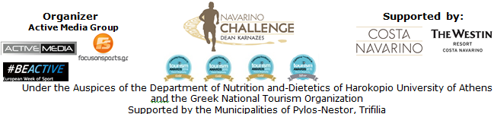

PRESS RELEASE
Athens, August 25th 2015

The Schedule of “Navarino Challenge 2015”!

“Navarino Challenge” in the European Week of Sport!

The multiple-award winning event “Navarino Challenge” was included by the European Commission and the Greek General Secretariat of Sports in the European Week of Sport (September 7-13, 2015)!
“Navarino Challenge” continues with distinctions and international recognitions to offer sports tourism services at the highest level!

This effort is assisted by Allianz Hellas, which is sensitized to issues pertaining health care and supports “Navarino Challenge” for a second consecutive year, reinforcing the message of health protection and the adoption of a healthier way of living through exercise and proper nutrition.
At the same time, for one more year, participating athletes will quench their thirst with the natural mineral water "Vikos" that contributes to the well-functioning of the body during sports.

“Navarino Challenge” collaborates every year with the top Greek athletes who are moral models and exemplary athletes for the younger generations. Alongside the ambassadors of the event the name of the World Champion in the open water swimming Kelly Araouzou is added. Kelly Araouzou distinguished a month ago, at the World Open Water Championship in Kazan, by winning the silver medal, will be in the beautiful Bay of Navarino in the picturesque port of Pylos, where this year's one mile (1.6 km.) and half mile (0.8 km ) for smaller friends, swimming routes will be held. Almost about a year before the significant challenge of the Olympic Games in Rio, Kelly will experience the “Navarino Challenge”.

Every new challenge brings an innovation…
Following the innovations offered by the event, “Navarino Challenge” will create and present for the first time in Greece in cooperation with the GoPro, Digitribe Mediahouse, Drakos Digital and WeThePeople companies, the first 360º YouTube video that will include activities like running and open water swimming.

Registrations for “Navarino Challenge”, will continue until Friday, September 4, 2015, through the official website of the event: http://navarinochallenge.com/registration_form.php or alternatively via Viva.gr online and via 150 physical locations throughout Greece (Viva Points / The Mall Athens, Public Shops, Papasotiriou, Ianos, Seven Spots, Reload Stores, Media Markt). You may register here: http://www.viva.gr/tickets/sports-tourism-event/pylos/navarino-challenge-en/

The event is held under the Auspices of the Department of Nutrition and-Dietetics of Harokopio University of Athens and the Greek National Tourism Organization with the support of Costa Navarino and The Westin Resort Costa Navarino as well as the Municipalities of Pylos-Nestor, Trifilia, for a 3rd consecutive year.

Navarino Challenge 2015 routes’ schedule is the following:

Saturday 12-09-2015
Swimming at Pylos Port (1mile route & 0,5mile for children)
08:30-10:30: Receive the numbers at Pylos Port
10:00: Start of 1 mile swimming route with the Olympic & World champion ambassador in swimming, Spyros Gianniotis at Pylos Port
11:00: Start of 0,5 mile swimming route for children at Pylos Port
11:30-12:00: Ceremony & Events at Pylos Port
Demonstration race with Optimist and Laser boats by the Maritime Athletic Pylos Association "Nestor"
12:30: End of activities

Sunday 13-09-2015
Running: Start from Costa Navarino - runners follow the coastal road towards Pylos with the route including several off road parts, while athletes of all distances will enjoy the spectacular backdrop of Voidokilia beach – Return to Costa Navarino [routes: Half-marathon (21.1km), 10km, 5km]
Costa Navarino (In the premises, 1km route for children)
07:30-08:30: Receive numbers from Navarino Outdoors, after the Westin Tennis Courts
08:30: Warm-up with the team of the pilates instructor, Mandy Persaki
08:45: Start of Half-marathon route (21.1km)
09:00: Start of 10km route
09:15: Start of 5km route (for running and dynamic walking)
10:30: Start of 1km route for children
11:00-11:30: Ceremony & Events
12:00: End of activities

For those who wish to stay at The Westin Resort Costa Navarino, the following benefits will be offered:

Friday 11-09-2015
09:00-18:00: Pick up numbers & participation kits at the House of Events entrance (across the entrance of the hotel reception)
10:00-11:00 (“History” Hall in House of Events) & 17:00-18:00: (Basketball Court) Taekwondo lessons for people of all ages by the twice Olympic champion Alexandros Nikolaidis
11:00-12:00 & 17:00-18:00 (“Synergy” Meeting Room in House of Events): Kick boxing lessons for people of all ages by the kick boxing champion Alexandros Nikolaidis
12:30-13:00 & 18:30-19:00 (In front of Morias): Pilates lessons by the team of the pilates instructor, Mandy Persaki – at the grassy area in front of Morias restaurant
13:00-13:30 (Indoor Climbing next to Basketball Court): Climbing lessons by the certified climbing instructor George Malamas - Navarino Rocks

Saturday 12-09-2015
09:00-18:00: (House of Events) Pick up numbers & participation kits at the House of Events entrance (across the entrance of the hotel reception)
13:00-13:30 (Indoor Climbing next to Basketball Court): Climbing lessons by the certified climbing instructor George Malamas - Navarino Rocks
17:00-18:00 (Basketball Court): Taekwondo lessons for people of all ages by the twice Olympic champion Alexandros Nikolaidis
17:00-18:00 (“Synergy” Meeting Room in House of Events): Kick boxing lessons for people of all ages by the kick boxing champion Alexandros Nikolaidis
18:30-19:00 (In front of Morias): Pilates lessons by the team of the pilates instructor, Mandy Persaki – at the grassy area in front of Morias restaurant
19:45-21:00: “A Night to Remember” By Qatar Airways, Cocktail Night / Awards Ceremony / Karnazes Speech - 1827 Square in The Westin Resort Costa Navarino

Sunday 13-09-2015
13:00-13:30 (Indoor Climbing next to Basketball Court): Climbing lessons by the certified climbing instructor George Malamas - Navarino Rocks
15:00-16:00: Celebrity Basketball Game at the indoor basketball hall in the premises
17:00-18:00 (“History” Hall in House of Events): Taekwondo lessons for people of all ages by the twice Olympic champion Alexandros Nikolaidis
17:00-18:00 (“Synergy” Meeting Room in House of Events): Kick boxing lessons for people of all ages by the kick boxing champion Alexandros Nikolaidis
18:00-18:30 (In front of Morias): Pilates lessons by the team of the pilates instructor, Mandy Persaki – at the grassy area in front of Morias restaurant
18:45: Bike Ride at Voidokilia – In cooperation with Navarino Outdoors

Official Sponsor: Allianz Hellas
Official Supporters: Natural Mineral Water “Vikos”, GoPro, NJV Athens Plaza
Assisted by: Health Runners Club of Messinia (SDYM), Pylos Association of Enterprises for Tourism Development, Maritime Athletic Pylos Association “Nestor”, Explore Messinia, Promopark, Aqua Divers Club, Digitribe Mediahouse, Drakos Digital, Navarino Outdoors, Lifeguard Hellas Training Center
Official Travel Agent: The Travel Company Experts
Official Broadcaster: Novasports
Strategic TV Partner: National Geographic Channel
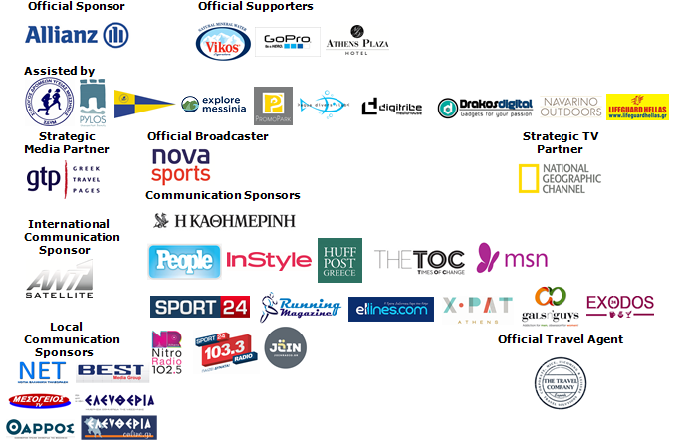

Under The Auspices of the Greek National Tourism Organization


Website: www.navarinochallenge.com
Facebook Page: www.facebook.com/Navarinochallenge
Facebook Event: https://www.facebook.com/events/509478955873290/
Twitter Account: https://twitter.com/NavarinoC
YouTube Channel: http://www.youtube.com/user/NavarinoChallenge
Google + Account: https://plus.google.com/115165548850159469774/posts
Instagram Page: http://instagram.com/navarinochallenge
Hashtag: #NavarinoChallenge

For More Information:
Press Office: Active Media
Tel: +30 210 9343020
Accommodation Packages & Bookings: The Travel Company Experts
Tel: +30 215 5608282

About Dean Karnazes
TIME magazine named Dean Karnazes as one of the "Top 100 Most Influential People in the World." Men's Fitness hailed him as one of the fittest men on the planet. An internationally recognized endurance athlete and NYC bestselling author, Dean has pushed his body and mind to inconceivable limits. Among his many accomplishments, he has run 350 continuous miles, foregoing sleep for three nights. He has run across Death Valley in 120 degree temperatures, and he has run a marathon to the South Pole in negative 40 degrees. On ten different occasions, he has run a 200-mile relay race solo, racing alongside teams of twelve.
His most recent endeavor was running 50 marathons, in all 50 US states, in 50 consecutive days, finishing with the NYC Marathon, which he ran in three hours flat.
Dean and his incredible adventures have been featured on 60 Minutes, The Late Show with David Letterman, CBS News, CNN, ESPN, The Howard Stern Show, NPR's Morning Edition, the BBC, and many others. He has appeared on the cover of Runner's World and Outside, and been featured in, to mention a few. He is a monthly columnist for Men's Health, the largest Men's publication in the world.

Costa Navarino
Costa Navarino is the prime, sustainable destination in the Mediterranean, located in the Greek region of Messinia in the southwest Peloponnese. One of the most unspoiled and breathtaking seaside Mediterranean landscapes, this area has been shaped by 4,500 years of history. Its philosophy is driven by a genuine desire to promote Messinia, while protecting and preserving its natural beauty and heritage. It will comprise a number of distinct sites featuring 5-star deluxe hotels, luxury residences, conference facilities, spa and thalassotherapy centres, signature golf courses, as well as a wide range of unique year-round activities for adults and children. Navarino Dunes, the first area, is home to two luxury 5-star hotels, The Romanos, a Luxury Collection Resort and The Westin Resort, Costa Navarino; The Dunes Course – the first signature golf course in Greece- Anazoe Spa, a 4,000sq.m. spa & thalassotherapy centre; the state-of-the-art conference centre House of Events; specially designed facilities for children; as well as a variety of gastronomy venues, sports, outdoor and cultural activities. Navarino Bay, the second area is home to the signature golf course, The Bay Course.
www.costanavarino.com

About The Westin Resort Costa Navarino
The Westin Resort Costa Navarino is one of the two luxury 5-star properties of Starwood Hotels and Resorts operating at Navarino Dunes, the first resort area in Costa Navarino, the prime destination in the Mediterranean. Overlooking the Ionian Sea coastline of the Dunes Beach, at The Westin Resort Costa Navarino 445 rooms and suites, inspired by old Messinian mansions, spring from nature and create an ambiance of genuine hospitality. Voted as the “Best Family Destination” in the Mediterranean amongst Europe’s Starwood Hotels & Resorts, The Westin Resort Costa Navarino is the ideal destination for family getaways as it proposes a plethora of children activities such as a wonderful aqua park with water slides, playground and recreational center as well as two specially designed hubs for children, Cocoon and SandCastle. At Navarino Dunes there is also The Romanos, a Luxury Collection Resort, the 18-hole signature golf course The Dunes Course the 4,000 sqm Anazoe Spa, a state-of-the-art conference center, as well as a variety of culinary venues, sports, outdoor and cultural activities. Navarino Bay, the second area in Costa Navarino, features the second 18-hole signature golf course, The Bay Course. For more information on The Westin Resort Costa Navarino, please visit www.westincostanavarino.com, or follow us on Twitter.

