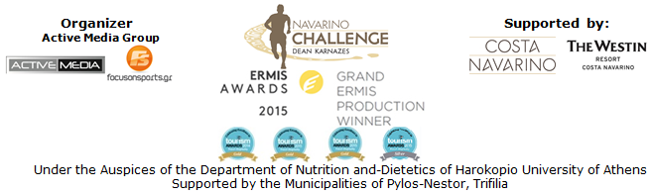

PRESS RELEASE

Running at Voidokilia and Kids’ Athletics in “Navarino Challenge”!

Special accommodation and airline packages!

Athens, July 4 2016 – “Navarino Challenge” never stops to surprise and to keep the public’s interest undiminished…!
More specifically, the -favorite to everyone- activity of running, that was established since 2013, with the Greek American ultramarathon runner Dean Karnazes as its key ambassador, returns with renewed routes!

On Sunday September 11, 2016 runners starting from Navarino Dunes in Costa Navarino will participate in a non-competitive running to Pylos beach, crossing Voidokilia beach for the first time and following the trail mapped out, back in Homer’s years, by Telemachus, Odysseus’ son, trying to find his missing father. According to the Homeric tradition, when the son of Odysseus arrived on the beach on a ship, he had with him the goddess Athena disguised as Mentor. On their way, runners will discover the mythical Voidokilia, the most famous beach in Messinia –with its unique shape that outlines the letter Omega of the Greek alphabet, written as “Ω”- and one of the best in the world!

This year's Half Marathon (21.1 km) and 10 km running routes will start at 08:15 in the morning while the 5km route (for running and dynamic walking) will start at 08:30. Similarly, the 1 km route designed for children will begin at 09:30 in the morning. The start and finish points are common. This year, the routes have been designed and edited by the former marathon runner, holder of national best performance on the classical route, running coach and director of All About Running, Nikos Polias. A detailed description of the routes including maps and technical details (altitude) is available in the following link: http://navarinochallenge.com/event_routes_2016_en.html

“Navarino Challenge” innovates and presents for the first time the activity of Kids' Athletics with its ambassador, the Olympic and World Champion in 400m. hurdles, Periklis Iakovakis. This is an activity aiming at getting children acquainted with the track and field sports, and has been developed and established by a special panel of scientists from IAAF (International Association of Athletics Federation). In Greece the activity is officially implemented by the Hellenic Athletics Federation (SEGAS) in cooperation with the Ministry of Education. Kids' Athletics include, among others, the activity of standing long jump, the sport of the world famous Olympic champion and legendary Kostis Tsiklitiras, who was born in Pylos Messinia, which will be presented on September 10th in the central Square of Pylos, and on Sunday the 11th of September in Costa Navarino. Periklis Iakovakis said about his participation: “I invite all our little friends at the Kids' Athletics program of Navarino Challenge to get to know the various sports of athletics. Through a program lasting about one hour, we will do jumps, throws, sprints and relay! But above all we will have a good time and have fun. Join us now and we will be expecting you for a wonderful weekend full of sports”.

For the first time in a sports tourism event, the top airline in the world, Qatar Airways, offers the opportunity to anyone who wishes to participate in “Navarino Challenge”, to book his/her flights from abroad, with a discount up to 25%, thus ideally completing the accommodation packages created and sold at a fast pace.
The new flights of the official airline partner of the event from Los Angeles, Boston, Atlanta in USA and the direct flights from Sydney and Adelaide in Australia, with one of the youngest aircraft fleets in the world, with the luxury and of course the comfort of Qatar Airways, combined with this significant discount in the cost of the airline tickets, will be an additional incentive for the arrival of visitors from these countries but also from all countries where the global network of the company reaches.
Please use the promo code ATHNAVCH6 to book the exclusive offer, via the following link: http://www.qatarairways.com/gr/el/cugs/navarinochallenge.page
Offer valid from 30 August 2016 to 11 September 2016 included (Outbound) and (Inbound) to be completed on or before 21 September 2016.

Book your room now (almost less than 75 days before the event) at The Westin Resort Costa Navarino and take advantage of the privileged prices available for those wishing to enjoy the full schedule of “Navarino Challenge. For further information please contact the event’s official travel agent Vita N Travel. Telephone: +30 210 3249070 or visit: http://navarinochallenge.com/event_accommodation_in_2016_en.html

“Navarino Challenge” will be held for the 4th consecutive year in Messinia and Costa Navarino on 9-11 September 2016, with more than 18 activities!
Registrations are open and anyone can take part in activities of running, swimming and SUP by filling the special form available at the following link:
http://activemedia.com.gr/product/navarino-challenge/

The event will be held for one more year, under the Auspices of the Department of Nutrition and-Dietetics of Harokopio University of Athens with the support of Costa Navarino and The Westin Resort Costa Navarino, as well as the Municipalities of Pylos-Nestor and Trifilia.

For more information about the event, you may contact us through the following special form: http://www.navarinochallenge.com/contact.html

Official Sponsors: Allianz Greece, “Vikos” Natural Mineral Water
Official Airline Partner: Qatar Airways
Official Supporters: BIC®, BIC® Sport, Navarino Icons, Village Cinemas
Assisted by: Health Runners Club of Messinia, Pylos Association of Enterprises for Tourism Development, Maritime Athletic Pylos Association “Nestor”, Explore Messinia, Navarino Outdoors, Swim Academy, Aqua Divers Club, Scuba Hellas, Navarino Golf Academy, Restaurant Posidonia Restaurant ThaMa, Alpha (Athlima SA), Department of Sports Organization & Management from University of Peloponnese, Anazoe Spa Costa Navarino, 1morekm, Hellenic Athletics Federation (SEGAS), IAAF Kids Athletics, Apia, Inbi
Official Travel Agent: Vita N Travel
Official Broadcaster: OTE TV
TV Communication Partner: National Geographic Channel

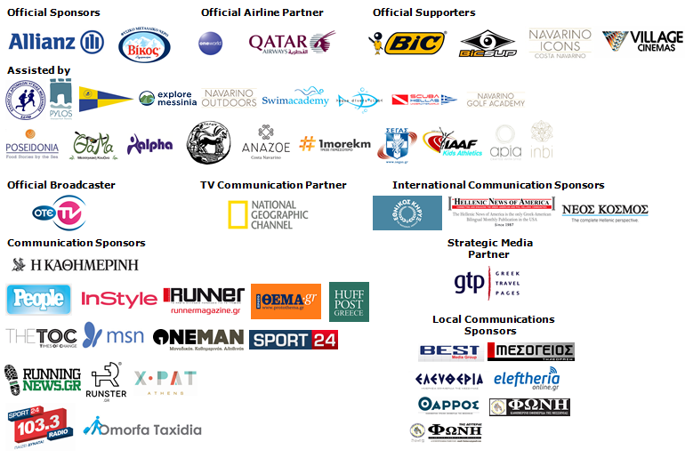

Website: www.navarinochallenge.com
Facebook Page: www.facebook.com/Navarinochallenge
Facebook Event: https://www.facebook.com/events/1575864132703599/
Twitter Account: https://twitter.com/NavarinoC
YouTube Channel: http://www.youtube.com/user/NavarinoChallenge
Google + Account: https://plus.google.com/115165548850159469774/posts
Instagram Page: http://instagram.com/navarinochallenge
Hashtags: #navarinochallenge #costanavarino #eatwell #runwell #livewell

Costa Navarino:
Costa Navarino is the prime, sustainable destination in the Mediterranean, located in the Greek region of Messinia in the southwest Peloponnese. One of the most unspoiled and breathtaking seaside Mediterranean landscapes, this area has been shaped by 4,500 years of history. Its philosophy is driven by a genuine desire to promote Messinia, while protecting and preserving its natural beauty and heritage. It will comprise a number of distinct sites featuring 5-star deluxe hotels, luxury residences, conference facilities, spa and thalassotherapy centres, signature golf courses, as well as a wide range of unique year-round activities for adults and children. Navarino Dunes, the first area, is home to two luxury 5-star hotels, The Romanos, a Luxury Collection Resort and The Westin Resort Costa Navarino; The Dunes Course – the first signature golf course in Greece- Anazoe Spa, a 4,000sq.m. spa & thalassotherapy centre; the state-of-the-art conference centre House of Events; specially designed facilities for children; as well as a variety of gastronomy venues, sports, outdoor and cultural activities. Navarino Bay, the second area is home to the signature golf course, The Bay Course.
High resolution photos can be accessed through the following link, by using the password nestor.

About The Westin Resort Costa Navarino:
The Westin Resort Costa Navarino is one of the two luxury 5-star properties at Navarino Dunes, the first resort area in Costa Navarino, the prime destination in the Mediterranean. Overlooking the Ionian Sea coastline of the Dunes Beach, The Westin Resort Costa Navarino 445 rooms and suites, inspired by old Messinian mansions, spring from nature and create an ambiance of genuine hospitality. Voted as the “Best Family Destination” in the Mediterranean amongst Europe’s Starwood Hotels & Resorts, The Westin Resort Costa Navarino is the ideal destination for family getaways as it proposes a plethora of children activities such as a wonderful aqua park with water slides, playground and recreational center as well as two specially designed hubs for children, Cocoon and SandCastle. At Navarino Dunes there is also The Romanos, a Luxury Collection Resort, the 18-hole signature golf course The Dunes Course the 4,000 sq.m Anazoe Spa, a state-of-the-art conference center, as well as a variety of culinary venues, sports, outdoor and cultural activities. Navarino Bay, the second area in Costa Navarino, features the second 18-hole signature golf course, The Bay Course. For more information on The Westin Resort Costa Navarino, please visit www.westincostanavarino.com, or follow us on Twitter.

