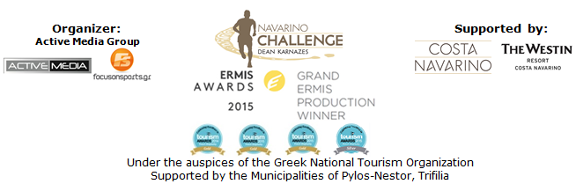

PRESS RELEASE

Register & book your room in Navarino Challenge 2017

The elite of Greek Olympic Champions in the 5th annual sports tourism fest of Messinia

Athens, June 27 2017 – We are counting down the days for the 5th consecutive event that will be held between October 13-15, 2017 in Messinia and Costa Navarino shortly before the historic Naval Battle of Navarino.

“Navarino Challenge” is the sports tourism event with the most Olympic ambassadors, and is hosted once more in Messinia with more than 10 Olympic sports!

“Navarino Challenge” promotes the value of “fair play” adopting the purpose of the Olympic Movement, supported by Olympic athletes and Champions who educate young people through sports, without any discrimination. At the same time, the athletes inform them about the benefits of exercise and the Mediterranean diet and prompt the audience to support the cause of the fight against childhood obesity.

Registrations for the multiple award-winning sports tourism event are open and everyone can now take part by completing the special entry form available at the following link: http://activemedia.com.gr/product/navarino-challenge-2017/

Runners of all ages, starting from Navarino Dunes in Costa Navarino will run a coastal route to Pylos beach, crossing Voidokilia beach and following the trail mapped out, back in Homer’s years, by Telemachus, Ulysses’ son, trying to find his missing father. According to the Homeric tradition, when the son of Ulysses arrived on the beach on a ship, he had with him the goddess Athena disguised as Mentor. On their way, runners will discover the mythical Voidokilia, the most famous beach in Messinia and one of the best in the world, with its unique shape that outlines the letter Omega of the Greek alphabet, written as “Ω”!
Participants may select to run in one of the following routes, the exquisite Half Marathon (21,1km), the 10 km route and the 5km run (for running and dynamic walking). At the same day a 1km running route for children will be held. The start and finish points are common. The routes have been designed and edited by the former marathon runner, holder of national best performance on the classical route, running coach and director of All About Running, Nikos Polias. This year, there will be race timing for all runners.

For one more year, sea lovers will have the opportunity to swim without competition, in the beautiful Navarino bay at the picturesque port of Pylos, covering the unique swimming route of one mile (1.6 km.) designed by the Federal Technical Director in Swimming, Nikos Gemelos (coach with countless distinctions in the Olympic Games and world championships in open water swimming).
Participating athletes will have the opportunity to quench their thirst with the Natural Mineral Water "Vikos" that contributes to the well-functioning of the body during sports. In addition, for the fourth consecutive year, athletes and organizers will move with the safety and efficient engines of the cars of Ford Motor Hellas, the official sponsor of “Navarino Challenge”.

Right after, the swimming activity, a Stand Up Paddling race by BIC® Sport will take place for the second consecutive year!
“Navarino Challenge” will present at the port of Pylos an innovative sport like Stand Up Paddling (SUP), which quickly became popular worldwide. It is an easy and ideal sport for someone to enjoy in an area surrounded by some of the best beaches in Greece. The entertaining routes for beginners or experts are the best choices for those who wish to experience the peacefulness of the Ionian Sea. One of the most recognized brands in the world, BIC® company with presence in the field of water sports with BIC® Sport since 1979, is supporting this activity. All athletes participating will have the opportunity to test the credibility of the SUP BIC® boards. Stand Up Paddling will be held with the support of the best surf club, Surf Salad!

The privileged accommodation packages at The Westin Resort Costa Navarino are now available for those wishing to enjoy the full schedule of “Navarino Challenge”. For further information please visit the following link: http://www.westincostanavarino.com/navarinochallenge2017
In order to get advantage of these privileged prices it is necessary to have completed your registration for at least one activity in running, swimming, or SUP (per reservation).

“Navarino Challenge” will be held under the Auspices of the Greek National Tourism Organization with the support of Costa Navarino and The Westin Resort Costa Navarino, as well as the Municipalities of Pylos-Nestor and Trifilia.

More information will be announced in the next few weeks.

Official Airline Partner: Qatar Airways
Official Sponsors: “Vikos” Natural Mineral Water, Ford Motor Hellas
Official Supporters: BIC®, BIC® Sport, Wyndham Grand Athens, Poseidonia, Surf Salad
Assisted by: Navarino Outdoors, Swim Academy, Navarino Racquet Academy, Apia
Strategic TV Partner: National Geographic
Under the auspices of the Greek National Tourism Organization
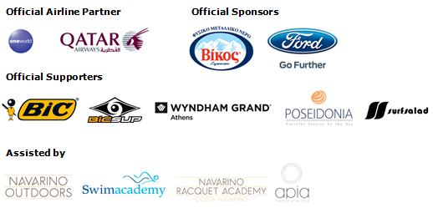
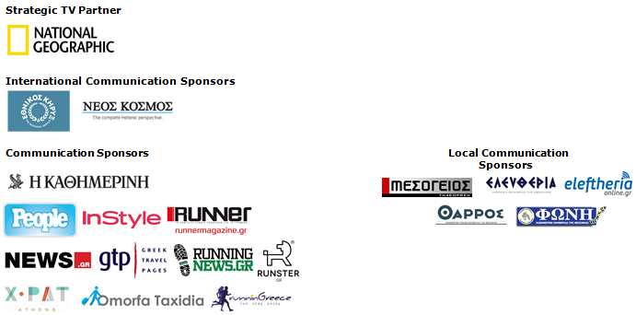

Website: www.navarinochallenge.com
Facebook Page: www.facebook.com/Navarinochallenge
Twitter Account: https://twitter.com/NavarinoC
YouTube Channel: http://www.youtube.com/user/NavarinoChallenge
Instagram Page: http://instagram.com/navarinochallenge
Hashtags: #navarinochallenge #costanavarino #eatwell #runwell #livewell

Costa Navarino:
Costa Navarino is the prime, sustainable destination in the Mediterranean, located in the Greek region of Messinia in the southwest Peloponnese. One of the most unspoiled and breathtaking seaside Mediterranean landscapes, this area has been shaped by 4,500 years of history. Its philosophy is driven by a genuine desire to promote Messinia, while protecting and preserving its natural beauty and heritage. It will comprise a number of distinct sites featuring 5-star deluxe hotels, luxury residences, conference facilities, spa and thalassotherapy centres, signature golf courses, as well as a wide range of unique year-round activities for adults and children. Navarino Dunes, the first area, is home to two luxury 5-star hotels, The Romanos, a Luxury Collection Resort and The Westin Resort Costa Navarino; The Dunes Course – the first signature golf course in Greece- Anazoe Spa, a 4,000sq.m. spa & thalassotherapy centre; the state-of-the-art conference centre House of Events; specially designed facilities for children; as well as a variety of gastronomy venues, sports, outdoor and cultural activities. Navarino Bay, the second area is home to the signature golf course, The Bay Course.
High resolution photos can be accessed through the following link, by using the password nestor.

About The Westin Resort Costa Navarino:
The Westin Resort Costa Navarino is one of the two luxury 5-star properties at Navarino Dunes, the first resort area in Costa Navarino, the prime destination in the Mediterranean. Overlooking the Ionian Sea coastline of the Dunes Beach, The Westin Resort Costa Navarino 445 rooms and suites, inspired by old Messinian mansions, spring from nature and create an ambiance of genuine hospitality. Voted as the “Best Family Destination” in the Mediterranean amongst Europe’s Starwood Hotels & Resorts, The Westin Resort Costa Navarino is the ideal destination for family getaways as it proposes a plethora of children activities such as a wonderful aqua park with water slides, playground and recreational center as well as two specially designed hubs for children, Cocoon and SandCastle. At Navarino Dunes there is also The Romanos, a Luxury Collection Resort, the 18-hole signature golf course The Dunes Course the 4,000 sq.m Anazoe Spa, a state-of-the-art conference center, as well as a variety of culinary venues, sports, outdoor and cultural activities. Navarino Bay, the second area in Costa Navarino, features the second 18-hole signature golf course, The Bay Course. For more information on The Westin Resort Costa Navarino, please visit www.westincostanavarino.com, or follow us on Twitter.

