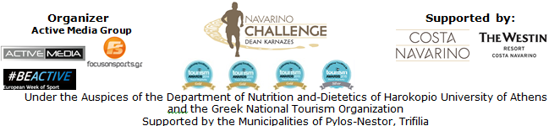

PRESS RELEASE
Athens, September 4th 2015

Running in the trail of Telemachus
& registrations extension till Sunday, September 6th!

“Navarino Challenge” is ready to welcome people of all ages from Greece and abroad on 11-13 September 2015 and provide a schedule full of sports and entertainment!
The interest for this year's event surpasses all expectations and participants will come in Messinia and Costa Navarino, from all parts of Greece (from Thessaloniki to Crete) and abroad (with entries from countries such as Switzerland, Hungary and Cyprus).

This year “Navarino Challenge” will "travel" with the leading airline Qatar Airways that participates as an official airline partner of the event.
Qatar Airways has been honored with three of the top aviation accolades at the annual Skytrax World Airline Awards, winning Airline of the Year for the third time – a major accomplishment for an airline to reach multiple times.

For 2nd consecutive year, athletes and organizers will drive with the safety and efficient engines of Ford's cars by using a complete range of models from Ford Fiesta 1.0L and Fiesta ST to the new Ford C-MAX, Mondeo, Focus ST and the Transit Custom & Courier. At the same time, cars of the event will move with the high-quality fuel BP Ultimate which is designed to allow the engine to operate at its full potential.

“Navarino Challenge” is promoting for 3rd consecutive year, through its activities, the awareness regarding childhood obesity and the benefits of the Mediterranean diet and exercise.
This message will be carried by the Gold Paralympic athlete in boccia, Grigoris Polychronidis who will participate for the first time in “Navarino Challenge” with the support of Allianz, the official sponsor of “Navarino Challenge” and the Hellenic Paralympic Committee.
Participants will have the opportunity to work out, through activities such as: Running, Swimming, Biking, Tae Kwon Do, Climbing, Pilates and Martial Arts!
Specifically, on Saturday, September 12th, the picturesque port of Pylos will host a magnificent open water swimming route. In the one mile route (1.6 km), participants will swim alongside our world champions, Spyros Gianniotis and Kelly Araouzou while in the half mile route (0.8 km), children will take action! The swimming day of “Navarino Challenge” is assisted by the social non-profitable initiative Safe Water Sports which will inform and raise awareness on issues related to security and prevention of accidents during sports and recreational activities.
On Sunday, September 13th, runners will start from Navarino Dunes in Costa Navarino following the coastal road towards Pylos (and the trail mapped out by Telemachus in Homer's years when he tried to find Odysseus) and discover the mythical beauty of Voidokilia. Running routes will start at the following times: 08:45am for the half-marathon route (21.1 km), 09:00am for the 10 km route, 9:15am for the 5 km route (which includes running and dynamic walking) and 10:30am for the children’s 1 km route.

Registrations for “Navarino Challenge”, will continue until Sunday, September 6, 2015, through the official website of the event: http://navarinochallenge.com/registration_form.php or alternatively via Viva.gr online and via 150 physical locations throughout Greece (Viva Points / The Mall Athens, Public Shops, Papasotiriou, Ianos, Seven Spots, Reload Stores, Media Markt). You may register here: http://www.viva.gr/tickets/sports-tourism-event/pylos/navarino-challenge-en/

The event is held under the Auspices of the Department of Nutrition and-Dietetics of Harokopio University of Athens and the Greek National Tourism Organization with the support of Costa Navarino and The Westin Resort Costa Navarino as well as the Municipalities of Pylos-Nestor, Trifilia, for a 3rd consecutive year. “Navarino Challenge” is included this year in the European Week of Sport (September 7-13, 2015).

Official Sponsor: Allianz Hellas
Official Airline Partner: Qatar Airways
Official Supporters: Hellenic Fuels S.A., Ford Motor Hellas, Natural Mineral Water “Vikos”, GoPro, Navarino Icons
Assisted by: Health Runners Club of Messinia (SDYM), Pylos Association of Enterprises for Tourism Development, Maritime Athletic Pylos Association “Nestor”, Explore Messinia, Promopark, Aqua Divers Club, Digitribe Mediahouse, Drakos Digital, Navarino Outdoors, Safe Water Sports, NJV Athens Plaza, Poseidonia restaurant, Lifeguard Hellas Training Center, ThaMa restaurant, Alpha (Athlima SA), Dole
Official Travel Agent: The Travel Company Experts
Official Broadcaster: Novasports
Strategic TV Partner: National Geographic Channel

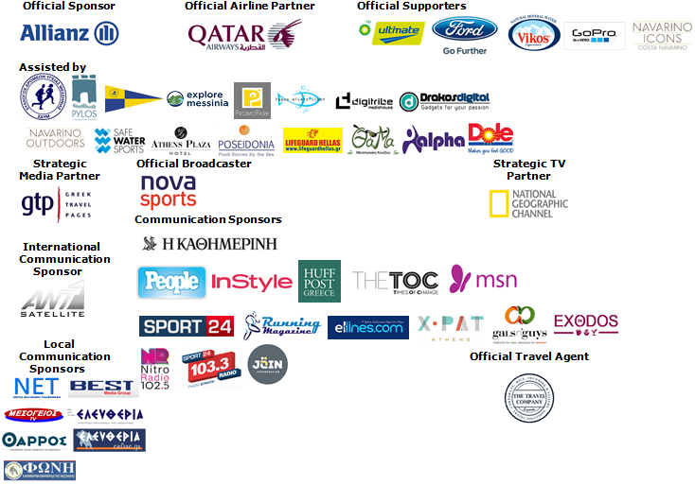

Under The Auspices of the Greek National Tourism Organization


Website: www.navarinochallenge.com
Facebook Page: www.facebook.com/Navarinochallenge
Facebook Event: https://www.facebook.com/events/509478955873290/
Twitter Account: https://twitter.com/NavarinoC
YouTube Channel: http://www.youtube.com/user/NavarinoChallenge
Google + Account: https://plus.google.com/115165548850159469774/posts
Instagram Page: http://instagram.com/navarinochallenge
Hashtag: #NavarinoChallenge

For More Information:
Press Office: Active Media
Tel: +30 210 9343020
Accommodation Packages & Bookings: The Travel Company Experts
Tel: +30 215 5608282

About Dean Karnazes
TIME magazine named Dean Karnazes as one of the "Top 100 Most Influential People in the World." Men's Fitness hailed him as one of the fittest men on the planet. An internationally recognized endurance athlete and NYC bestselling author, Dean has pushed his body and mind to inconceivable limits. Among his many accomplishments, he has run 350 continuous miles, foregoing sleep for three nights. He has run across Death Valley in 120 degree temperatures, and he has run a marathon to the South Pole in negative 40 degrees. On ten different occasions, he has run a 200-mile relay race solo, racing alongside teams of twelve.
His most recent endeavor was running 50 marathons, in all 50 US states, in 50 consecutive days, finishing with the NYC Marathon, which he ran in three hours flat.
Dean and his incredible adventures have been featured on 60 Minutes, The Late Show with David Letterman, CBS News, CNN, ESPN, The Howard Stern Show, NPR's Morning Edition, the BBC, and many others. He has appeared on the cover of Runner's World and Outside, and been featured in, to mention a few. He is a monthly columnist for Men's Health, the largest Men's publication in the world.

Costa Navarino
Costa Navarino is the prime, sustainable destination in the Mediterranean, located in the Greek region of Messinia in the southwest Peloponnese. One of the most unspoiled and breathtaking seaside Mediterranean landscapes, this area has been shaped by 4,500 years of history. Its philosophy is driven by a genuine desire to promote Messinia, while protecting and preserving its natural beauty and heritage. It will comprise a number of distinct sites featuring 5-star deluxe hotels, luxury residences, conference facilities, spa and thalassotherapy centres, signature golf courses, as well as a wide range of unique year-round activities for adults and children. Navarino Dunes, the first area, is home to two luxury 5-star hotels, The Romanos, a Luxury Collection Resort and The Westin Resort, Costa Navarino; The Dunes Course – the first signature golf course in Greece- Anazoe Spa, a 4,000sq.m. spa & thalassotherapy centre; the state-of-the-art conference centre House of Events; specially designed facilities for children; as well as a variety of gastronomy venues, sports, outdoor and cultural activities. Navarino Bay, the second area is home to the signature golf course, The Bay Course.
www.costanavarino.com

About The Westin Resort Costa Navarino
The Westin Resort Costa Navarino is one of the two luxury 5-star properties of Starwood Hotels and Resorts operating at Navarino Dunes, the first resort area in Costa Navarino, the prime destination in the Mediterranean. Overlooking the Ionian Sea coastline of the Dunes Beach, at The Westin Resort Costa Navarino 445 rooms and suites, inspired by old Messinian mansions, spring from nature and create an ambiance of genuine hospitality. Voted as the “Best Family Destination” in the Mediterranean amongst Europe’s Starwood Hotels & Resorts, The Westin Resort Costa Navarino is the ideal destination for family getaways as it proposes a plethora of children activities such as a wonderful aqua park with water slides, playground and recreational center as well as two specially designed hubs for children, Cocoon and SandCastle. At Navarino Dunes there is also The Romanos, a Luxury Collection Resort, the 18-hole signature golf course The Dunes Course the 4,000 sqm Anazoe Spa, a state-of-the-art conference center, as well as a variety of culinary venues, sports, outdoor and cultural activities. Navarino Bay, the second area in Costa Navarino, features the second 18-hole signature golf course, The Bay Course. For more information on The Westin Resort Costa Navarino, please visit www.westincostanavarino.com, or follow us on Twitter.

