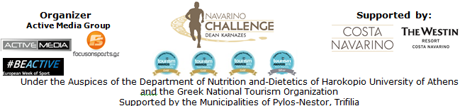

PRESS RELEASE
Athens, September 15th 2015

A weekend full of sports for everyone!

Great ambassadors and people of all ages participated massively
in the top sports tourism event!

More than 1,000 participant athletes from Greece and abroad (with entries from countries such as USA, England, Germany, Italy, Switzerland, Hungary, Romania and Cyprus), consisted a dynamic crowd in the third year of “Navarino Challenge”.
On 11-13, September 2015, people of all ages (from the youngest athlete, aged 6 months old, up to the oldest, aged 70 years old) visited Pylos and Costa Navarino, to enjoy the rich schedule of the event, which included activities such as running, swimming, taekwondo, climbing, pilates, cycling, boccia, basketball and kick boxing!

On Saturday 12/09 morning, more than 100 participant swimmers swam against the strong wind, the one mile distance, at the picturesque port of Pylos, along with the Olympic Champion and Twice Gold World Champion in open water swimming, Spyros Gianniotis and the World Champion in open water swimming, Kelly Araouzou under the technical directions of the Federal Swimming Coach, Nikos Gemelos who designed the routes. Then, a half mile route was held for children.
The swimming day of “Navarino Challenge” was assisted by the social non-profitable initiative Safe Water Sports which informed and raised awareness on issues related to security and prevention of accidents during sports and recreational activities. The swimming day could not have taken place without the assistance of Pylos-Nestor Municipality, the Port Authority of Pylos, Pylos Association of Enterprises for Tourism Development, Maritime Athletic Pylos Association “Nestor”, Explore Messinia and Aqua Divers Club. At the end of the activities, a demonstration race followed with Optimist and Laser boats by “Nestor” Association.

Another unique activity, the sport boccia, was presented with the contribution of the official sponsor of the event Allianz Greece, with the participation of the Gold Paralympic athlete Grigoris Polychronidis. Along with him, the Greek-American ultramarathon runner, Dean Karnazes the Twice Silver Olympic medalist in taekwondo, Alexandros Nikolaidis and the team of Allianz, tested their skills in the sport.

On Saturday night, “Navarino Challenge” “traveled” with the leading airline Qatar Airways, which participated as an official airline partner in the event. The welcoming of guests and the coordination of the “Cocktail Night by Qatar Airways” was handled by the presenter Maria Bekatorou and the journalist Dora Tsampazi while the group Hot Club De Grece accompanied with their music. For their overall contribution to Greek sports, awards were given to great athletes and sports personalities such as the Twice Silver Olympic medalist in taekwondo, Alexandros Nikolaidis by Trifilia Mayor, Mr. Panagiotis Katsivelas, the Olympic Champion and Twice Gold World Champion in open water swimming, Spyros Gianniotis by the Director of Local Operations of TEMES SA, Mr. George Chatziiosif, the World Champion in open water swimming, Kelly Araouzou by the Complex General Manager Costa Navarino, Mr. Jirayr Kececian, the Federal Swimming Coach, Nikos Gemelos by the President & CEO of Ford Motor Hellas, Mr. Nikos Notaras, the Gold Paralympic athlete in boccia, Grigoris Polychronidis by the Commercial Manager Greece of Qatar Airways, Mr. Alexandros Michalopoulos, the ultramarathon runner Dean Karnazes by the CEO of Active Media, Mr. Akis Tsolis and the Co-Founder of Navarino Challenge, Mr. Peter Poulos and the Olympic and World Champion in 400m. hurdles, Periklis Iakovakis by the General Manager of Allianz Greece, Mrs. Philippa Michali. At the end of the awards ceremony, the speech of the “Navarino Challenge” ambassador Dean Karnazes followed, who sent his own message, strengthening the position of our country on the world map of sports tourism.

For 2nd consecutive year, athletes and organizers drove with the safety and efficient engines of Ford's cars with the high-quality fuel BP Ultimate. At the same time, participating athletes quenched their thirst with the natural mineral water "Vikos" that contributes to the well-functioning of the body during sports.

On Sunday, September 13th, runners started from Navarino Dunes in Costa Navarino (that was also the finishing point) following the coastal road towards Pylos (and the trail mapped out by Telemachus in Homer's years). Running fans loved and were delighted by the magical images of Voidokilia, before they returned back to the finishing point. “Navarino Challenge” included a half marathon (21.1km), routes of 10km and 5km (running & dynamic walking) and a 1km route for children. Upon the finishing of Dean Karnazes, the ambassador of the event was awarded by the Vice-Chairman & Managing Director of TEMES SA, Mr. Stephanos Theodorides.

This year's rich program included once again the very successful activities of taekwondo and pilates, while there was an addition of the new activity of kick boxing. Specifically, the Olympic medalist in taekwondo, Alexandros Nikolaidis, the leading pilates instructor, Mandy Persaki with her team and the other Alexandros Nikolaidis, the kick boxing champion, offered, each one separately in his/her sector, their knowledge and experience to the audience that got better acquainted with “Navarino Challenge” activities. The certified climbing instructor, George Malamas offered his knowledge to the learning of climbing, which surpassed all expectations in participation, as more than ninety people were initiated into the secrets of this activity. In the afternoon of Sunday, a bike ride was organized in Voidokilia in cooperation with Navarino Outdoors. As always, “Navarino Challenge” prepares the “ground” for some extra sports. The ambassadors and several guests of the event got a taste of the new activities that are ready to be added next year such as basketball, golf, surf and baby swimming, making “Navarino Challenge” the sports tourism event with the most sporting activities in Greece!

The event was held under the Auspices of the Department of Nutrition and-Dietetics of Harokopio University of Athens (supporting actions and always assisting efforts that promote health and the fight against childhood obesity through the Mediterranean diet and exercise) and the Greek National Tourism Organization with the support of Costa Navarino and The Westin Resort Costa Navarino as well as the Municipalities of Pylos-Nestor and Trifilia. “Navarino Challenge” was included this year in the European Week of Sport (September 7-13, 2015).

Official supporters of the event were also the GoPro and Navarino Icons. The event was assisted by: Health Runners Club of Messinia (SDYM), Promopark, Digitribe Mediahouse, Drakos Digital, NJV Athens Plaza, Poseidonia Restaurant, ThaMa Restaurant, Alpha (Athlima SA) and Dole while The Travel Company Experts was the official travel agent of the event.
For yet another year, the University of Peloponnese with the Department of Sports Organization & Management, as well as the Hellenic Red Cross Sector of Samaritans, Rescuers and Lifeguards supported the event with volunteers while Messiniakos Gymnastic Club, the Athletic Club Akritas, Kalamata Taekwondo and Kyparissia Taekwondo recorded a dynamic presence with their teams.

Official Sponsor: Allianz Greece
Official Airline Partner: Qatar Airways
Official Supporters: Hellenic Fuels S.A., Ford Motor Hellas, Natural Mineral Water “Vikos”, GoPro, Navarino Icons
Assisted by: Health Runners Club of Messinia (SDYM), Pylos Association of Enterprises for Tourism Development, Maritime Athletic Pylos Association “Nestor”, Explore Messinia, Promopark, Aqua Divers Club, Digitribe Mediahouse, Drakos Digital, Navarino Outdoors, Safe Water Sports, NJV Athens Plaza, Poseidonia restaurant, ThaMa restaurant, Alpha (Athlima SA), Dole
Official Travel Agent: The Travel Company Experts
Official Broadcaster: Novasports
Strategic TV Partner: National Geographic Channel
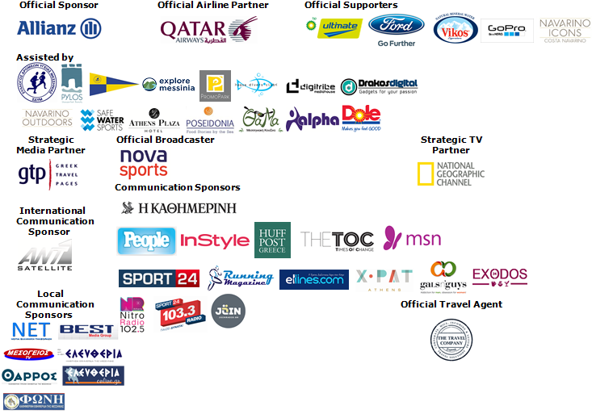

Under The Auspices of the Greek National Tourism Organization


Website: www.navarinochallenge.com
Facebook Page: www.facebook.com/Navarinochallenge
Facebook Event: https://www.facebook.com/events/509478955873290/
Twitter Account: https://twitter.com/NavarinoC
YouTube Channel: http://www.youtube.com/user/NavarinoChallenge
Google + Account: https://plus.google.com/115165548850159469774/posts
Instagram Page: http://instagram.com/navarinochallenge
Hashtag: #NavarinoChallenge

For More Information:
Press Office: Active Media
Tel: +30 210 9343020
Accommodation Packages & Bookings: The Travel Company Experts
Tel: +30 215 5608282

About Dean Karnazes
TIME magazine named Dean Karnazes as one of the "Top 100 Most Influential People in the World." Men's Fitness hailed him as one of the fittest men on the planet. An internationally recognized endurance athlete and NYC bestselling author, Dean has pushed his body and mind to inconceivable limits. Among his many accomplishments, he has run 350 continuous miles, foregoing sleep for three nights. He has run across Death Valley in 120 degree temperatures, and he has run a marathon to the South Pole in negative 40 degrees. On ten different occasions, he has run a 200-mile relay race solo, racing alongside teams of twelve.
His most recent endeavor was running 50 marathons, in all 50 US states, in 50 consecutive days, finishing with the NYC Marathon, which he ran in three hours flat.
Dean and his incredible adventures have been featured on 60 Minutes, The Late Show with David Letterman, CBS News, CNN, ESPN, The Howard Stern Show, NPR's Morning Edition, the BBC, and many others. He has appeared on the cover of Runner's World and Outside, and been featured in, to mention a few. He is a monthly columnist for Men's Health, the largest Men's publication in the world.

Costa Navarino
Costa Navarino is the prime, sustainable destination in the Mediterranean, located in the Greek region of Messinia in the southwest Peloponnese. One of the most unspoiled and breathtaking seaside Mediterranean landscapes, this area has been shaped by 4,500 years of history. Its philosophy is driven by a genuine desire to promote Messinia, while protecting and preserving its natural beauty and heritage. It will comprise a number of distinct sites featuring 5-star deluxe hotels, luxury residences, conference facilities, spa and thalassotherapy centres, signature golf courses, as well as a wide range of unique year-round activities for adults and children. Navarino Dunes, the first area, is home to two luxury 5-star hotels, The Romanos, a Luxury Collection Resort and The Westin Resort, Costa Navarino; The Dunes Course – the first signature golf course in Greece- Anazoe Spa, a 4,000sq.m. spa & thalassotherapy centre; the state-of-the-art conference centre House of Events; specially designed facilities for children; as well as a variety of gastronomy venues, sports, outdoor and cultural activities. Navarino Bay, the second area is home to the signature golf course, The Bay Course.
www.costanavarino.com

About The Westin Resort Costa Navarino
The Westin Resort Costa Navarino is one of the two luxury 5-star properties of Starwood Hotels and Resorts operating at Navarino Dunes, the first resort area in Costa Navarino, the prime destination in the Mediterranean. Overlooking the Ionian Sea coastline of the Dunes Beach, at The Westin Resort Costa Navarino 445 rooms and suites, inspired by old Messinian mansions, spring from nature and create an ambiance of genuine hospitality. Voted as the “Best Family Destination” in the Mediterranean amongst Europe’s Starwood Hotels & Resorts, The Westin Resort Costa Navarino is the ideal destination for family getaways as it proposes a plethora of children activities such as a wonderful aqua park with water slides, playground and recreational center as well as two specially designed hubs for children, Cocoon and SandCastle. At Navarino Dunes there is also The Romanos, a Luxury Collection Resort, the 18-hole signature golf course The Dunes Course the 4,000 sqm Anazoe Spa, a state-of-the-art conference center, as well as a variety of culinary venues, sports, outdoor and cultural activities. Navarino Bay, the second area in Costa Navarino, features the second 18-hole signature golf course, The Bay Course. For more information on The Westin Resort Costa Navarino, please visit www.westincostanavarino.com, or follow us on Twitter.

