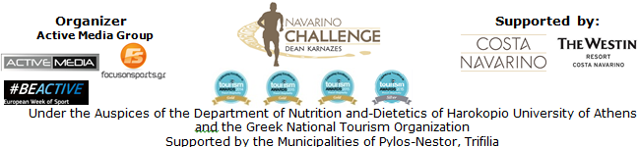

PRESS RELEASE
Athens, October 8th 2015

“Navarino Challenge” continues to innovate!

Watch the first 360-degree videos in a Greek sports tourism event!

Even though “Navarino Challenge 2015” concluded a few weeks ago, the beautiful images and memories of the top sports tourism event still remain indelible!

“Navarino Challenge” introduces for the first time in a sports tourism event in Greece, the 360-degree technology in its videos and brings back the unique moments we experienced this year!

The innovative event which combines the greatest number of sports and activities in relation to any other sports tourism event in Greece, presents two 4K 360-degree videos, created by Digitribe Mediahouse. The videos were created by the official portable GoPro camera of “Navarino Challenge” and the assistance of Drakos Digital, the only official exclusive distributor of GoPro products in Greece and Cyprus. Active Media undertook the coordination for the creation of both videos. Videos will also be available very soon, through the official facebook page of “Navarino Challenge”: www.facebook.com/Navarinochallenge

360-degree videos are visible through any computer and mobile screen and through a virtual reality headset. When videos play on facebook, the user can see them towards any direction in desktop computers and android systems. On desktop, this is done by using the mouse, while on mobile devices by moving the device. They are also visible on iOS through the official application of YouTube.

The first video is related to the activity of running at “Navarino Challenge 2015” which included a Half-Marathon (21,1km), 10km and 5km routes (Running & dynamic gait) and a children's 1 km route, with a starting and finishing point at Navarino Dunes of Costa Navarino.
You may see the video here: https://youtu.be/5XvWpil5v58

The second video presents the activity of open water swimming held in the Bay of Navarino in the picturesque port of Pylos which included swimming routes of one mile for the adults and a half mile distance for children.
You may see the video here: https://youtu.be/unmHxVGLqTI

The Chief Executive Officer of Active Media, Mr. Akis Tsolis stated about this new innovation of the event: “We believe a lot in the effectiveness of new technologies in our events and in the virtual reality’s future. With the innovative use of 360-degree videos, we introduce for the first time this technology in sports tourism events, hoping thereby to open new perspectives in the field of tourism. Our goal is not only to attract visitors but also to create and promote the beautiful images of our country through these special technological applications. We are very proud to begin, although timidly, such practices in Navarino Challenge.”

The multiple award-winning sports tourism event “Navarino Challenge” is organized each year with the participation of people of all ages. The non-competitive event aims to raise awareness about the benefits of healthy living, exercise and the Mediterranean diet as well as the issue of childhood obesity through its numerous sports activities. The technologically pioneering event is also held each year with respect to the environment, to highlight the Greek natural beauty and also according to the sustainable tourism practices implemented at Costa Navarino.

The event was held under the Auspices of the Department of Nutrition and-Dietetics of Harokopio University of Athens and the Greek National Tourism Organization with the support of Costa Navarino and The Westin Resort Costa Navarino as well as the Municipalities of Pylos-Nestor and Trifilia. “Navarino Challenge” was included this year in the European Week of Sport (September 7-13, 2015).

“Navarino Challenge” renews its appointment for September 2016!

Official Sponsor: Allianz Greece
Official Airline Partner: Qatar Airways
Official Supporters: Hellenic Fuels S.A., Ford Motor Hellas, Natural Mineral Water “Vikos”, GoPro, Navarino Icons
Assisted by: Health Runners Club of Messinia (SDYM), Pylos Association of Enterprises for Tourism Development, Maritime Athletic Pylos Association “Nestor”, Explore Messinia, Promopark, Aqua Divers Club, Digitribe Mediahouse, Drakos Digital, Navarino Outdoors, Safe Water Sports, NJV Athens Plaza, Poseidonia restaurant, ThaMa restaurant, Alpha (Athlima SA), Dole
Official Broadcaster: Novasports
Strategic TV Partner: National Geographic Channel
Official Travel Agent: The Travel Company Experts
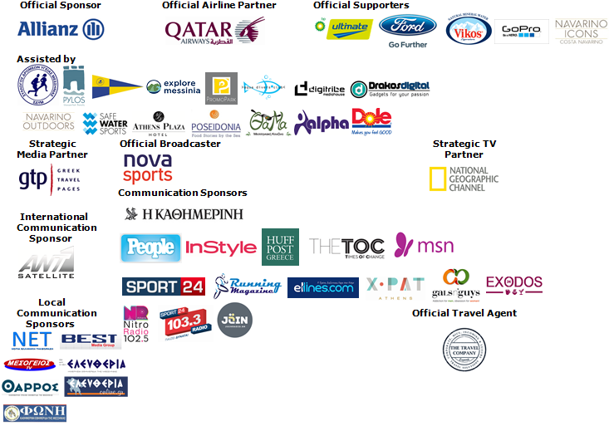

Under The Auspices of the Greek National Tourism Organization


Website: www.navarinochallenge.com
Facebook Page: www.facebook.com/Navarinochallenge
Facebook Event: https://www.facebook.com/events/509478955873290/
Twitter Account: https://twitter.com/NavarinoC
YouTube Channel: http://www.youtube.com/user/NavarinoChallenge
Google + Account: https://plus.google.com/115165548850159469774/posts
Instagram Page: http://instagram.com/navarinochallenge
Hashtag: #NavarinoChallenge

For More Information:
Press Office: Active Media
Tel: +30 210 9343020

About Dean Karnazes
TIME magazine named Dean Karnazes as one of the "Top 100 Most Influential People in the World." Men's Fitness hailed him as one of the fittest men on the planet. An internationally recognized endurance athlete and NYC bestselling author, Dean has pushed his body and mind to inconceivable limits. Among his many accomplishments, he has run 350 continuous miles, foregoing sleep for three nights. He has run across Death Valley in 120 degree temperatures, and he has run a marathon to the South Pole in negative 40 degrees. On ten different occasions, he has run a 200-mile relay race solo, racing alongside teams of twelve.
His most recent endeavor was running 50 marathons, in all 50 US states, in 50 consecutive days, finishing with the NYC Marathon, which he ran in three hours flat.
Dean and his incredible adventures have been featured on 60 Minutes, The Late Show with David Letterman, CBS News, CNN, ESPN, The Howard Stern Show, NPR's Morning Edition, the BBC, and many others. He has appeared on the cover of Runner's World and Outside, and been featured in, to mention a few. He is a monthly columnist for Men's Health, the largest Men's publication in the world.

Costa Navarino
Costa Navarino is the prime, sustainable destination in the Mediterranean, located in the Greek region of Messinia in the southwest Peloponnese. One of the most unspoiled and breathtaking seaside Mediterranean landscapes, this area has been shaped by 4,500 years of history. Its philosophy is driven by a genuine desire to promote Messinia, while protecting and preserving its natural beauty and heritage. It will comprise a number of distinct sites featuring 5-star deluxe hotels, luxury residences, conference facilities, spa and thalassotherapy centres, signature golf courses, as well as a wide range of unique year-round activities for adults and children. Navarino Dunes, the first area, is home to two luxury 5-star hotels, The Romanos, a Luxury Collection Resort and The Westin Resort, Costa Navarino; The Dunes Course – the first signature golf course in Greece- Anazoe Spa, a 4,000sq.m. spa & thalassotherapy centre; the state-of-the-art conference centre House of Events; specially designed facilities for children; as well as a variety of gastronomy venues, sports, outdoor and cultural activities. Navarino Bay, the second area is home to the signature golf course, The Bay Course.
www.costanavarino.com

About The Westin Resort Costa Navarino
The Westin Resort Costa Navarino is one of the two luxury 5-star properties of Starwood Hotels and Resorts operating at Navarino Dunes, the first resort area in Costa Navarino, the prime destination in the Mediterranean. Overlooking the Ionian Sea coastline of the Dunes Beach, at The Westin Resort Costa Navarino 445 rooms and suites, inspired by old Messinian mansions, spring from nature and create an ambiance of genuine hospitality. Voted as the “Best Family Destination” in the Mediterranean amongst Europe’s Starwood Hotels & Resorts, The Westin Resort Costa Navarino is the ideal destination for family getaways as it proposes a plethora of children activities such as a wonderful aqua park with water slides, playground and recreational center as well as two specially designed hubs for children, Cocoon and SandCastle. At Navarino Dunes there is also The Romanos, a Luxury Collection Resort, the 18-hole signature golf course The Dunes Course the 4,000 sqm Anazoe Spa, a state-of-the-art conference center, as well as a variety of culinary venues, sports, outdoor and cultural activities. Navarino Bay, the second area in Costa Navarino, features the second 18-hole signature golf course, The Bay Course. For more information on The Westin Resort Costa Navarino, please visit www.westincostanavarino.com, or follow us on Twitter.

