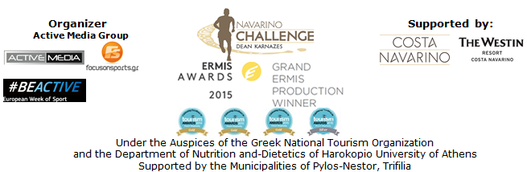

PRESS RELEASE

“Navarino Challenge 2016” was completed leaving wonderful impressions!

Thousands of participants from Greece and abroad took part in the richest schedule of activities ever presented by an event!

Athens, September 14 2016 – “Navarino Challenge 2016” completed successfully for a 4th consecutive year, confirming its title as the top sports tourism event in Greece, offering unique moments and creating great memories to each participant!

More than 2,000 amateur and professional athletes, friends of sports of all ages (according to the updated results - the oldest athlete was 82 years old), embraced the event by participating in more than 15 activities in Messinia and Costa Navarino from 9 to 11 September 2016.
“Navarino Challenge” attracted the global interest with participants coming from countries as USA, Canada, Australia, Britain, Sweden, Denmark, France, Germany, Switzerland, Italy, South Africa, Ghana, Turkey, Bulgaria, Romania and Cyprus. Meanwhile, bookings at The Westin Resort Costa Navarino, ran extremely high during the weekend, on the occasion of the event, supporting thus the hotel & hospitality tourism and promoting Messinia as a destination worldwide.

For the third consecutive year, “Navarino Challenge” had the safety and dynamic support of Allianz Greece. The company which is sensitive to issues related to health care and supports reinforcing the message of health protection and the adoption of a healthier lifestyle through exercise and balanced nutrition, supported the event (with its numerous team). The company’s principles and values are inextricably linked with those of the organization.

On Friday, September 9, 2016, the schedule of “Navarino Challenge” included activities for those staying at The Westin Resort Costa Navarino, such as: aqua aerobic lessons for all and baby swimming (for children up to 3 years old) with the support of Swim Academy, of the Federal Swimming Coach, Nikos Gemelos and the Silver medalist and World Champion in open water swimming, Spyros Gianniotis, TaeKwonDo lessons from the twice silver Olympic medalist Alexandros Nikolaidis (with the dynamic participation of the teams from Kyparissia, Kalamata and the whole region of Messinia) pilates lessons by the physical education instructor, specialized in pilates, Mandy Persaki, kick boxing lessons by the kick boxing champion Alexandros Nikolaidis, climbing lessons (by the certified climbing instructor of Navarino Outdoors, George Malamas) and a beautiful bike ride at Voidokilia -with the support of both activities from Navarino Outdoors. At the same time there was also a 4on4 basketball tournament (with the support of basketblog.gr) and the participation of Olympic medalists, champions, media groups and VIP guests of the event, golf clinics with the support of Navarino Golf Academy and scuba diving with the support of the Aqua Divers Club and Scuba Hellas.

During the weekend, participating athletes quenched their thirst with the Natural Mineral Water "Vikos" that contributes to the well-functioning of the body during sports.

On Saturday, September 10, 2016 morning, the weather being an ally (on a sunny day), the whole activity of the event was transferred in the Municipality of Pylos-Nestor, for the swim sports.
In the beautiful bay of Navarino at the picturesque port of Pylos, hundreds of friends of the sea had the opportunity to swim without competition, in the calm waters, covering the dreamy one mile (1.6 km) swimming route designed by Nikos Gemelos.
Meanwhile, the activity of Kids' Athletics was presented for the first time in Pylos Square by the ambassador of the event, the Olympic and World Champion in 400m. hurdles Periklis Iakovakis. The activity aimed at getting children acquainted with the track and field sports, as it has been developed and established by a special panel of scientists from IAAF (International Association of Athletics Federation) and is officially implemented in Greece by the Hellenic Athletics Federation (SEGAS) in cooperation with the Ministry of Education. Kids' Athletics included, among others, the activity of standing long jump, the sport of the world famous Olympic champion and legendary Kostis Tsiklitiras, who was born in Pylos Messinia.

For the third consecutive year, athletes and organizers moved with the safety and efficient engines of the cars of Ford Motor Hellas, the official supporter of “Navarino Challenge”.

Right after, within the same day, a Stand Up Paddling race by BIC® Sport took place for the first time in the event!
With the support of one of the most recognized brands in the world, BIC® company, present in the field of water sports with BIC® Sport since 1979, participants were divided into groups of beginners and professionals, covering the half mile and one mile routes respectively at the port of Pylos. All athletes had the opportunity to test the credibility of the SUP BIC® boards. Stand Up Paddling was held with the support of Surf Salad!

Mediterranean diet was highlighted by the food blogger Gogo Papadionysiou also known as Mamatsita who made traditional lalagia & diples with the assistance of local women and the team of Poseidonia restaurant in Pylos. The Mayor of Pylos-Nestor, Mr. Dimitrios Kafantaris awarded Spyros Gianniotis, Kelly Araouzou and Nikos Gemelos and offered them a tour at the home of Tsiklitiras in Pylos.

The “sea-day” was concluded with a demonstration race with 25 Optimist and 3 big open boats from Maritime Athletic Pylos Association “Nestor”, the Sailing Club of Kalamata “Poseidon” and the Sailing Club of Kalamata “Eolos” with the assistance of the Municipality Pylos-Nestor, the Port Authority of Pylos, Pylos Association of Enterprises for Tourism Development and Explore Messinia.

In the midday of Saturday, the action returned at The Westin Resort Costa Navarino! There, for the second consecutive year the boccia activity was presented, with the dynamic presence and support of the team of Allianz Greece (more than 90 people attended the demonstration of the sport). The ambassador and Gold Paralympic athlete of boccia, Grigoris Polychronidis greeted the event with its own private message, (as he was in Rio for the Paralympic Games), giving the pass for the demonstration of the sports to the athletes of the Greek boccia national team Christos Galaios (6th position in the European Championship) and Christos Kypriotis (Greek Champion) and the coach Jenny Rodiou and Evangelia Galaiou.

Saturday night ended in the most glittering and spectacular way, with the colors of the official airline partner of the event, Qatar Airways!

The cocktail “A Night to Remember by Qatar Airways”, was presented by the journalists Dimos Bouloukos and Dora Tsampazi. The evening moved into Swing, Jazz, Funk, Soul, Latin and Blues rhythms by Brandy Souare and included greetings, awards and many surprises for the honorees and high guests of the event.
The first award of the evening was given to the silver Olympic medalist and World Champion in open water swimming Spyros Gianniotis by TEMES S.A., Marketing & Business Development Director Mrs. Marina Papatsoni. The first surprise was announced, with the award of a set of business class airline tickets given to the silver Olympic medalist from the Commercial Director of Qatar Airways in Greece, Mr. Alexandros Michalopoulos. The World Champion in open water swimming, Kelly Araouzou was then awarded by Vikos SA Sales & Marketing Director, Mr. Konstantinos Sepetas. The event continued with the award given to the Federal Swimming Coach, Nikos Gemelos by the Chief Executive Officer of Allianz Greece, Mrs. Philippa Michali and the award which was given to the team of Allianz World Run (with the presence of Gerosideri Charis and Kafantari Dora who participated in the global initiative) by the Chief Executive Officer of Active Media, Mr. Akis Tsolis. Two more surprises were hidden next, to celebrate the four years of the event. National Geographic Channel team was awarded by the Co-Founder of Navarino Challenge & Director of Development of The Hellenic Initiative, Mr. Peter Poulos for its four years of support to the event as TV Communication Partner. The Commercial Director of FOX Networks Group, Mrs. Nadia Demiri received the relevant award, while Vargiamidis family was awarded by the ultramarathon Dean Karnazes for the four years of continuous participation in Navarino Challenge.
Immediately after that, the activity “Like for a good cause” was presented -that ran recently for the five best photos of the event chosen by the people through social media- and its charitable cause was revealed for the first time. The photographs selected were converted into canvasses and now these works will be auctioned through Charity Idols, where all revenue generated will be given to the humanitarian non-profit Foundation of the Professor Afksendiyos Kalagkos, Coeurs pour Tous Hellas - Hearts for All, which supports children with congenital heart disease. The event was welcomed by the President of the institution Coeurs pour Tous Hellas, Mrs. Anna Grimani and the Executive Committee Member at the Department of Communication, Ms. Ioanna Moundrea.
Further, another set of economy class airline tickets was drawn by Qatar Airways to a lucky couple, while throughout the duration of the “Navarino Challenge” the top airline ran another contest to the participants of the event.
The evening ended with the award given to the ultramarathon Dean Karnazes by the Marketing Director of Ford Motor Hellas, Mrs. Petri Logara.
The exceptional gifts and awards of the evening at the Cocktail were created by the Apia store of George Drougos and Natasha Dourala.

“Navarino Challenge” promotes the value of “a healthy mind in a healthy body” and the spirit of “fair play” adopting the purpose of the Olympic Movement, supported by Olympic athletes and Champions who educate youth through sport, without any discrimination. At the same time, the athletes inform them about the benefits of exercise and the Mediterranean diet and prompt the audience to support the cause of the fight against childhood obesity. Overall more than 800 children were actively involved in all activities of the “Navarino Challenge” weekend of!

“Navarino Challenge” was also supported by the Navarino Icons products, Michael & Trianthe Dakolias, Village Cinemas, the Inbi restaurant, the New Hotel and Surf Salad.

The interest of the people, that surpassed all expectations with their participation, peaked on the third and last day of the event, on Sunday, September 11th 2016. Runners of all ages, starting from Navarino Dunes in Costa Navarino ran to Pylos beach, crossing Voidokilia beach for the first time and following the trail mapped out, back in Homer’s years, by Telemachus, Ulusses’ ’ son, trying to find his missing father. The start was given early in the morning for the top Half Marathon (21,1km) -with the participation of Greek-American ultramarathon Dean Karnazes- and the 10 km route, while the 5km run followed (for running and dynamic walking). The running activity ended amid countless smiles from children who participated in the 1km, with the support of the natural mineral water “Vikos”. Routes were designed and edited by the former marathon runner, holder of national best performance on the classical route, running coach and director of All About Running, Nikos Polias. The teams of Messiniakos and Akritas had a strong presence on the running and then also in the activity of Kids’ Athletics with the ambassador Periklis Iakovakis.
Food blogger Mamatsita, with her second in a row cooking challenge, undertook to revitalize and support the participants in running by offering them traditional Messinian food in Costa Navarino with the support of Posidonia Restaurant.

“Navarino Challenge” presented a great innovation with the “Navarino Challenge” chatbot!
The MPASS company participated for the first time in the event and contributed to its success by creating the “Navarino Challenge” chatbot. This is a global innovation since this is the first sports tourism chatbot that gave participants the opportunity to have, instantly, automatic personal updates on offers and events, by sending just one message in the official Facebook page of “Navarino Challenge”. The most important was that someone was able, for the first time, to receive automatically his finish time, in any route he participated with a personal message on Facebook messenger, by simply typing his BIB number.

“Navarino Challenge” was held under the Auspices of the Greek National Tourism Organization and the Department of Nutrition and-Dietetics of Harokopio University of Athens with the support of Costa Navarino and The Westin Resort Costa Navarino, as well as the Municipalities of Pylos-Nestor and Trifilia. The event was included, for one more year, in the European Week of Sport with the #BeActive activity which is supported by the European Commission and the Greek General Secretariat of Sports.

The event was also assisted by the Health Runners Club of Messinia, ThaMa Restaurant, Alpha (Athlima SA), the Department of Sports Organization & Management from University of Peloponnese, Anazoe Spa Costa Navarino, 1morekm, Hellenic Athletics Federation (SEGAS), IAAF Kids Athletics, Diana “exoplizein” and Nargile while Vita N Travel was the official travel agent.
The event was finally supported by the Hellenic Red Cross Sector of Samaritans, Rescuers and Lifeguards.

Official Sponsors: Allianz Greece, “Vikos” Natural Mineral Water
Official Airline Partner: Qatar Airways
Official Supporters: Ford Motor Hellas, BIC®, BIC® Sport, Navarino Icons, Michael & Trianthe Dakolias, Village Cinemas, Poseidonia Restaurant, Inbi, New Hotel, Surf Salad
Assisted by: Health Runners Club of Messinia, Pylos Association of Enterprises for Tourism Development, Maritime Athletic Pylos Association “Nestor”, Explore Messinia, Navarino Outdoors, Swim Academy, Aqua Divers Club, Scuba Hellas, Navarino Golf Academy, ThaMa Restaurant, Alpha (Athlima SA), Department of Sports Organization & Management from University of Peloponnese, Anazoe Spa Costa Navarino, 1morekm, Hellenic Athletics Federation (SEGAS), IAAF Kids Athletics, Apia, Diana “exoplizein”, Nargile
Official Travel Agent: Vita N Travel
Official Broadcaster: OTE TV
TV Communication Partner: National Geographic Channel
Under the Auspices of the Greek National Tourism Organization
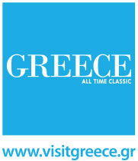
Under the Auspices of the Department of Nutrition and-Dietetics of Harokopio University of Athens
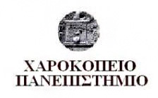

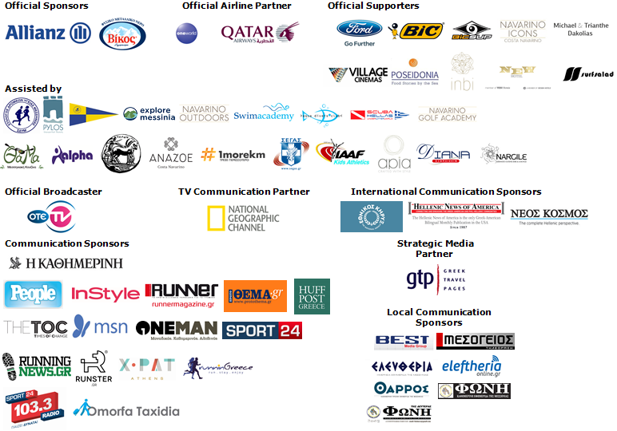

Website: www.navarinochallenge.com
Facebook Page: www.facebook.com/Navarinochallenge
Facebook Event: https://www.facebook.com/events/1575864132703599/
Twitter Account: https://twitter.com/NavarinoC
YouTube Channel: http://www.youtube.com/user/NavarinoChallenge
Google + Account: https://plus.google.com/115165548850159469774/posts
Instagram Page: http://instagram.com/navarinochallenge
Hashtags: #navarinochallenge #costanavarino #eatwell #runwell #livewell

Costa Navarino:
Costa Navarino is the prime, sustainable destination in the Mediterranean, located in the Greek region of Messinia in the southwest Peloponnese. One of the most unspoiled and breathtaking seaside Mediterranean landscapes, this area has been shaped by 4,500 years of history. Its philosophy is driven by a genuine desire to promote Messinia, while protecting and preserving its natural beauty and heritage. It will comprise a number of distinct sites featuring 5-star deluxe hotels, luxury residences, conference facilities, spa and thalassotherapy centres, signature golf courses, as well as a wide range of unique year-round activities for adults and children. Navarino Dunes, the first area, is home to two luxury 5-star hotels, The Romanos, a Luxury Collection Resort and The Westin Resort Costa Navarino; The Dunes Course – the first signature golf course in Greece- Anazoe Spa, a 4,000sq.m. spa & thalassotherapy centre; the state-of-the-art conference centre House of Events; specially designed facilities for children; as well as a variety of gastronomy venues, sports, outdoor and cultural activities. Navarino Bay, the second area is home to the signature golf course, The Bay Course.
High resolution photos can be accessed through the following link, by using the password nestor.

About The Westin Resort Costa Navarino:
The Westin Resort Costa Navarino is one of the two luxury 5-star properties at Navarino Dunes, the first resort area in Costa Navarino, the prime destination in the Mediterranean. Overlooking the Ionian Sea coastline of the Dunes Beach, The Westin Resort Costa Navarino 445 rooms and suites, inspired by old Messinian mansions, spring from nature and create an ambiance of genuine hospitality. Voted as the “Best Family Destination” in the Mediterranean amongst Europe’s Starwood Hotels & Resorts, The Westin Resort Costa Navarino is the ideal destination for family getaways as it proposes a plethora of children activities such as a wonderful aqua park with water slides, playground and recreational center as well as two specially designed hubs for children, Cocoon and SandCastle. At Navarino Dunes there is also The Romanos, a Luxury Collection Resort, the 18-hole signature golf course The Dunes Course the 4,000 sq.m Anazoe Spa, a state-of-the-art conference center, as well as a variety of culinary venues, sports, outdoor and cultural activities. Navarino Bay, the second area in Costa Navarino, features the second 18-hole signature golf course, The Bay Course. For more information on The Westin Resort Costa Navarino, please visit www.westincostanavarino.com, or follow us on Twitter.

