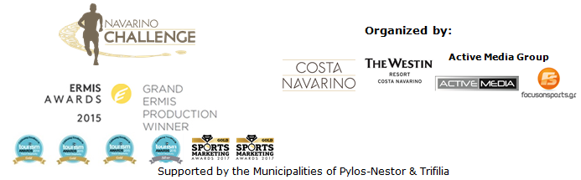

PRESS RELEASE

“Navarino Challenge" with over 20 activities!

Twelve Olympic sports in the top sports tourism event

Athens, 17 May 2018 - This year's 6th Navarino Challenge, which will take place between 12-14 October 2018 in Messinia and Costa Navarino, announces its accommodation packages at The Westin Resort Costa Navarino.

The participants of Navarino Challenge who will book their accommodation package in The Westin Resort and choose to take part in the main activities (running, swimming, SUP) will also have the opportunity to enjoy free of charge the full activities program of the event. The program for those staying at The Westin Resort Costa Navarino includes: tae kwon do, climbing, cycling, pilates, basketball, golf, kick boxing, baby swimming, aqua aerobics, kids' athletics, beach volley, tennis cross training, crossfit, beach yoga, boxing, survivor games for kids and demonstration race with optimist boats.
More information about the privileged accommodation packages at the following link on the renewed website of the event: http://www.navarinochallenge.com/accommodation-packages

Navarino Challenge, which has as its main goal the promotion of sports and fair play, will be full of activities covering the requirements of all ages. At the same time, the secondary objective is to extend the tourist season. The sports tourism event with the most Olympic ambassadors returns once again in Messinia with 12 Olympic sports! Along with running, swimming, tae kwon do, this year we will live the experience of another major Olympic sport such as beach volley, with the presence of one of the biggest and most historic athletes of Greek as well as international volleyball, Michalis Triantafyllidis. This is the addition of a tournament called the King & Queen Beach Volley Tournament by Triantafyllidis Beach Arena and the beach volley courses by Triantafyllidis Beach Arena.

The former Greek national volleyball player holds the record of participations in the Greek National Team (ranked 3rd in the European Cup at 1987) and holds the most titles of an athlete in volleyball and beach volley in Greece. Michalis Triantafyllidis said: “I find it very important that beach volley is included this year in the program of an already very successful event, such as the Navarino Challenge. For my part, I think we will have the best possible organization at both the beach volleyball tournament “King & Queen Beach Volley” and the beach volleyball training courses. I hope it will become a part of the successful organization”.

Registrations opened for the multi-awarded sports tourism organization! The three (3) main activities are running, swimming and the Stand Up Paddling by BIC® Sport. Participants can complete the special form, which is available at the following link: http://activemedia.com.gr/product/navarino-challenge-2018/. At the same time, the pre-sale can also be made via www.viva.gr, by phone at 11876, as well as at the pre-sale points of the Viva network. Registrations will be completed on August 31, 2018.

This year's event is expected to host for one more year hundreds of professional and amateur athletes who will take part in numerous activities. In the 2018 teaser you can get a taste of the event: https://youtu.be/OJNicwfxqxk

Official sponsors are, once again, Natural Mineral Water “Vikos” and Ford Motor Hellas. Official supporters are Poseidonia, BIC®, BIC® Sport and Avance.

“Navarino Challenge” will be held with the co-organization of Costa Navarino, The Westin Resort Costa Navarino and Active Media Group and the support of the Municipalities of Pylos-Nestor and Trifilia.

Official Sponsors: Natural Mineral Water “Vikos”, Ford Motor Hellas
Official Supporters: Poseidonia, BIC®, BIC® Sport, Avance Rent A Car
Partners: Navarino Outdoors, Swim Academy, Surf Salad, Triantafyllidis Beach Arena, FitnessArt, Vizantinos target sport club
Assisted by: Navarino Racquet Academy, Pylos Association of Enterprises for Tourism Development, Maritime Athletic Pylos Association “Nestor”, Explore Messinia, Navarino Golf Academy, Target Security, The Diner
Strategic Partner: National Geographic

Hashtags: #navarinochallenge #costanavarino #eatwell #runwell #livewell
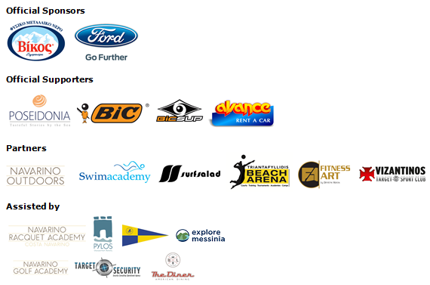

Website: www.navarinochallenge.com
Facebook Page: www.facebook.com/Navarinochallenge
Twitter Account: https://twitter.com/NavarinoC
YouTube Channel: http://www.youtube.com/user/NavarinoChallenge
Instagram Page: http://instagram.com/navarinochallenge

Costa Navarino
Costa Navarino is located in Messinia in the southwest Peloponnese, in one of the most unspoiled and breathtaking landscapes in the Mediterranean. Its philosophy is driven by a genuine desire to promote Messinia, while protecting and preserving not only its natural beauty but also a remarkable cultural heritage spanning 4,500 years. Costa Navarino is home to two 5-star deluxe hotels, The Romanos, a Luxury Collection Resort and The Westin Resort, Costa Navarino, Anazoe Spa, a 4,000m2. spa & thalassotherapy center, two signature golf courses, over 20 fine dining venues, a wide range of sports, outdoor and cultural activities, plus an array of 5-star services.
www.costanavarino.com

The Westin Resort Costa Navarino
The Westin Resort has been voted one of the best resorts in Greece and one of the foremost holiday destinations in Europe. In 2017 The Westin Resort Costa Navarino has been voted among the Best Resorts in Europe in Condé Nast Traveler Reader’s Choice Awards. It features an amazing selection of deluxe rooms, family rooms and suites in a privileged seaside location on a verdant hillside that affords an alluring mix of golf, sea and pool views. Voted “Best Family Destination” in the Mediterranean among Starwood Hotels & Resorts, this exceptional 5-star family resort in Greece allows children to choose from an enormous variety of supervised fun activities, tailored specifically for them, at the Cocoon and the SandCastle, giving parents plenty of time to indulge in their own favorite sports or simply unwind. At the Cocoon crèche, infants and toddlers from just 4 months to 3 years old are creatively engaged and encouraged to develop their skills under the supervision of qualified baby nurses and trained staff. Whilst the SandCastle, which offers both recreational and educational activities as well as overnight stay options, is aimed at children aged 4 to 7 and 8 to 12, with specially devised programs for each age group. For more information on The Westin Resort Costa Navarino, please visit www.westincostanavarino.com or follow us on Twitter.

