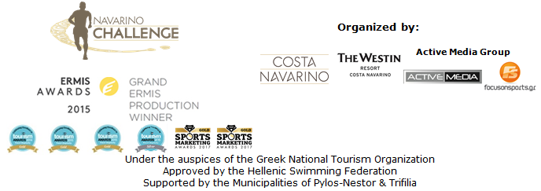

PRESS RELEASE

World class athletes and accolades for the 6th Navarino Challenge

“Navarino Challenge” scores with Joe Arlauckas and two more awards in Sports Marketing and Digital Media Awards

Athens, 28 June 2018 - This year's 6th edition of Navarino Challenge, which will take place between 12-14 October 2018 in Messinia and Costa Navarino, continues with even more awards and additions to its ambassadors.

The Ambassadors
One of the biggest names in basketball and former ace of Real Madrid and Sacramento Kings, Joe Arlauckas will be in Costa Navarino for Navarino Challenge to remind us of the high level basketball he has played in his career but also to teach us his golf secrets as he has been deeply involved with this sport recently. Euroleague basketball legend said for this participation: “Apart from the beauty and serenity that Costa Navarino offers, I am so pleased to join such a special event like the Navarino Challenge 2018. The location is perfect, and the idea is something that should be considered all over the world. The opportunity to bring families together through sporting activities is not just a special occasion, but at the same time it teaches children values such as dedication, sacrifice and teamwork through activity. I am so excited to join the team this year”.

The awards
Navarino Challenge is a world class event, which grows every year both in activities and in number of participations. The internationally acclaimed event enriches Greece’s sports tourism, extends the country’s tourist season and presents the beauties of Greece all over the world. For all these reasons, Navarino Challenge was awarded for one more year at the Sports Marketing Awards 2018, in the category “Sports Tourism” of the section “Sports Events / Branded Events”.
At the same time, it was awarded at the Digital Media Awards 2018, in the category “Best Public Service / CSR Award” of the “Digital Communication & Marketing” section.

“Navarino Challenge” will take place this year with the approval of the Hellenic Swimming Federation under the auspices of the Greek National Tourism Organization. Registrations have opened and can be completed through the special form available at the following link: http://activemedia.com.gr/product/navarino-challenge-2018/.
The pre-sale is available also via www.viva.gr, by phone at 11876, as well as at the pre-sale points of the Viva network. Registrations end on August 31st, 2018.

Navarino Challenge participants who will book their accommodation package at The Westin Resort Costa Navarino and choose to take part in at least one of the main activities (running, swimming, SUP) will also be able to enjoy the organization’s full program of activities free of charge. The program for those staying at The Westin Resort Costa Navarino includes: Tae kwon do, climbing, cycling, pilates, basketball, golf, kick boxing, baby swimming, aqua aerobics, kids' athletics, beach volley, tennis cross training, crossfit, beach yoga, boxing, beachathlon and demonstration race with optimist boats.
More information about the accommodation packages may be found at the following link at the renewed website of the event: http://www.navarinochallenge.com/accommodation-packages.

For a brief taste of the event, you may click on the 2018 video teaser: https://youtu.be/OJNicwfxqxk

The official sponsors of the event are for another year the Natural Mineral Water “Vikos” and Ford Motor Hellas. Official sponsors are Poseidonia, BIC®, BIC® Sport, Avance and the Municipality of Pylos-Nestor.

For the first time, Navarino Challenge will be assisted by the Hellenic Recovery Recycling Corporation (Herrco), which in cooperation with the Municipality of Pylos-Nestor raise awareness for better environmental control and recycling in Messinia.

“Navarino Challenge” will be co-organized with Costa Navarino, The Westin Resort Costa Navarino and Active Media Group and the support of the Municipalities of Pylos-Nestor and Trifilia.

Official Sponsors: Natural Mineral Water “Vikos”, Ford Motor Hellas
Official Supporters: Poseidonia, BIC®, BIC® Sport, Avance Rent A Car, Municipality of Pylos-Nestor
Partners: Navarino Outdoors, Swim Academy, Surf Salad, Triantafyllidis Beach Arena, FitnessArt, Vizantinos target sport club, Red Swim Academy
Assisted by: Lifeguard Patrol, Navarino Racquet Academy, Pylos Association of Enterprises for Tourism Development, Maritime Athletic Pylos Association “Nestor”, Explore Messinia, Navarino Golf Academy, Target Security, The Diner, Hellenic Recovery Recycling Corporation, Athens Easy Transfers
Strategic Partner: National Geographic

Hashtags: #navarinochallenge #costanavarino #eatwell #runwell #livewell
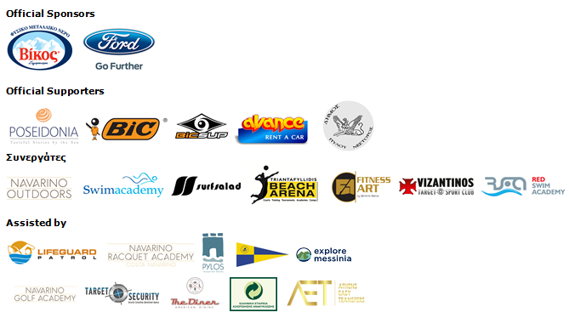
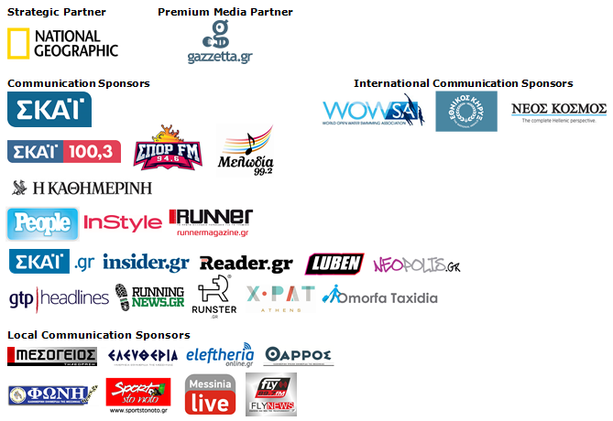
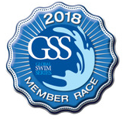
Under the Auspices of the Greek National Tourism Organization
Approved by the Hellenic Swimming Federation
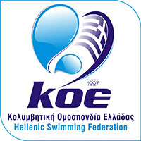

Website: www.navarinochallenge.com
Facebook Page: www.facebook.com/Navarinochallenge
Twitter Account: https://twitter.com/NavarinoC
YouTube Channel: http://www.youtube.com/user/NavarinoChallenge
Instagram Page: http://instagram.com/navarinochallenge

Costa Navarino
Costa Navarino is located in Messinia in the southwest Peloponnese, in one of the most unspoiled and breathtaking landscapes in the Mediterranean. Its philosophy is driven by a genuine desire to promote Messinia, while protecting and preserving not only its natural beauty but also a remarkable cultural heritage spanning 4,500 years. Costa Navarino is home to two 5-star deluxe hotels, The Romanos, a Luxury Collection Resort and The Westin Resort, Costa Navarino, Anazoe Spa, a 4,000m2. spa & thalassotherapy center, two signature golf courses, over 20 fine dining venues, a wide range of sports, outdoor and cultural activities, plus an array of 5-star services.
www.costanavarino.com

The Westin Resort Costa Navarino
The Westin Resort has been voted one of the best resorts in Greece and one of the foremost holiday destinations in Europe. In 2017 The Westin Resort Costa Navarino has been voted among the Best Resorts in Europe in Condé Nast Traveler Reader’s Choice Awards. It features an amazing selection of deluxe rooms, family rooms and suites in a privileged seaside location on a verdant hillside that affords an alluring mix of golf, sea and pool views. Voted “Best Family Destination” in the Mediterranean among Starwood Hotels & Resorts, this exceptional 5-star family resort in Greece allows children to choose from an enormous variety of supervised fun activities, tailored specifically for them, at the Cocoon and the SandCastle, giving parents plenty of time to indulge in their own favorite sports or simply unwind. At the Cocoon crèche, infants and toddlers from just 4 months to 3 years old are creatively engaged and encouraged to develop their skills under the supervision of qualified baby nurses and trained staff. Whilst the SandCastle, which offers both recreational and educational activities as well as overnight stay options, is aimed at children aged 4 to 7 and 8 to 12, with specially devised programs for each age group. For more information on The Westin Resort Costa Navarino, please visit www.westincostanavarino.com or follow us on Twitter.

