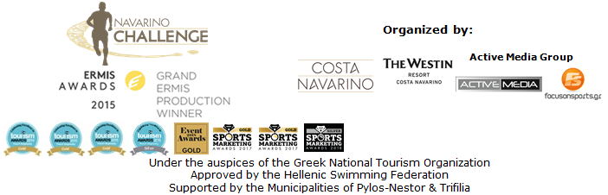

PRESS RELEASE

Navarino Challenge: The “Best Tourism Event in Greece”

New distinction for the top sports tourism event at the Event Awards 2018
New “beachathlon” races for kids in this year’s program

Athens, July 30 2018 – “Navarino Challenge” continues its impressive course with more distinctions. The top sports tourism event was honored this time with the gold award as the best tourism event in Greece at the Event Awards 2018.

The event, which will take place for the 6th consecutive year, in Messinia and Costa Navarino, 12-14 October 2018, enriches its program with new activities for kids. This year’s event includes “beachathlon”, namely track and field races for children at The Dunes Beach under the supervision of the Olympic and European Champion in 400m. with hurdles, Periklis Iakovakis.
Periklis Iakovakis said for the particular activity: “Classic sports have three general categories of racing: running, jumps and throws. This year at Navarino Challenge we will become acquainted with some of these races in a slightly different way. We will not conduct them at a stadium, nor at any other sports venue, but on the beautiful beach of Costa Navarino! Taking advantage of the unique facilities of this area we thought about creating a track and field event on the beach. That’s how we decided to create Beachathlon. On the sand, children will have the opportunity to test their strengths in various track and field sports that will be adapted to this environment. Our goal is to make this acquaintance with the classic sports activities even more entertaining and original and to give the opportunity to children of all ages to discover their abilities at Navarino Challenge Beachathlon! We are looking forward to seeing you all there”.

Fysiotek Sports Lab will assist the award-winning sports tourism event “Navarino Challenge” with one more innovative activity. Fysiotek Sports Lab, as a pioneer in the field of rehabilitation and preventive medicine in sports, will cover the sports medical needs throughout the event and will support its activities, with a state-of-the-art recovery station in the established running races.

“Navarino Challenge” participants will have the opportunity during their stay at The Westin Resort Costa Navarino to enjoy special discounts from the sponsors and partners of the event.In the following link you may find the available offers: http://www.navarinochallenge.com/offers

Registration continues and can be completed through the special form available at the following link: http://activemedia.com.gr/product/navarino-challenge-2018/.
The pre-sale is available also via www.viva.gr, by phone at 11876, as well as at the pre-sale points of the Viva network. Registrations end on August 31st, 2018.

Navarino Challenge participants who will book their accommodation package at The Westin Resort Costa Navarino and choose to take part in at least one of the main activities (running, swimming, SUP) will also be able to enjoy the organization’s full program of activities free of charge, including:Tae kwon do, climbing, cycling, pilates, basketball, golf, kick boxing, baby swimming, aqua aerobics, kids’ athletics, beach volley, tennis cross training, crossfit, beach yoga, boxing, beachathlon and demonstration race with optimist boats.
More information about the accommodation packages may be found at the following link at the website of the event: http://www.navarinochallenge.com/accommodation-packages.

Samsung is the official technology partner of the event for a 2nd consecutive year.
For another year Vikos SA as an official sponsor will spread the message of sporting energy with the natural mineral water “Vikos”, offering the necessary hydration and revitalization to all participants. The natural mineral water “Vikos” offers the necessary balance, well-being and energy that the athletes need during their exercise in order to be able to continue their efforts.
Ford Motor Hellas promotes sports and “fair play” and supports the efforts of the fight against childhood obesity while promoting healthy diet by participating for another year in the support team of “Navarino Challenge”. For the fifth consecutive year, athletes and organizers will move with the safety and efficient engines of the cars of Ford Motor Hellas, the official sponsor of “Navarino Challenge”.

Official supporters are Poseidonia, BIC®, BIC® Sport, Avance and the Municipality of Pylos-Nestor.

The 6th Navarino Challenge is co-organized by Costa Navarino, The Westin Resort Costa Navarino and Active Media Group and with the support of the Municipalities of Pylos-Nestor and Trifilia. Navarino Challenge will take place with the approval of the Hellenic Swimming Federation, under the auspices of the Greek National Tourism Organization.

Official Technology Partner: Samsung
Official Sponsors: Natural Mineral Water “Vikos”, Ford Motor Hellas
Official Supporters: Poseidonia, BIC®, BIC® Sport, Avance Rent A Car, Municipality of Pylos-Nestor
Partners: Navarino Outdoors, Swim Academy, Surf Salad, Triantafyllidis Beach Arena, FitnessArt, Vizantinos target sport club, Red Swim Academy
Strategic Partner: National Geographic
Assisted by: Lifeguard Patrol, Navarino Racquet Academy, Pylos Association of Enterprises for Tourism Development, Maritime Athletic Pylos Association “Nestor”, Explore Messinia, Navarino Golf Academy, Target Security, The Diner, Hellenic Recovery Recycling Corporation, Athens Easy Transfers, Anazoe Spa, Fysiotek Sports Lab

Hashtags: #navarinochallenge #costanavarino #eatwell #runwell #livewell
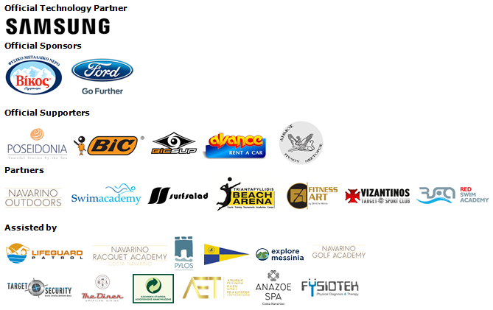
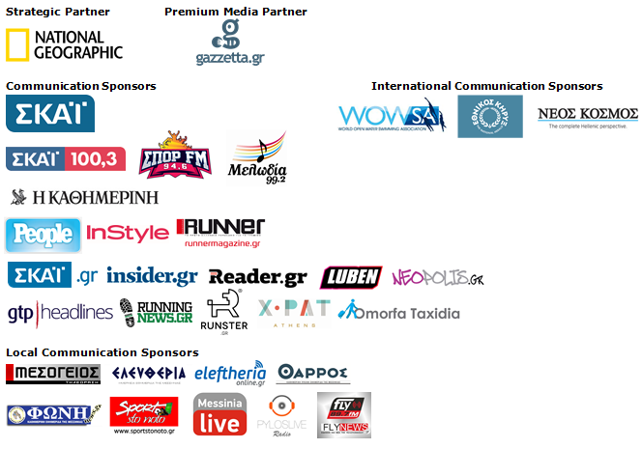
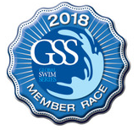
Under the Auspices of the Greek National Tourism Organization
Approved by the Hellenic Swimming Federation
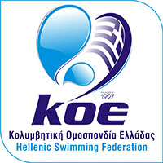

Website: www.navarinochallenge.com
Instagram Page: http://instagram.com/navarinochallenge
Facebook Page: www.facebook.com/Navarinochallenge
Twitter Account: https://twitter.com/NavarinoC
YouTube Channel: http://www.youtube.com/user/NavarinoChallenge

About Costa Navarino
Costa Navarino is the prime, sustainable destination in the Mediterranean, located in the Greek region of Messinia in the southwest Peloponnese. One of the most unspoiled and breathtaking seaside Mediterranean landscapes, this area has been shaped by 4,500 years of history. Its philosophy is driven by a genuine desire to promote Messinia, while protecting and preserving its natural beauty and heritage. It will comprise a number of distinct sites featuring 5-star deluxe hotels, luxury residences, conference facilities, spa and thalassotherapy centres, signature golf courses, as well as a wide range of unique year-round activities for adults and children. Navarino Dunes, the first area, is home to two luxury 5-star hotels, The Romanos, a Luxury Collection Resort and The Westin Resort Costa Navarino; The Dunes Course – the first signature golf course in Greece- Anazoe Spa, a 4,000sq.m. spa & thalassotherapy centre; the state-of-the-art conference centre House of Events; specially designed facilities for children; as well as a variety of gastronomy venues, sports, outdoor and cultural activities. Navarino Bay, the second area is home to the signature golf course, The Bay Course. Download high resolution photos and logos from the press section in downloads on the website www.costanavarino.com, using the password Nestor.

The Westin Resort Costa Navarino
The Westin Resort has been voted one of the best resorts in Greece and one of the foremost holiday destinations in Europe. In 2017 The Westin Resort Costa Navarino has been voted among the Best Resorts in Europe in Condé Nast Traveler Reader’s Choice Awards. It features an amazing selection of deluxe rooms, family rooms and suites in a privileged seaside location on a verdant hillside that affords an alluring mix of golf, sea and pool views. Voted “Best Family Destination” in the Mediterranean among Starwood Hotels & Resorts, this exceptional 5-star family resort in Greece allows children to choose from an enormous variety of supervised fun activities, tailored specifically for them, at the Cocoon and the SandCastle, giving parents plenty of time to indulge in their own favorite sports or simply unwind. At the Cocoon crèche, infants and toddlers from just 4 months to 3 years old are creatively engaged and encouraged to develop their skills under the supervision of qualified baby nurses and trained staff. Whilst the SandCastle, which offers both recreational and educational activities as well as overnight stay options, is aimed at children aged 4 to 7 and 8 to 12, with specially devised programs for each age group. For more information on The Westin Resort Costa Navarino, please visit www.westincostanavarino.com or follow us on Twitter.

