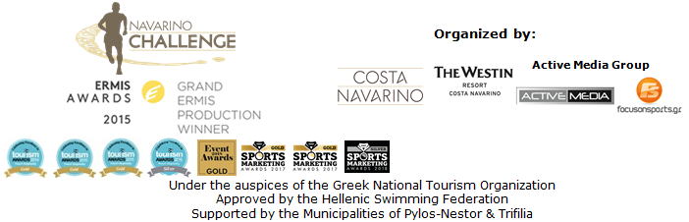

PRESS RELEASE

Registrations for Navarino Challenge 2018 will soon be completed!

Athens, September 5, 2018 – The registration period for those wishing to take part in “Navarino Challenge” comes to an end September 14th; The award winning sports tourism event will be held for the 6th consecutive time in Messinia and in Costa Navarino, October 12th to 14th 2018.

The open water swimming race of “Navarino Challenge” will be held for the first time with timing at Navarino bay, the place where the historic naval battle that changed the history of Greece was held. The Olympic sport of swimming will be organized with the approval of the Hellenic Swimming Federation and the supervision of the Greek federal coach Nikos Gemelos.
Nikos Gemelos highlighted on the event: “A few days before Navarinia, we celebrate the opening of the events with the activity of swimming at the splendid landscape of the bay, at the very beautiful port of Pylos with the valuable assistance of the Mayor of Pylos-Nestor and the local businesses that really stand as helpers and support Navarino Challenge for the 6th year. The race is held with complete safety thanks to the efforts of the Port Authority of Pylos and the Maritime Athletic Pylos Association “Nestor”, the lifeguards of the credible Lifeguard Patrol School, the stunning Explore Messinia team, Surf Salad and the conditions and regulations set by the Hellenic Swimming Federation and FINA.
The second day of Navarino Challenge with sport activities such as sup, swim and sailing with optimist & laser boats gives the motto of this year's event, which is that Sports Unite People (#sportsunitepeople)! Come and swim this year and experience the magic of Navarino Challenge!”.

Registrations continue for a few more days and can be completed through the special form available at the following link: http://activemedia.com.gr/product/navarino-challenge-2018/. The pre-sale is available also via www.viva.gr, by phone at 11876, as well as at the pre-sale points of the Viva network.

One of the biggest online gaming companies worldwide, Bwin, consistent with its efforts to enhance Greek sports, supports the event as the Grand Sponsor of this year's Navarino Challenge. By promoting actions of public good, Bwin recognizes the goal of Navarino Challenge, which is to raise awareness of the issue of childhood obesity and to promote physical and mental well-being through the message “sports unite people”. Bwin will be there to welcome the participants of Navarino Challenge by organizing the Bwin Welcome Party with the voice of Penny Baltatzi, in retro swing and jazz music rhythms (#sportsunitepeople #bwincares).

For the second consecutive year “Navarino Challenge” innovates with Samsung the event’s official technology partner. Samsung will enrich the experience of those participating and attending the event with the innovative Samsung Galaxy ecosystem services such as the Samsung Galaxy S9 and S9+ coupled with the Gear 360 and Gear VR with unique content at 360 degrees, as well as the QLED TVs with their outstanding picture quality and stylish design. For the days of the event, Samsung will create a special Samsung Business Lounge and a Samsung Gaming Corner and offer endless fun, information and entertainment to the Navarino Challenge participants. At the same time, it will sponsor the Samsung King & Queen Beach Volley Tournament by Triantafyllidis Beach Arena that will be held at Costa Navarino.

Surprises don’t stop here… as the all-new Ford Focus comes in Navarino Challenge 2018!
Everything you know and love on the Ford Focus. Add a brand new level of smart design, a modern style and more space than ever before. Combine them now with the highly advanced connectivity and a range of impressive technological driver assistance systems that you will truly appreciate. This is the new Focus. At Costa Navarino you can discover them all... driving it!

At Navarino Challenge, we believe in the ancient saying of “a healthy mind in a healthy body” and this year, with the support of the Hippophae of Meteora, Hippocrates Farm, we realize it.
The Greek Hippophae of Rezos Brands is grown on the model multifunctional farm Hippocrates Farm in Meteora and aims to promote the hippophae as a top Greek super food with unique beneficial quality for the human body. An excellent food, a fruit with 190 beneficial elements!

Navarino Challenge participants who will book their accommodation package at The Westin Resort Costa Navarino and choose to take part in at least one of the main activities (running, swimming, SUP) will also be able to enjoy the organization’s full program of activities free of charge, including:Tae kwon do, climbing, cycling, pilates, basketball, golf, kick boxing, baby swimming, aqua aerobics, kids’ athletics, beach volley, tennis cross training, crossfit, beach yoga, boxing, beachathlon and demonstration race with optimist boats.
More information about the accommodation packages may be found at the following link at the website of the event: http://www.navarinochallenge.com/accommodation-packages

Official sponsors of the event are for another year the Natural Mineral Water “Vikos” and Ford Motor Hellas. Luanvi is the official sports supplier of the event for the first time.
Official supporters are Poseidonia, BIC®, BIC® Sport, Avance and the Municipality of Pylos-Nestor.

Navarino Challenge is co-organized by Costa Navarino, The Westin Resort Costa Navarino and Active Media Group with the support of the Municipalities of Pylos-Nestor and Trifilia. Navarino Challenge will take place with the approval of the Hellenic Swimming Federation, under the auspices of the Greek National Tourism Organization.

Grand Sponsor: Bwin
Official Technology Partner: Samsung
Official Sponsors: Natural Mineral Water “Vikos”, Ford Motor Hellas
Official Sports Supplier: Luanvi
Official Supporters: Poseidonia, BIC®, BIC® Sport, Avance Rent A Car, Hippocrates Farm, Municipality of Pylos-Nestor
Partners: Navarino Outdoors, Swim Academy, Surf Salad, Triantafyllidis Beach Arena, FitnessArt, Vizantinos target sport club, Red Swim Academy, Fysiotek Sports Lab
Strategic Partner: National Geographic
Assisted by: Lifeguard Patrol, Navarino Racquet Academy, Pylos Association of Enterprises for Tourism Development, Maritime Athletic Pylos Association “Nestor”, Explore Messinia, Navarino Golf Academy, Target Security, The Diner, Hellenic Recovery Recycling Corporation, Athens Easy Transfers, Anazoe Spa, Kayak, Collective Resort, Department of Sports Organization & Management from University of Peloponnese, Karalis City Hotel & Spa, Karalis Beach Hotel

Hashtags: #navarinochallenge #costanavarino #sportsunitepeople #eatwell #runwell #livewell
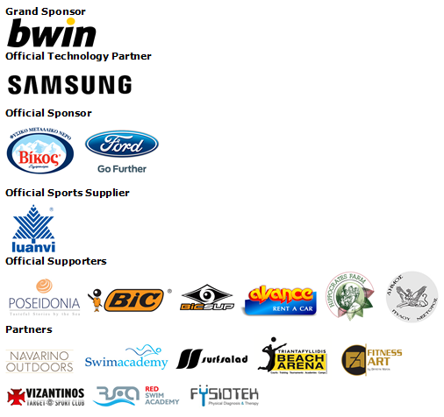
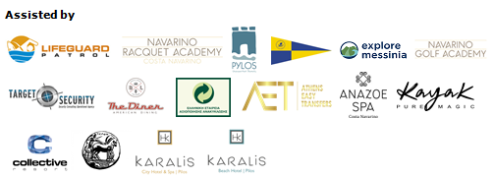
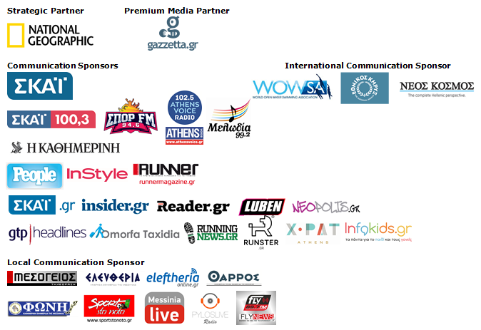
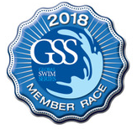

Under the Auspices of the Greek National Tourism Organization
Approved by the Hellenic Swimming Federation
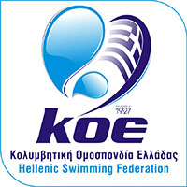

Website: www.navarinochallenge.com
Instagram Page: http://instagram.com/navarinochallenge
Facebook Page: www.facebook.com/Navarinochallenge
Twitter Account: https://twitter.com/NavarinoC
YouTube Channel: http://www.youtube.com/user/NavarinoChallenge

About Costa Navarino
Costa Navarino is the prime, sustainable destination in the Mediterranean, located in the Greek region of Messinia in the southwest Peloponnese. One of the most unspoiled and breathtaking seaside Mediterranean landscapes, this area has been shaped by 4,500 years of history. Its philosophy is driven by a genuine desire to promote Messinia, while protecting and preserving its natural beauty and heritage. It will comprise a number of distinct sites featuring 5-star deluxe hotels, luxury residences, conference facilities, spa and thalassotherapy centres, signature golf courses, as well as a wide range of unique year-round activities for adults and children. Navarino Dunes, the first area, is home to two luxury 5-star hotels, The Romanos, a Luxury Collection Resort and The Westin Resort Costa Navarino; The Dunes Course – the first signature golf course in Greece- Anazoe Spa, a 4,000sq.m. spa & thalassotherapy centre; the state-of-the-art conference centre House of Events; specially designed facilities for children; as well as a variety of gastronomy venues, sports, outdoor and cultural activities. Navarino Bay, the second area is home to the signature golf course, The Bay Course. Download high resolution photos and logos from the press section in downloads on the website www.costanavarino.com, using the password Nestor.

The Westin Resort Costa Navarino
The Westin Resort has been voted one of the best resorts in Greece and one of the foremost holiday destinations in Europe. In 2017 The Westin Resort Costa Navarino has been voted among the Best Resorts in Europe in Condé Nast Traveler Reader’s Choice Awards. It features an amazing selection of deluxe rooms, family rooms and suites in a privileged seaside location on a verdant hillside that affords an alluring mix of golf, sea and pool views. Voted “Best Family Destination” in the Mediterranean among Starwood Hotels & Resorts, this exceptional 5-star family resort in Greece allows children to choose from an enormous variety of supervised fun activities, tailored specifically for them, at the Cocoon and the SandCastle, giving parents plenty of time to indulge in their own favorite sports or simply unwind. At the Cocoon crèche, infants and toddlers from just 4 months to 3 years old are creatively engaged and encouraged to develop their skills under the supervision of qualified baby nurses and trained staff. Whilst the SandCastle, which offers both recreational and educational activities as well as overnight stay options, is aimed at children aged 4 to 7 and 8 to 12, with specially devised programs for each age group. For more information on The Westin Resort Costa Navarino, please visit www.westincostanavarino.com or follow us on Twitter.

