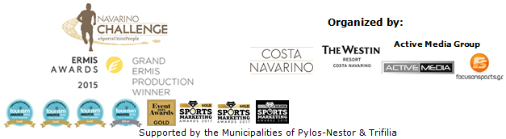

PRESS RELEASE

Registrations for the 7th Navarino Challenge are now open
The much-anticipated sporting event takes place from 11-13 October 2019
at Costa Navarino

Athens, March 12, 2019 – The award-winning “Navarino Challenge”, now an established date on the sporting calendar, celebrates sports tourism for the 7th consecutive year!
“Navarino Challenge” hosted over 2,500 professional and amateur athletes last year and will take place this year from 11-13 October 2019 in Messinia and Costa Navarino, with more than 10 Olympic sports and numerous activities for everyone.

Through its central message “sports unite people”, Navarino Challenge aims to promote sports with inter-generational activities catering to all age groups. For the 7th consecutive year, the sporting event will continue to promote the fight against child obesity through information, and awareness of the benefits of the Mediterranean diet and exercise.

Running tracks
Participants will have the opportunity to choose between the Half Marathon (21.1km), 10km, and 5km (running & power walking). Starting from the Navarino Dunes of Costa Navarino, professional and amateur athletes will run along the picturesque coast to Pylos, crossing the beautiful Voidokilia beach, tracing history beneath their feet in King Nestor’s land. They will follow the trail mapped out in the Homeric era by Telemachus, Ulysses’ son, trying to find his missing father. It is the only trail run that combines soil, sand and asphalt. On the same day, the children’s 1km course will take place. The routes have been planned by the former marathon runner, current classic marathon course national record holder, running coach and director of All About Running, Nikos Polias. The event includes race timing for all runners.

Open water swimming
Open water swimming enthusiasts will have the chance to compete in a chip-timed event at the beautiful Navarino bay from the scenic Pylos harbour, covering the unique 1 mile (1.6 km) swimming route by Vikos. The route has been designed by the national federal technical coach, Nikos Gemelos (the coach who has given us countless Olympic and world-class honours in open water swimming).

Runners and swimmers can act immediately to take advantage of the early bird offer by registering to a 30% discount until 31 May (children’s participation is free of charge).

Entries for the award-winning sporting event are underway and interested parties can take part by completing the special form available at the following link: http://activemedia.com.gr/product/navarino-challenge-2019/. Pre-sale is also available online via www.viva.gr or by phone at 11876 as well as at all Viva pre-sale points.

“Navarino Challenge” participants who book their package at The Westin Resort Costa Navarino and choose to take part in the main events (running, swimming) will also have the opportunity to enjoy the full activities programme. More information on premium hosting packages will be announced in the coming weeks.

Watch the teaser video for the 7th Navarino Challenge at the following link: https://youtu.be/KWq6FHGUA5c

“Navarino Challenge”, has been consistently awarded with Ermis Awards, Tourism Awards, Event Awards and Sports Marketing Awards for its excellence in sports tourism.

Samsung is the official technology partner for another year. Official sponsors of the event are Ford Motor Hellas and the Natural Mineral Water “Vikos”. Luanvi is the official sports supplier of the event for one more year.
Official supporters are Municipality of Pylos-Nestor, Poseidonia and Avance Rent A Car.

Navarino Challenge is co-organized by Costa Navarino, The Westin Resort Costa Navarino and Active Media Group with the support of the Municipalities of Pylos-Nestor and Trifilia.

The event is part of the Global Swim Series (GSS) [numbering more than 150 swimming races]. This way, all participants in “Navarino Challenge” as well as in the rest of GSS races will earn a global ranking. The rating is based equally on participation and speed. The more races they do the higher their ranking will be. Respectively, “Navarino Challenge” has become part of the global community of World’s Marathons [numbering more than 4.410 running races worldwide].

Official Technology Partner: Samsung
Official Sponsors: Ford Motor Hellas, Natural Mineral Water “Vikos”
Official Sports Supplier: Luanvi
Official Supporters: Municipality of Pylos-Nestor, Poseidonia, Avance Rent A Car
Partners: Navarino Outdoors, Swim Academy, Triantafyllidis Beach Arena, FitnessArt, Vizantinos target sport club, Red Swim Academy, Fysiotek Sports Lab
Assisted by: Lifeguard Patrol, Navarino Racquet Academy, Pylos Association of Enterprises for Tourism Development, Maritime Athletic Pylos Association “Nestor”, Explore Messinia, Navarino Golf Academy, Target Security, Athens Easy Transfers, Karalis City Hotel & Spa, Karalis Beach Hotel

Hashtags: #navarinochallenge #costanavarino #sportsunitepeople #eatwell #runwell #livewell

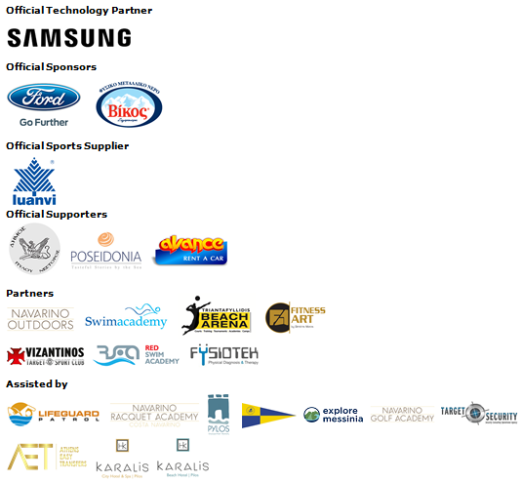
Member of:



Website: www.navarinochallenge.com
Facebook Page: www.facebook.com/Navarinochallenge
Instagram Page: http://instagram.com/navarinochallenge
Twitter Account: https://twitter.com/NavarinoC
YouTube Channel: http://www.youtube.com/user/NavarinoChallenge

About Costa Navarino
Costa Navarino is the prime, sustainable destination in the Mediterranean, located in the Greek region of Messinia in the southwest Peloponnese. One of the most unspoiled and breathtaking seaside Mediterranean landscapes, this area has been shaped by 4,500 years of history. Its philosophy is driven by a genuine desire to promote Messinia, while protecting and preserving its natural beauty and heritage. It will comprise a number of distinct sites featuring 5-star deluxe hotels, luxury residences, conference facilities, spa and thalassotherapy centres, signature golf courses, as well as a wide range of unique year-round activities for adults and children. Navarino Dunes, the first area, is home to two luxury 5-star hotels, The Romanos, a Luxury Collection Resort and The Westin Resort Costa Navarino; Navarino Residences, a collection of luxury villas for private ownership; The Residences at The Westin Resort Costa Navarino, fully-furnished resort apartments for sale; the signature golf course The Dunes Course, Anazoe Spa, a 4,000m2 spa and thalassotherapy centre; the state-of-the-art conference centre House of Events; specially designed facilities for children; as well as a variety of gastronomy venues, sports, outdoor and cultural activities. Navarino Bay, the second area, is home to the signature golf course, The Bay Course. Navarino Hills, with two 18-hole golf courses, is currently under construction, and there are two further sites underway. Download high resolution photos and logos from the press section in downloads on the website www.costanavarino.com, using the password Nestor.

The Westin Resort Costa Navarino
The Westin Resort has been voted one of the best resorts in Greece and one of the foremost holiday destinations in Europe. In 2017 The Westin Resort Costa Navarino has been voted among the Best Resorts in Europe in Condé Nast Traveler Reader’s Choice Awards. It features an amazing selection of deluxe rooms, family rooms and suites in a privileged seaside location on a verdant hillside that affords an alluring mix of golf, sea and pool views. Voted “Best Family Destination” in the Mediterranean among Starwood Hotels & Resorts, this exceptional 5-star family resort in Greece allows children to choose from an enormous variety of supervised fun activities, tailored specifically for them, at the Cocoon and the SandCastle, giving parents plenty of time to indulge in their own favorite sports or simply unwind. At the Cocoon crèche, infants and toddlers from just 4 months to 3 years old are creatively engaged and encouraged to develop their skills under the supervision of qualified baby nurses and trained staff. Whilst the SandCastle, which offers both recreational and educational activities as well as overnight stay options, is aimed at children aged 4 to 7 and 8 to 12, with specially devised programs for each age group. For more information on The Westin Resort Costa Navarino, please visit www.westincostanavarino.com or follow us on Twitter.

