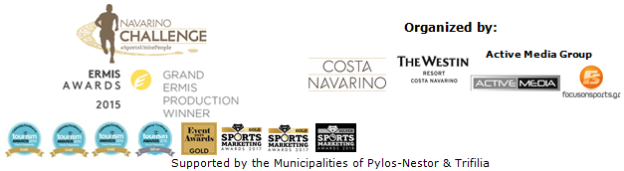

PRESS RELEASE

Basketball legend Nick Galis at the 7th Navarino Challenge

Special sports tourism accommodation packages available

Athens, April 8, 2019 – For the 7th consecutive year, “Navarino Challenge”, the annual celebration of sports, comes to Messinia and Costa Navarino from October 11 to 13, 2019 with new surprises and new activities!

Greek basketball legend Nick Galis, the first Greek basketball player to have joined the Hall of Fame, and to have been counted among the pantheon of world basketball greats, will be present at the award-winning event for the first time. Emphasizing the role of sports in bringing people together, Nick Galis pointed out: “Sport unites people. Sport unites nations. The Navarino Challenge brings together professional and amateur athletes, people of different ages, genders and skills. It creates friendships and special bonds between participants who all speak the same language, that of sports. As a society, we have to send the message that sports unites people - #sportsunitespeople - but to also give young children core ethical values through sport. Costa Navarino and Navarino Challenge are pioneers in promoting this idea and I will contribute to spreading the message with great pleasure”.

Nick Galis will be the guest of honour at this year's event and he will be the one to tip off the 4on4 tournament at Costa Navarino. Participants who book their accommodation package at The Westin Resort Costa Navarino will, for the first time this year, have the opportunity to form their own championship team and compete in the tournament until the finals.
Basketball clinic with Joe Arlauckas
Basketball will be the sport of honour with Euroleague legend Joe Arlaukas leading basketball lessons for children aged between 5 and 17.

Free participation in the Authentic Marathon of Athens for the first 50
The first 50 to book a package at The Westin Resort Costa Navarino will earn a free participation in the Athens Authentic Marathon’s 5km race on November 10, 2019. With the main goal of promoting sport and fair play through its message “sport unites people”, Navarino Challenge will include more than 10 Olympic sports and numerous activities for everyone in its programme.
Navarino Challenge participants who’ve booked their accommodation package at The Westin Resort Costa Navarino and choose to take part in the main activities (running, swimming) can also enjoy all the other event activities. More information on accommodation packages can be found on the following link on the website of: http://www.navarinochallenge.com/accommodation-packages-2019

Runners and swimmers can act immediately to take advantage of the early bird offer by registering to a 30% discount until 31 May (children’s participation is free of charge).

Entries for the award-winning sporting event are underway and interested parties can take part by completing the special form available at the following link: http://activemedia.com.gr/product/navarino-challenge-2019/. Pre-sale is also available online via www.viva.gr or by phone at 11876 as well as at all Viva pre-sale points.

“Navarino Challenge” participants who book their package at The Westin Resort Costa Navarino and choose to take part in the main events (running, swimming) will also have the opportunity to enjoy the full activities programme. More information on premium hosting packages will be announced in the coming weeks.

Samsung is the official technology partner for another year. Official sponsors of the event are Ford Motor Hellas and the Natural Mineral Water “Vikos”. Luanvi is the official sports supplier of the event for one more year.
Official supporters are Municipality of Pylos-Nestor, Poseidonia and Avance Rent A Car.

“Navarino Challenge” has joined the Greek actions of the #BeactiveHellas 2019 programme of the European Commission and is under the auspices of the General Secretariat of Sports.
Navarino Challenge is co-organized by Costa Navarino, The Westin Resort Costa Navarino and Active Media Group with the support of the Municipalities of Pylos-Nestor and Trifilia.

Official Technology Partner: Samsung
Official Sponsors: Ford Motor Hellas, Natural Mineral Water “Vikos”
Official Sports Supplier: Luanvi
Official Supporters: Municipality of Pylos-Nestor, Poseidonia, Avance Rent A Car
Partners: Navarino Outdoors, Swim Academy, Triantafyllidis Beach Arena, FitnessArt, Vizantinos target sport club, Red Swim Academy, Fysiotek Sports Lab, Climb Up
Assisted by: Lifeguard Patrol, Navarino Racquet Academy, Pylos Association of Enterprises for Tourism Development, Maritime Athletic Pylos Association “Nestor”, Explore Messinia, Navarino Golf Academy, Target Security, Athens Easy Transfers, Karalis City Hotel & Spa, Karalis Beach Hotel, Pylos Poems

Hashtags: #navarinochallenge #costanavarino #sportsunitepeople #eatwell #runwell #livewell

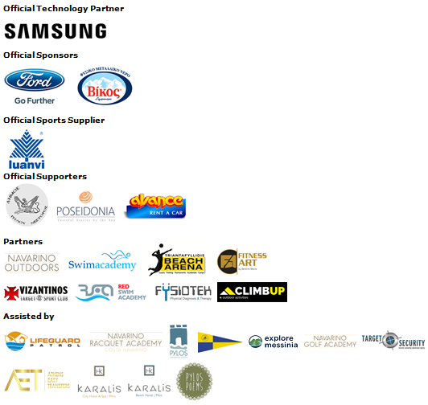
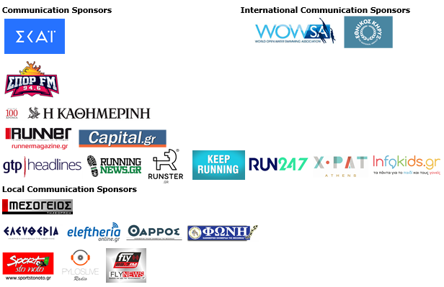
Under the Auspices of:

Member of:





---
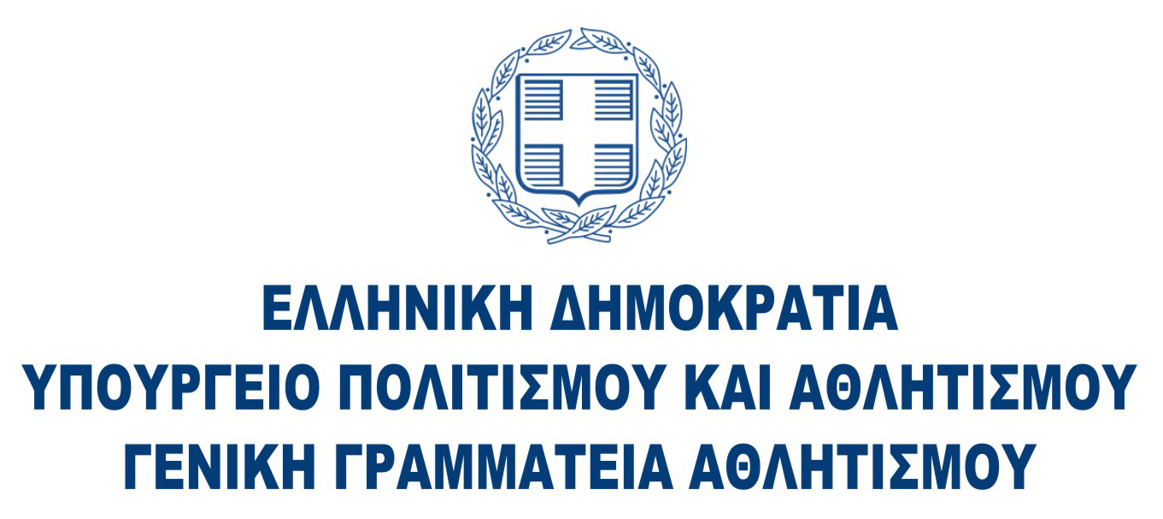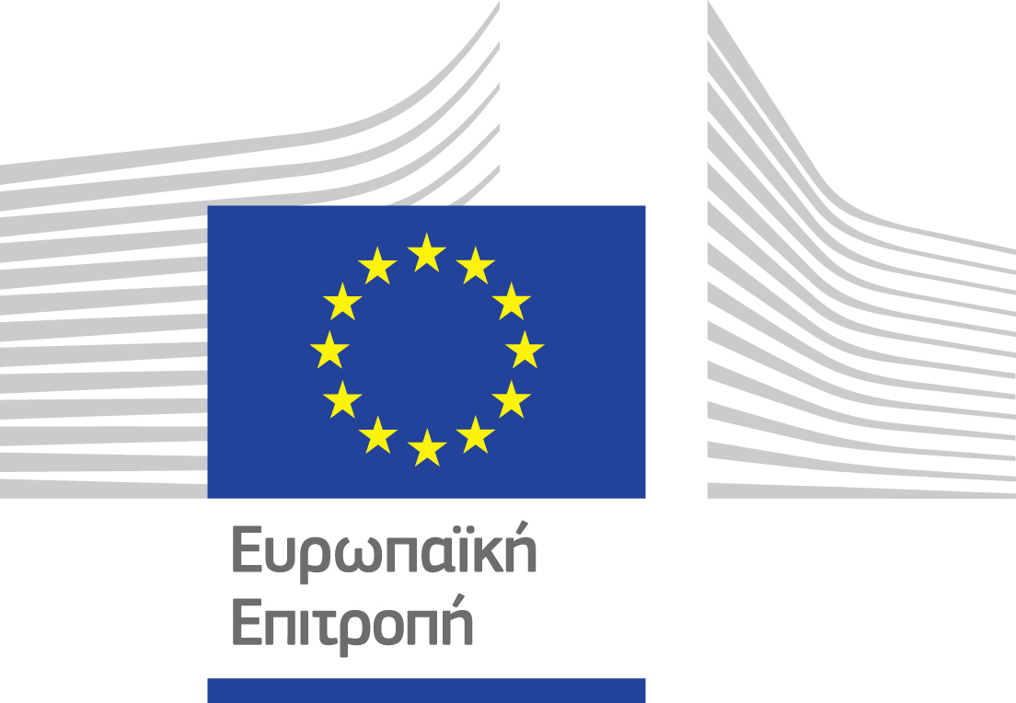

Website: www.navarinochallenge.com
Facebook Page: www.facebook.com/Navarinochallenge
Instagram Page: http://instagram.com/navarinochallenge
Twitter Account: https://twitter.com/NavarinoC
YouTube Channel: http://www.youtube.com/user/NavarinoChallenge

About Costa Navarino
Costa Navarino is the prime, sustainable destination in the Mediterranean, located in the Greek region of Messinia in the southwest Peloponnese. One of the most unspoiled and breathtaking seaside Mediterranean landscapes, this area has been shaped by 4,500 years of history. Its philosophy is driven by a genuine desire to promote Messinia, while protecting and preserving its natural beauty and heritage. It will comprise a number of distinct sites featuring 5-star deluxe hotels, luxury residences, conference facilities, spa and thalassotherapy centres, signature golf courses, as well as a wide range of unique year-round activities for adults and children. Navarino Dunes, the first area, is home to two luxury 5-star hotels, The Romanos, a Luxury Collection Resort and The Westin Resort Costa Navarino; Navarino Residences, a collection of luxury villas for private ownership; The Residences at The Westin Resort Costa Navarino, fully-furnished resort apartments for sale; the signature golf course The Dunes Course, Anazoe Spa, a 4,000m2 spa and thalassotherapy centre; the state-of-the-art conference centre House of Events; specially designed facilities for children; as well as a variety of gastronomy venues, sports, outdoor and cultural activities. Navarino Bay, the second area, is home to the signature golf course, The Bay Course. Navarino Hills, with two 18-hole golf courses, is currently under construction, and there are two further sites underway. Download high resolution photos and logos from the press section in downloads on the website www.costanavarino.com, using the password Nestor.

The Westin Resort Costa Navarino
The Westin Resort has been voted one of the best resorts in Greece and one of the foremost holiday destinations in Europe. In 2017 The Westin Resort Costa Navarino has been voted among the Best Resorts in Europe in Condé Nast Traveler Reader’s Choice Awards. It features an amazing selection of deluxe rooms, family rooms and suites in a privileged seaside location on a verdant hillside that affords an alluring mix of golf, sea and pool views. Voted “Best Family Destination” in the Mediterranean among Starwood Hotels & Resorts, this exceptional 5-star family resort in Greece allows children to choose from an enormous variety of supervised fun activities, tailored specifically for them, at the Cocoon and the SandCastle, giving parents plenty of time to indulge in their own favorite sports or simply unwind. At the Cocoon crèche, infants and toddlers from just 4 months to 3 years old are creatively engaged and encouraged to develop their skills under the supervision of qualified baby nurses and trained staff. Whilst the SandCastle, which offers both recreational and educational activities as well as overnight stay options, is aimed at children aged 4 to 7 and 8 to 12, with specially devised programs for each age group. For more information on The Westin Resort Costa Navarino, please visit www.westincostanavarino.com or follow us on Twitter.

