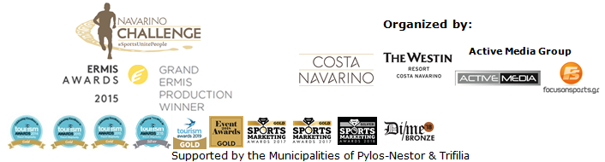
PRESS RELEASE

Navarino Challenge: Enriched activities in Messinia

Another Gold Award at the Tourism Awards 2019

Athens, May 23, 2019 – The Greek sports tourism event “Navarino Challenge” comes back for a 7th consecutive year, on October 11-13 2019, in Messinia and Costa Navarino.
The annual event was recently bestowed with a Gold Award at the Tourism Awards, the highest distinction in Greek tourism. Navarino Challenge enriches its programme this year with innovative activities at the Municipality of Pylos-Nestor aiming at breaking the record of 7,500 athletes, visitors and volunteers.

The event’s enriched 3-day programme includes:

Open Water Swimming
Open water swimming enthusiasts will have the chance to compete in a chip-timed event on Saturday October 12, at the beautiful Navarino bay from the scenic Pylos harbour, covering the unique 1 mile (1.6 km) route of the open water swimming race by Vikos. The route has been designed by the national federal technical coach, Nikos Gemelos (the coach who has earned countless Olympic and world-class honours in open water swimming for Greece).

Challenge The Wind – Sailing Races
An interclub sailing race of triangle course with OPTIMIST and LASER 4.7 boats will be held for the first time from October 11-13. The race will be co-organized with the Maritime Athletic Pylos Association “Nestor”, under the aegis of the Hellenic Sailing Federation.
To be held on the second weekend of October, “Challenge The Wind”, as its name suggests, hopes to become an annual tradition and sporting benchmark for sailing competitions in the coming years.

Sea Κayaking in the Navarino Bay
The activity, to be held for the first time on Saturday October 12, will start from the port of Pylos at Poseidonia, and head to the island of Sphacteria, supported by Explore Messinia. Participants will paddle towards the inside of the bay exploring the coastline of Sphacteria.

Basketball camp with Joe Arlauckas
Basketball will be the sport of honour at the Pylos indoor basketball court.
On Sunday October 13, children from Pylos and Messinia, aged between 8 and 16 will have the opportunity to attend basketball lessons for free by the Euroleague legend Joe Arlaukas, while on Saturday, October 12, a basketball clinic will be held at Costa Navarino.

Kids’ Athletics at Pylos Square
Kids’ Athletics returns for another year to Pylos Square on Saturday October 12, with Periklis Iakovakis, the Olympic & World Champion in 400m. hurdles, as its ambassador. This is an activity that aims at getting children acquainted with track and field sports. The Kids' Athletics activities includes long jump, the sport of the world famous Olympic champion and legendary Kostis Tsiklitiras, who was born in Pylos, Messinia.

A Visit to the house of the Olympic champion Tsiklitiras
On Saturday October 12, 2019, visitors to Pylos can visit the refurbished family home of the Olympic champion, Kostis Tsiklitiras, now a museum housing a Library and Art Gallery with rare documents, paintings, historical maps and many interesting exhibits.

Traditional local flavours
On Saturday October 12, athletes and visitors can partake of Messinia’s rich culinary heritage as Pylos comes alive with booths celebrating local flavours: traditional lalagia, loukoums, sesame seed bars and nuts with honey, created by food blogger Mamatsita, Poseidonia and Pylos Poems.

Sunset Beach Yoga at Voidokilia
On Friday, October 11, instructor Dimitris Moros and FitnessArt hold sunset beach yoga sessions by Messinian Spa to the backdrop of the mythical Voidokilia, Messinia’s famed beach that traces the letter Omega of the Greek alphabet (written as “Ω”).

Active Media, the organizing company which innovates in the field of destination and hotel sports tourism, distinguished each year with Gold Awards at the Tourism Awards and first places in the sports production category, for the last 4 years at the Ermis Awards, promises a unique event with many surprises for everyone. On the occasion of the activities enrichment at Pylos, Active Media Group Chief Executive Officer, Mr. Akis Tsolis highlighted: “Sports tourism is one of the fastest-growing segments in the entire travel industry, and we’ve been fortunate over the past several years to really establish Messinia as a go-to sporting destination with Navarino Challenge. Youth, amateur or professional athletes are traveling to compete more than ever today, and they’re bringing with them their coaches, fans, parents, siblings and friends – all of whom contribute to the hosting region’s local economy. That is why we are honored to have the Municipality of Pylos-Nestor and local companies such as Poseidonia, Pylos Association of Enterprises for Tourism Development, Maritime Athletic Pylos Association “Nestor”, Explore Messinia, Karalis City Hotel & Spa, Karalis Beach Hotel and Pylos Poems as main supporters to our vision. Messinia is a unique region offering unparalleled on-field experiences as well as awesome restaurants, hotels and attractions to visiting athletes, to enjoy during their leisure time. That’s a rare combination in the travel sports industry, and something we’ve really been able to leverage”.

Visit Messinia
Travel and discover the beauty of Pylos and Messinia during Navarino Challenge. Enjoy your stay combining the sports action with history. Before you visit Messinia in October you may watch the following video: https://youtu.be/FrO9VMoG5uk

Accommodation packages at The Westin Resort Costa Navarino
Navarino Challenge participants who’ve booked their accommodation package at The Westin Resort Costa Navarino and choose to take part in the main activities (running, swimming) can also enjoy the event’s full programme with more than 20 sports activities. More information on accommodation packages can be found on the following link on the website of: http://www.navarinochallenge.com/accommodation-packages-2019

30% discount on registrations until 31/5
Runners and swimmers can act immediately to take advantage of the early bird offer by registering to a 30% discount until 31 May (children’s participation is free of charge). Entries for the award-winning sporting event are underway and interested parties can take part by completing the special form available at the following link: http://activemedia.com.gr/product/navarino-challenge-2019/. Pre-sale is also available online via www.viva.gr or by phone at 11876 as well as at all Viva pre-sale points.

For more information on accommodation packages in the region visit VitaNTravel: http://vitantravel.gr/

Samsung is the official technology partner for another year. Official sponsors of the event are Ford Motor Hellas and the Natural Mineral Water “Vikos”.
Luanvi is the official sports supplier of the event for one more year.
Official supporters are Poseidonia, Municipality of Pylos-Nestor and PlantBox. Messinian Spa is the Official Beauty Partner for the first time. Partners of the event are Pylos Poems, Fysiotek Sports Lab, Athens Easy Transfers.
Avance Rent A Car is the official rental partner.
National Geographic is the strategic partner of the event and 24 Media its premium media partner.

“Navarino Challenge” has joined the Greek actions of the #BeactiveHellas 2019 programme of the European Commission and is under the auspices of the General Secretariat of Sports.
Navarino Challenge is co-organized by Costa Navarino, The Westin Resort Costa Navarino and Active Media Group with the support of the Municipalities of Pylos-Nestor and Trifilia.

Athletic Partners: Explore Messinia, FitnessArt, Navarino Golf Academy, Navarino Outdoors, Navarino Racquet Academy, Pilates by Mandy, Red Swim Academy, Swim Academy, Triantafyllidis Beach Arena, Vizantinos target sport club
Assisted by: Karalis City Hotel & Spa, Karalis Beach Hotel, Lifeguard Patrol, Pylos Association of Enterprises for Tourism Development, Maritime Athletic Pylos Association “Nestor”, Target Security, METAXA, The Blue Beetle, Fever-Tree, NoS, Southern Comfort

Hashtags: #navarinochallenge #costanavarino #sportsunitepeople #eatwell #runwell #livewell

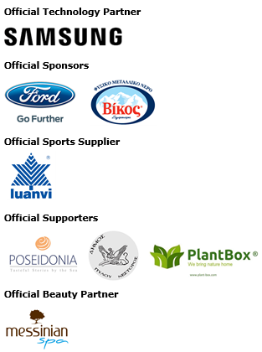
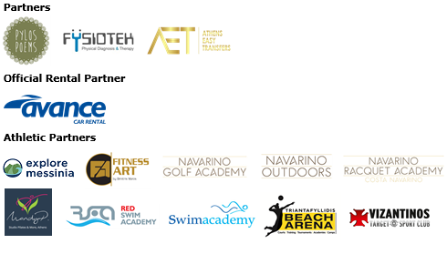
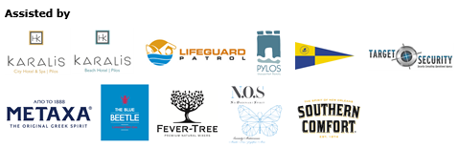



Member of:

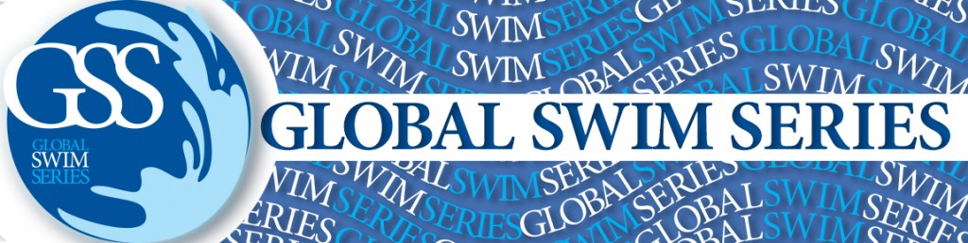



---
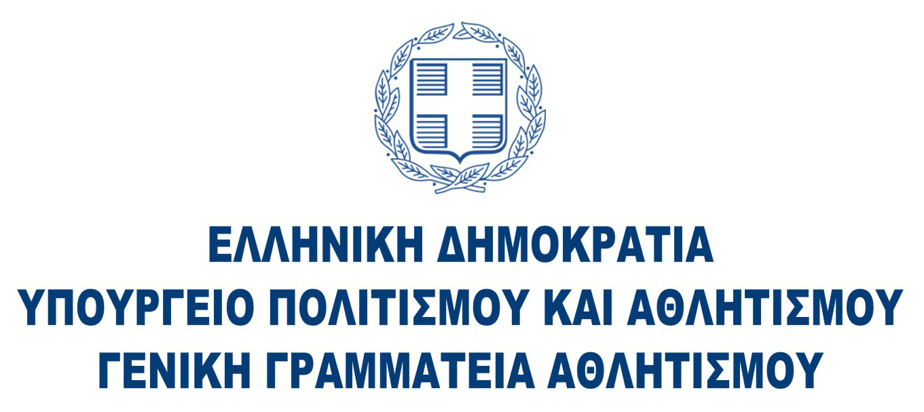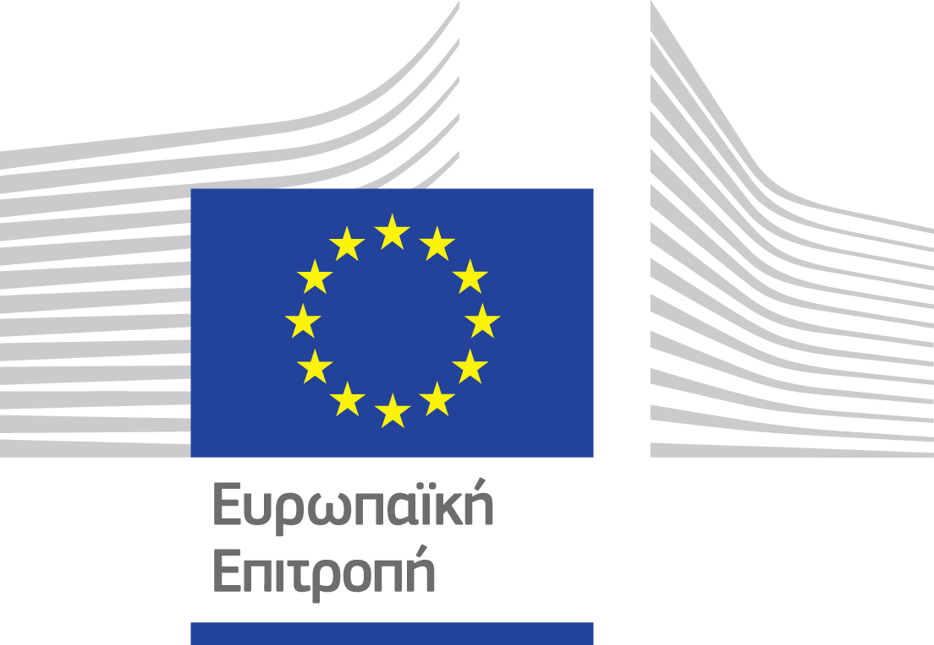

Website: www.navarinochallenge.com
Facebook Page: www.facebook.com/Navarinochallenge
Instagram Page: http://instagram.com/navarinochallenge
Twitter Account: https://twitter.com/NavarinoC
YouTube Channel: http://www.youtube.com/user/NavarinoChallenge

About Costa Navarino
Costa Navarino is the prime, sustainable destination in the Mediterranean, located in the Greek region of Messinia in the southwest Peloponnese. One of the most unspoiled and breathtaking seaside Mediterranean landscapes, this area has been shaped by 4,500 years of history. Its philosophy is driven by a genuine desire to promote Messinia, while protecting and preserving its natural beauty and heritage. It will comprise a number of distinct sites featuring 5-star deluxe hotels, luxury residences, conference facilities, spa and thalassotherapy centres, signature golf courses, as well as a wide range of unique year-round activities for adults and children. Navarino Dunes, the first area, is home to two luxury 5-star hotels, The Romanos, a Luxury Collection Resort and The Westin Resort Costa Navarino; Navarino Residences, a collection of luxury villas for private ownership; The Residences at The Westin Resort Costa Navarino, fully-furnished resort apartments for sale; the signature golf course The Dunes Course, Anazoe Spa, a 4,000m2 spa and thalassotherapy centre; the state-of-the-art conference centre House of Events; specially designed facilities for children; as well as a variety of gastronomy venues, sports, outdoor and cultural activities. Navarino Bay, the second area, is home to the signature golf course, The Bay Course. Navarino Hills, with two 18-hole golf courses, is currently under construction, and there are two further sites underway. Download high resolution photos and logos from the press section in downloads on the website www.costanavarino.com, using the password Nestor.

The Westin Resort Costa Navarino
The Westin Resort has been voted one of the best resorts in Greece and one of the foremost holiday destinations in Europe. In 2017 The Westin Resort Costa Navarino has been voted among the Best Resorts in Europe in Condé Nast Traveler Reader’s Choice Awards. It features an amazing selection of deluxe rooms, family rooms and suites in a privileged seaside location on a verdant hillside that affords an alluring mix of golf, sea and pool views. Voted “Best Family Destination” in the Mediterranean among Starwood Hotels & Resorts, this exceptional 5-star family resort in Greece allows children to choose from an enormous variety of supervised fun activities, tailored specifically for them, at the Cocoon and the SandCastle, giving parents plenty of time to indulge in their own favorite sports or simply unwind. At the Cocoon crèche, infants and toddlers from just 4 months to 3 years old are creatively engaged and encouraged to develop their skills under the supervision of qualified baby nurses and trained staff. Whilst the SandCastle, which offers both recreational and educational activities as well as overnight stay options, is aimed at children aged 4 to 7 and 8 to 12, with specially devised programs for each age group. For more information on The Westin Resort Costa Navarino, please visit www.westincostanavarino.com or follow us on Twitter.

