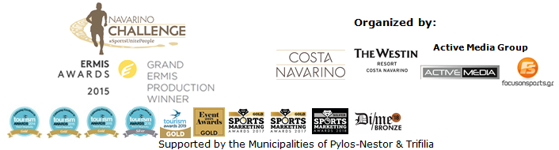
PRESS RELEASE

Navarino Challenge 2019 goes green

Supports three NGOs and a sustainable event

Athens, June 27, 2019 – In its 7th edition, “Navarino Challenge”, to be held from 11-13 October 2019, in Messinia and at Costa Navarino, continues to innovate with a roster of environmentally friendly activities.

“Navarino Challenge” allows participants to be informed and involved in its activities to support the sacred goal of combating childhood obesity through exercise and awareness of the benefits of a Mediterranean diet.
With a view to adopting a more eco-friendly strategy, the organizers: a) have declared the start and end points of the Navarino Dunes runways as strictly smoke-free areas, b) have declared the beautiful Voidokilia beach, through which the runners cross, as strictly plastic-free, c) will offer participants an eco-friendly bag by Luanvi, event’s official sports supplier.

This year, the event will further promote charity by supporting: a) the Institute of Preventive Medicine, Environmental and Occupational Health, Prolepsis with a program on Food Aid and Promotion of Healthy Nutrition, DIATROFI.
Additionally, the Captain Vasilis and Carmen Konstantakopoulos Foundation will support b) WWF Hellas and c) Karkinaki. All participants can contribute any sum they wish through the GivenGain online platform.
As part of this year’s “Navarino Challenge”, Barney Spender and Roddy Gibson’s award-winning documentary “The Road to Sparta” that recounts the effort of four runners, including that of Greek-American ultramarathon Dean Karnazes (who participated with the Navarino Challenge Support Team) to run the “Sparthathlon” race, will be screened at the Agora, Costa Navarino, on Friday, October 11.

Running routes
Participants can choose between the top-of-the-range Ford Go Further Greek Half-Marathon (21.1km), 10km by PlantBox, and 5km (running & dynamic walking). Starting from the Navarino Dunes of Costa Navarino, professional and amateur athletes will run along the coast to Pylos, crossing the beautiful Voidokilia beach, following the Homeric trail that Telemachos traced for Odysseus in King Nestor’s land. It is the only trail run that combines soil, sand and asphalt.
On the same day, the children’s 1km course will take place. The routes have been planned by the former marathon runner, current classic marathon course national record holder, running coach and director of All About Running, Nikos Polias. The event includes race timing for all runners.

The olive tree, a key symbol of Ancient Greece, the Olympic Games, of the Mediterranean diet, and of Messinia in particular, is given its due place of honour at Navarino Challenge. Peloponnese-based PlantBox, the award-winning team at the Athens Startup Awards, will offer an original olive tree package to each participant. Participants will also receive high quality cosmetics by Messinian Spa, a range of cosmetics based on Kalamata olive oil and other natural Greek products.
Enjoy the uniqueness of the running routes in the following video: https://youtu.be/WCuXpo5Mh1Y
Learn more details about the route of the Ford Go Further Greek Half-Marathon in the following video: https://youtu.be/Ii0aQfPlc5k

Accommodation Packages at The Westin Resort Costa Navarino
Navarino Challenge participants who have booked their package at The Westin Resort Costa Navarino, taking part in the main events (running, swimming) can also enjoy the full programme that includes more than 20 sporting activities.
The first 50 to book their package at The Westin Resort Costa Navarino stand a chance to win a free participation at the Authentic Athens Marathon 5km race on Sunday November 10, 2019.
More information on accommodation packages can be found on:
http://www.navarinochallenge.com/accommodation-packages-2019

Registrations continue for running and swimming
Entries for the award-winning sporting event are underway and interested parties can take part by completing the special form available at the following link: http://activemedia.com.gr/product/navarino-challenge-2019/. Pre-sale is also available online via www.viva.gr or by phone at 11876 as well as at all Viva pre-sale points.

For more information on accommodation packages in the region visit VitaNTravel: http://vitantravel.gr/

Samsung is the official technology partner for another year. Official sponsors of the event are Ford Motor Hellas and the Natural Mineral Water “Vikos”.
Luanvi is the official sports supplier of the event for one more year.
Official supporters are Poseidonia, Municipality of Pylos-Nestor and PlantBox. Messinian Spa is the Official Beauty Partner for the first time. Partners of the event are Pylos Poems, Fysiotek Sports Lab, Athens Easy Transfers.
Avance Rent A Car is the official rental partner.
National Geographic is the strategic partner of the event and 24 Media its premium media partner.

“Navarino Challenge” has joined the Greek actions of the #BeactiveHellas 2019 programme of the European Commission and is under the auspices of the General Secretariat of Sports.
The event is held under the auspices of the Greek National Tourism Organization with the approval of the Hellenic Swimming Federation.
Navarino Challenge is co-organized by Costa Navarino, The Westin Resort Costa Navarino and Active Media Group with the support of the Municipalities of Pylos-Nestor and Trifilia.

Athletic Partners: Explore Messinia, FitnessArt, Navarino Golf Academy, Navarino Outdoors, Navarino Racquet Academy, Pilates by Mandy, Red Swim Academy, Swim Academy, Triantafyllidis Beach Arena, Vizantinos target sport club
Assisted by: Karalis City Hotel & Spa, Karalis Beach Hotel, Lifeguard Patrol, Pylos Association of Enterprises for Tourism Development, Maritime Athletic Pylos Association “Nestor”, Target Security, METAXA, The Blue Beetle, Fever-Tree, NoS, Southern Comfort

Hashtags: #navarinochallenge #costanavarino #sportsunitepeople #eatwell #runwell #livewell

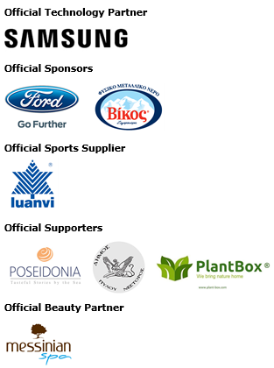
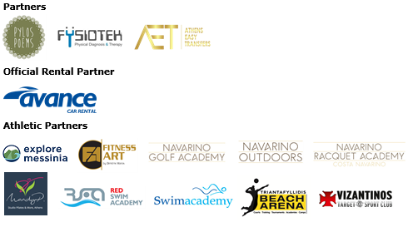
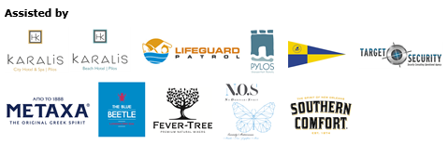



Member of:





Under the Auspices of the Greek National Tourism Organization


Approved by the Hellenic Swimming Federation
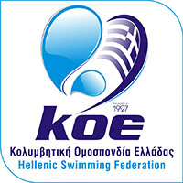

---
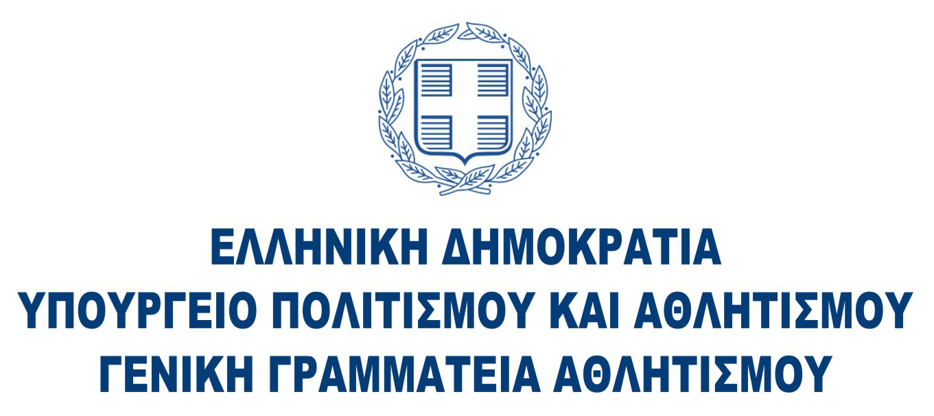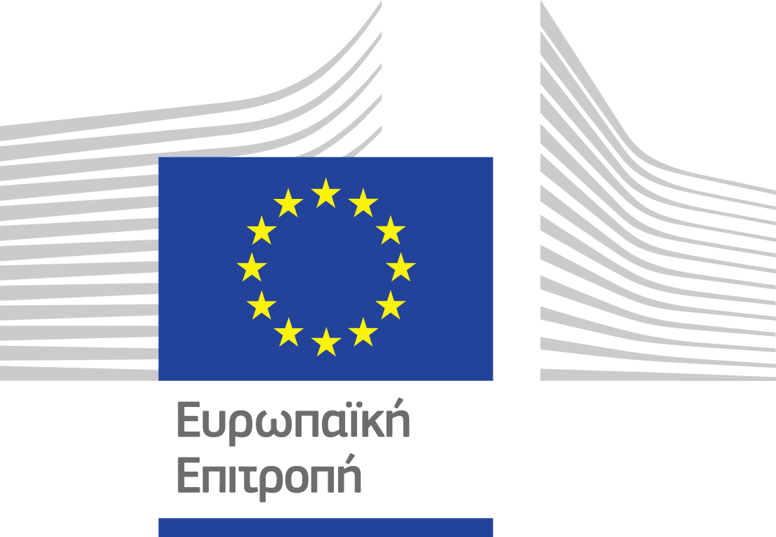

Website: www.navarinochallenge.com
Facebook Page: www.facebook.com/Navarinochallenge
Instagram Page: http://instagram.com/navarinochallenge
Twitter Account: https://twitter.com/NavarinoC
YouTube Channel: http://www.youtube.com/user/NavarinoChallenge

About Costa Navarino
Costa Navarino is the prime, sustainable destination in the Mediterranean, located in the Greek region of Messinia in the southwest Peloponnese. One of the most unspoiled and breathtaking seaside Mediterranean landscapes, this area has been shaped by 4,500 years of history. Its philosophy is driven by a genuine desire to promote Messinia, while protecting and preserving its natural beauty and heritage. It will comprise a number of distinct sites featuring 5-star deluxe hotels, luxury residences, conference facilities, spa and thalassotherapy centres, signature golf courses, as well as a wide range of unique year-round activities for adults and children. Navarino Dunes, the first area, is home to two luxury 5-star hotels, The Romanos, a Luxury Collection Resort and The Westin Resort Costa Navarino; Navarino Residences, a collection of luxury villas for private ownership; The Residences at The Westin Resort Costa Navarino, fully-furnished resort apartments for sale; the signature golf course The Dunes Course, Anazoe Spa, a 4,000m2 spa and thalassotherapy centre; the state-of-the-art conference centre House of Events; specially designed facilities for children; as well as a variety of gastronomy venues, sports, outdoor and cultural activities. Navarino Bay, the second area, is home to the signature golf course, The Bay Course. Navarino Hills, with two 18-hole golf courses, is currently under construction, and there are two further sites underway. Download high resolution photos and logos from the press section in downloads on the website www.costanavarino.com, using the password Nestor.

The Westin Resort Costa Navarino
The Westin Resort has been voted one of the best resorts in Greece and one of the foremost holiday destinations in Europe. In 2017 The Westin Resort Costa Navarino has been voted among the Best Resorts in Europe in Condé Nast Traveler Reader’s Choice Awards. It features an amazing selection of deluxe rooms, family rooms and suites in a privileged seaside location on a verdant hillside that affords an alluring mix of golf, sea and pool views. Voted “Best Family Destination” in the Mediterranean among Starwood Hotels & Resorts, this exceptional 5-star family resort in Greece allows children to choose from an enormous variety of supervised fun activities, tailored specifically for them, at the Cocoon and the SandCastle, giving parents plenty of time to indulge in their own favorite sports or simply unwind. At the Cocoon crèche, infants and toddlers from just 4 months to 3 years old are creatively engaged and encouraged to develop their skills under the supervision of qualified baby nurses and trained staff. Whilst the SandCastle, which offers both recreational and educational activities as well as overnight stay options, is aimed at children aged 4 to 7 and 8 to 12, with specially devised programs for each age group. For more information on The Westin Resort Costa Navarino, please visit www.westincostanavarino.com or follow us on Twitter.

