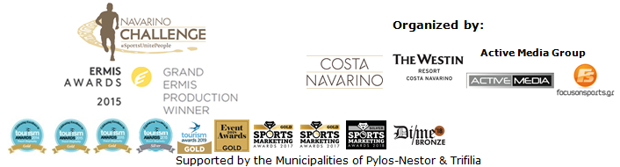
PRESS RELEASE

Sports unite people for a 7th consecutive year

Rowing, swimming and beach sports among activities

Athens, July 25, 2019 – “Navarino Challenge” follows, as every year, the ideals of the Olympic Movement, which is to educate youth through sports, without discrimination and in keeping with the Olympic spirit of fair play. Messinia has started spreading the message “Sports unite people” around the world with the participation of Olympic athletes and hall of famers such as Nick Galis, Olympic silver swimming champion, Spyros Gianniotis as well as participants of all ages and sporting abilities. “Navarino Challenge” will be held for the 7th consecutive year, from 11-13 October 2019, in Messinia and Costa Navarino.

Open water swimming at Pylos
On Saturday October 12, amateur and professional athletes can swim alongside silver Olympic medalist and world champion in open water swimming, Spyros Gianniotis, at the picturesque harbor of Pylos, at the site of the critical naval battle that led to Greece’s independence. The open water swimming race by Vikos, approved by the Hellenic Swimming Federation, covers a unique 1-mile (1.6 km) route charted by Nikos Gemelos, the Greek National coach who has given us countless Olympic and world-class honors in open water swimming.
Check out the following video and enjoy beautiful snapshots from last year’s competition: https://youtu.be/82Q9y_Iiz9Q

Coastal rowing for the first time at “Navarino Challenge”
On Saturday October 12, a coastal rowing relay race and demonstration will be held for the first time at the historic Navarino bay under the auspices of the Hellenic Rowing Federation in the presence of Greek and twice Olympic medalist in lightweight double sculls competition, Vassilis Polymeros (federation’s curator of national teams), who will be honored at this year's event.

Activities for parents and children at The Dunes Beach
The Dunes Beach offers peace and tranquility as well as sporting opportunities for participants at the Navarino Challenge.
Following the enthusiastic participation of children at the beachathlon activities last year, this year parents get to join in the fun too! Under the expert supervision of 400m. obstacle Olympic and World Champion, Periklis Iakovakis, will guide 6-13 year olds and their parents through a series of track and field competitions.

Beach volleyball returns this year with the former Greek national volleyball player who holds the record of appearances in the Greek National Team, Michalis Triantafyllidis. During the weekend, beach volley lessons by Samsung, as well as the Samsung King & Queen Beach Volley Tournament by Triantafyllidis Beach Arena, will be held with Michalis Triantafyllidis.
To wrap up, the advantages of exercise and well-being will benefit children and grown-ups who will be choosing beach yoga by Messinian Spa from FitnessArt of Dimitris Moros, with instructor Katiana Priovolou.
Enjoy some unique moments from the activities to be held at The Dunes Beach in the following video: https://youtu.be/Cu9KOxAWFQU

Accommodation Packages at The Westin Resort Costa Navarino
Navarino Challenge participants who have booked their package at The Westin Resort Costa Navarino, taking part in the main events (running, swimming) will be able to also enjoy the full programme that includes more than 30 sporting activities.
The program includes: boccia with the gold Paralympic medalist Grigoris Polychronidis, pilates lessons with Mandy Persaki, high intensity training for people of all ages by Dimitris Moros & FitnessArt, indoor cycling (team teaching) for people of all ages by the trainer Tess Arlauckas and Dimitris Moros, powered by FitnessArt, baby swimming lessons for kids up to 3 years old by Swim Academy & Red Swim Academy, aqua aerobic lessons by Swim Academy & Red Swim Academy, climbing lessons by the Navarino Outdoors team, bike ride in Voidokilia supported by Navarino Outdoors, as well as golf clinics supported by Navarino Golf Academy.
Free participation in the Authentic Marathon of Athens for the first 50
The first 50 to book their package at The Westin Resort Costa Navarino stand a chance to win a free participation at the Authentic Athens Marathon 5km race on Sunday November 10, 2019.
More information on accommodation packages can be found on:
http://www.navarinochallenge.com/accommodation-packages-2019

Registrations continue for running and swimming
Entries for the award-winning sporting event are underway and interested parties can take part by completing the special form available at the following link: http://activemedia.com.gr/product/navarino-challenge-2019/. Pre-sale is also available online via www.viva.gr or by phone at 11876 as well as at all Viva pre-sale points.

For more information on accommodation packages in the region visit VitaNTravel: http://vitantravel.gr/

Samsung is the official technology partner for another year. Official sponsors of the event are Ford Motor Hellas and the Natural Mineral Water “Vikos”.
Luanvi is the official sports supplier of the event for one more year.
Official supporters are Poseidonia, Municipality of Pylos-Nestor and PlantBox. Messinian Spa is the Official Beauty Partner for the first time. Partners of the event are Pylos Poems, Fysiotek Sports Lab, Karalis Beach Hotel, Athens Easy Transfers.
Avance Rent A Car is the official rental partner.
National Geographic is the strategic partner of the event and 24MEDIA its premium media partner.

“Navarino Challenge” has joined the Greek actions of the #BeactiveHellas 2019 programme of the European Commission and is under the auspices of the General Secretariat of Sports.
The event is held under the auspices of the Greek National Tourism Organization with the approval of the Hellenic Swimming Federation.
Navarino Challenge is co-organized by Costa Navarino, The Westin Resort Costa Navarino and Active Media Group with the support of the Municipalities of Pylos-Nestor and Trifilia.

Athletic Partners: Explore Messinia, F45 The Pearl, FitnessArt, Navarino Golf Academy, Navarino Outdoors, Navarino Racquet Academy, Pilates by Mandy, Red Swim Academy, Swim Academy, Triantafyllidis Beach Arena, Vizantinos target sport club
CSR Partners: Captain Vasilis and Carmen Konstantakopoulos Foundation, WWF Greece, Karkinaki, Institute of Preventive Medicine Environmental and Occupational Health Prolepsis
Assisted by: VitaNTravel, Karalis City Hotel & Spa, Lifeguard Patrol, Pylos Association of Enterprises for Tourism Development, Maritime Athletic Pylos Association “Nestor”, Target Security, Pilia Express, METAXA, The Blue Beetle, Fever-Tree, NoS, Southern Comfort
Discount Partners: Anazoe Spa, Attica Selections, Kessaris, Panellinios Agora Boutique, Tsamis Eyewear Boutique

Hashtags: #navarinochallenge #costanavarino #sportsunitepeople #eatwell #runwell #livewell

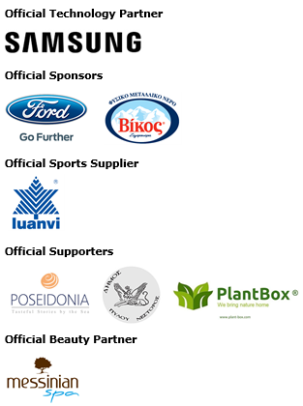

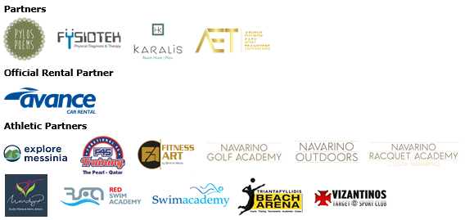

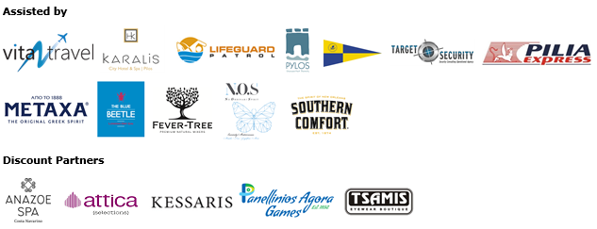





Member of:





Under the Auspices of the Greek National Tourism Organization


Approved by the Hellenic Swimming Federation
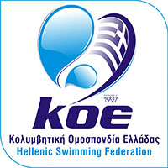

---
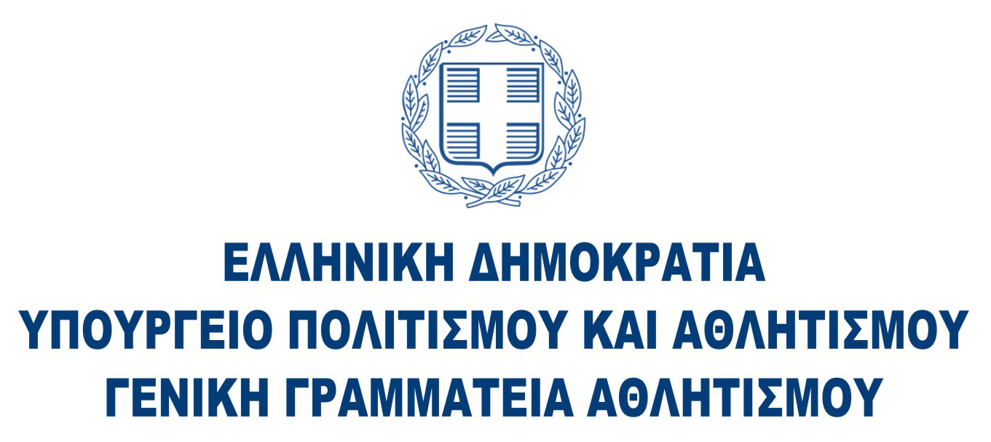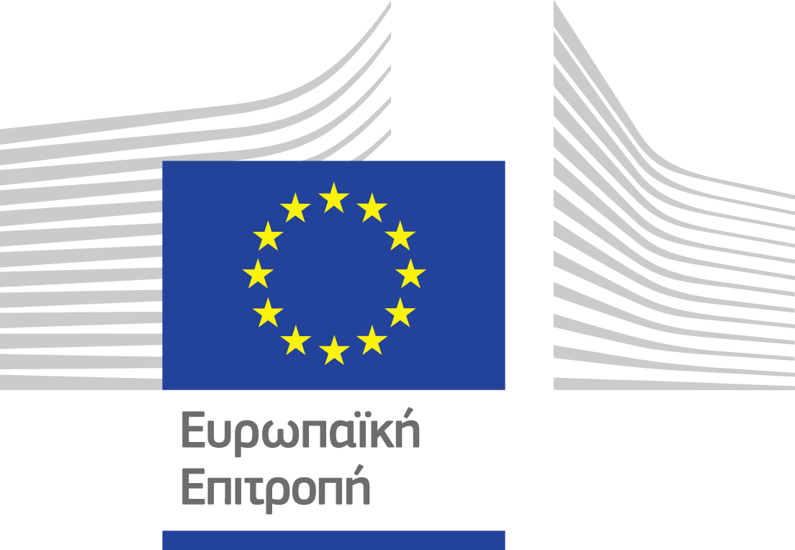

Website: www.navarinochallenge.com
Facebook Page: www.facebook.com/Navarinochallenge
Instagram Page: http://instagram.com/navarinochallenge
Twitter Account: https://twitter.com/NavarinoC
YouTube Channel: http://www.youtube.com/user/NavarinoChallenge

About Costa Navarino
Costa Navarino is the prime, sustainable destination in the Mediterranean, located in the Greek region of Messinia in the southwest Peloponnese. One of the most unspoiled and breathtaking seaside Mediterranean landscapes, this area has been shaped by 4,500 years of history. Its philosophy is driven by a genuine desire to promote Messinia, while protecting and preserving its natural beauty and heritage. It will comprise a number of distinct sites featuring 5-star deluxe hotels, luxury residences, conference facilities, spa and thalassotherapy centres, signature golf courses, as well as a wide range of unique year-round activities for adults and children. Navarino Dunes, the first area, is home to two luxury 5-star hotels, The Romanos, a Luxury Collection Resort and The Westin Resort Costa Navarino; Navarino Residences, a collection of luxury villas for private ownership; The Residences at The Westin Resort Costa Navarino, fully-furnished resort apartments for sale; the signature golf course The Dunes Course, Anazoe Spa, a 4,000m2 spa and thalassotherapy centre; the state-of-the-art conference centre House of Events; specially designed facilities for children; as well as a variety of gastronomy venues, sports, outdoor and cultural activities. Navarino Bay, the second area, is home to the signature golf course, The Bay Course. Navarino Hills, with two 18-hole golf courses, is currently under construction, and there are two further sites underway. Download high resolution photos and logos from the press section in downloads on the website www.costanavarino.com, using the password Nestor.

The Westin Resort Costa Navarino
The Westin Resort has been voted one of the best resorts in Greece and one of the foremost holiday destinations in Europe. In 2017 The Westin Resort Costa Navarino has been voted among the Best Resorts in Europe in Condé Nast Traveler Reader’s Choice Awards. It features an amazing selection of deluxe rooms, family rooms and suites in a privileged seaside location on a verdant hillside that affords an alluring mix of golf, sea and pool views. Voted “Best Family Destination” in the Mediterranean among Starwood Hotels & Resorts, this exceptional 5-star family resort in Greece allows children to choose from an enormous variety of supervised fun activities, tailored specifically for them, at the Cocoon and the SandCastle, giving parents plenty of time to indulge in their own favorite sports or simply unwind. At the Cocoon crèche, infants and toddlers from just 4 months to 3 years old are creatively engaged and encouraged to develop their skills under the supervision of qualified baby nurses and trained staff. Whilst the SandCastle, which offers both recreational and educational activities as well as overnight stay options, is aimed at children aged 4 to 7 and 8 to 12, with specially devised programs for each age group. For more information on The Westin Resort Costa Navarino, please visit www.westincostanavarino.com or follow us on Twitter.

