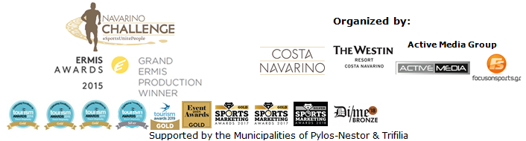
PRESS RELEASE

Navarino Challenge 2019 – a programme with more than 30 sports activities

Nick Galis & Dean Karnazes – two great Greek athletes partner with Navarino Challenge

Athens, August 29, 2019 – “Navarino Challenge” will be held for the 7th consecutive year, from 11-13 October 2019, in Messinia and Costa Navarino, honouring basketball legend Nick Galis and the event’s main ambassador, the Greek-American ultramarathoner Dean Karnazes, who will participate in the half marathon and run alongside children on the 1km route.

The event’s athletic partners will offer more than 30 sporting activities, showcasing Navarino Challenge as the top multi-sport event. This year’s programme features among others:

Boxing
The Olympic sport and one of the most beloved sports for ancient Greeks, will take center stage this year. As part of the event, lessons will be held for participants of all ages by boxing champion Christos Gatsis and the Vizantinos Target Sport Club.

Crossfit
Crossfit training will enhance the fitness of the event’s participants through lessons by expert personal trainer Dimitris Moros and FitnessArt.
Partnership with F45 The Pearl in Qatar
For the first time, the event will partner with Europe’s top fitness centers, F45, to create special packages for those who wish to travel from Qatar’s Pearl, via Doha, and participate in the Navarino Challenge while training at The Westin Resort Costa Navarino.

Karate - with a World Champion
Karate, which will feature for the first time at the Tokyo Olympic Games 2020, will be introduced in the Navarino Challenge programme. Coaches of the Pammesiniakos Athletic Club Karate will conduct lessons and World karate champion Eleni Chatziliadou, one of the guests of honour at the 2019 Navarino Challenge, will be present to promote the sport.

Kick Boxing
The dynamic sport of kick boxing will be part of the event’s schedule yet again, with lessons by martial arts champion Alexandros Nikolaidis.

TaeKwonDo
Two-times Olympic silver medalist and a top athlete who dominated the sport from 2000 to 2012, Alexandros Nikolaidis will introduce TaeKwonDo lessons to enthusiastic teams and children from Messinia.

Tennis
The much-loved sport will be held once again with the support of the Navarino Racquet Academy. With the experience of the Panellinios Agora Games, a company that innovates in Greek tennis, beginners will have the opportunity to try Tennis Cross Training, a fitness programme that combines Tennis and Cross Training.

Watch the following video and enjoy beautiful moments from the event’s dynamic activities: https://youtu.be/lWKDOIn7yLE

Programme
For more information on the detailed event programme, click on the following link: http://www.navarinochallenge.com/event-2019/schedule-2019/

Offers
Participants at the 7th Navarino Challenge will have the opportunity to enjoy special discounts from sponsors and discount partners of the event during their stay at The Westin Resort Costa Navarino. To view current offers, please click here: http://www.navarinochallenge.com/event-2019/offers-2019

Accommodation Packages at The Westin Resort Costa Navarino
More information on accommodation packages can be found at:
http://www.navarinochallenge.com/accommodation-packages-2019

Registrations continue for running and swimming
Entries for the award-winning sporting event are underway and interested parties can take part by completing the special form available at the following link: http://activemedia.com.gr/product/navarino-challenge-2019/. Pre-sale is also available online via www.viva.gr or by phone at 11876 as well as at all Viva pre-sale points.

For more information on accommodation packages in the region visit VitaNTravel: http://vitantravel.gr/

Samsung is the official technology partner for another year. Official sponsors of the event are Ford Motor Hellas and the Natural Mineral Water “Vikos”.
Luanvi is the official sports supplier of the event for one more year.
Nutramins is the official health supporter of the event.
Official supporters are Poseidonia, Municipality of Pylos-Nestor and PlantBox. Messinian Spa is the Official Beauty Partner for the first time. Partners of the event are Pylos Poems, Fysiotek Sports Lab, Karalis Beach Hotel, Athens Easy Transfers.
Avance Rent A Car is the official rental partner.
National Geographic is the strategic partner of the event and 24MEDIA its premium media partner.
All event’s equipment transfers will be made with Pilia Express.

“Navarino Challenge” supports: a) the Institute of Preventive Medicine, Environmental and Occupational Health, Prolepsis with a program on Food Aid and Promotion of Healthy Nutrition, DIATROFI, and through the Captain Vasilis and Carmen Konstantakopoulos Foundation: b) WWF Greece and c) Karkinaki, through the GivenGain online platform: https://bit.ly/33KTNhD

“Navarino Challenge” has joined the Greek actions of the #BeactiveHellas 2019 programme of the European Commission and is held under the auspices of the General Secretariat of Sports.
The event is held under the auspices of the Greek National Tourism Organization with the approval of the Hellenic Swimming Federation.
Navarino Challenge is co-organized by Costa Navarino, The Westin Resort Costa Navarino and Active Media Group with the support of the Municipalities of Pylos-Nestor and Trifilia.

Athletic Partners: Explore Messinia, F45 The Pearl, FitnessArt, Navarino Golf Academy, Navarino Outdoors, Navarino Racquet Academy, Pilates by Mandy, Red Swim Academy, Swim Academy, Triantafyllidis Beach Arena, Vizantinos target sport club
CSR Partners: Captain Vasilis and Carmen Konstantakopoulos Foundation, WWF Greece, Karkinaki, Institute of Preventive Medicine Environmental and Occupational Health Prolepsis
Volunteering Partner: Phaos
Assisted by: VitaNTravel, Karalis City Hotel & Spa, Lifeguard Patrol, Pylos Association of Enterprises for Tourism Development, Maritime Athletic Pylos Association “Nestor”, Target Security, Pilia Express, METAXA, The Blue Beetle, Fever-Tree, NoS, Southern Comfort
Discount Partners: Anazoe Spa, Attica Selections, Kessaris, Panellinios Agora Games, Tsamis Eyewear Boutique

Hashtags: #navarinochallenge #costanavarino #sportsunitepeople #eatwell #runwell #livewell

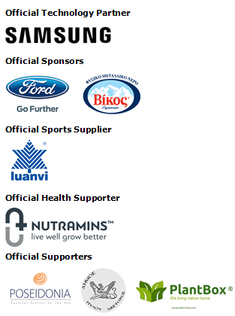
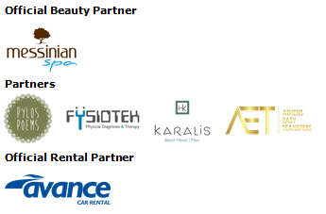
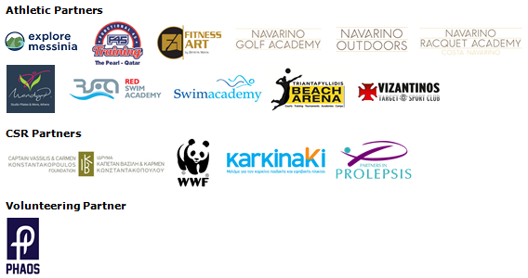
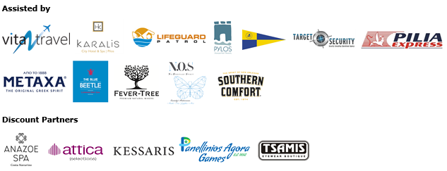

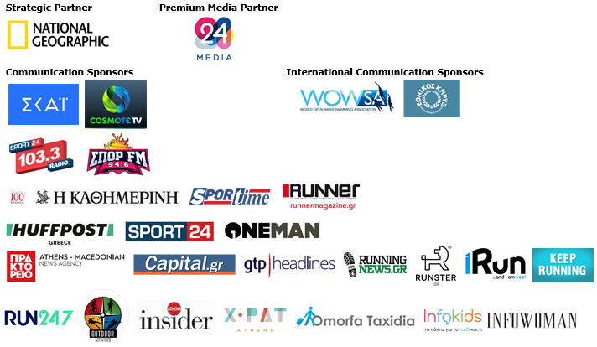



Member of:

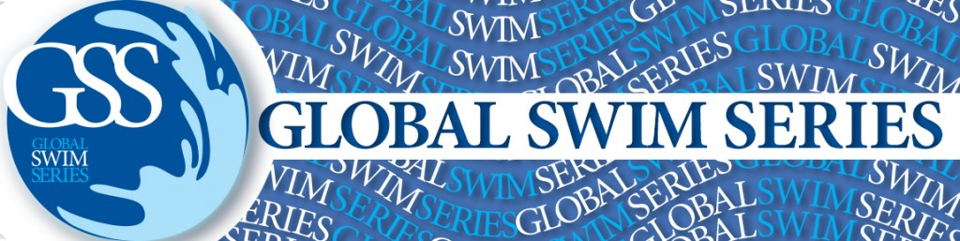



Under the Auspices of the Greek National Tourism Organization


Approved by the Hellenic Swimming Federation
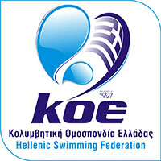

---
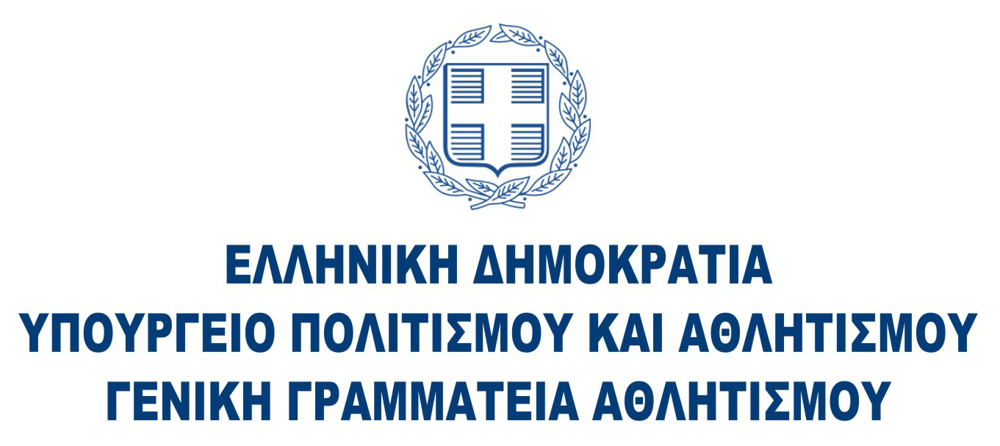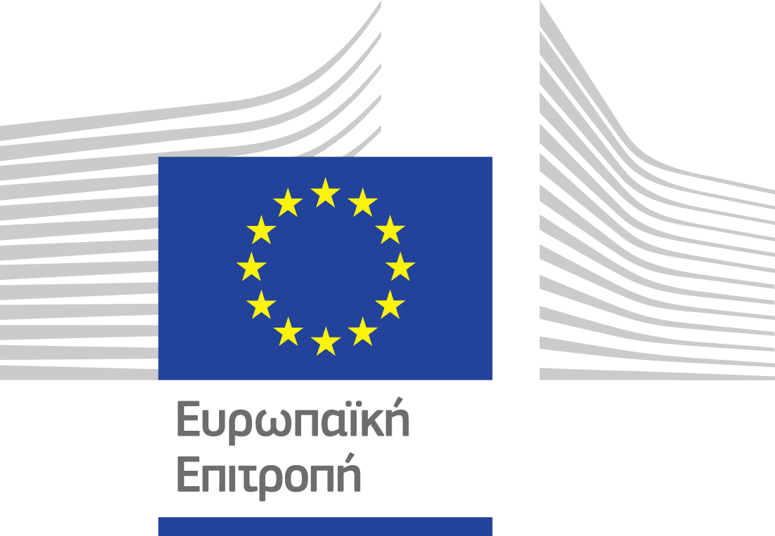

Website: www.navarinochallenge.com
Facebook Page: www.facebook.com/Navarinochallenge
Instagram Page: http://instagram.com/navarinochallenge
Twitter Account: https://twitter.com/NavarinoC
YouTube Channel: http://www.youtube.com/user/NavarinoChallenge

About Costa Navarino
Costa Navarino is the prime, sustainable destination in the Mediterranean, located in the Greek region of Messinia in the southwest Peloponnese. One of the most unspoiled and breathtaking seaside Mediterranean landscapes, this area has been shaped by 4,500 years of history. Its philosophy is driven by a genuine desire to promote Messinia, while protecting and preserving its natural beauty and heritage. It will comprise a number of distinct sites featuring 5-star deluxe hotels, luxury residences, conference facilities, spa and thalassotherapy centres, signature golf courses, as well as a wide range of unique year-round activities for adults and children. Navarino Dunes, the first area, is home to two luxury 5-star hotels, The Romanos, a Luxury Collection Resort and The Westin Resort Costa Navarino; Navarino Residences, a collection of luxury villas for private ownership; The Residences at The Westin Resort Costa Navarino, fully-furnished resort apartments for sale; the signature golf course The Dunes Course, Anazoe Spa, a 4,000m2 spa and thalassotherapy centre; the state-of-the-art conference centre House of Events; specially designed facilities for children; as well as a variety of gastronomy venues, sports, outdoor and cultural activities. Navarino Bay, the second area, is home to the signature golf course, The Bay Course. Navarino Hills, with two 18-hole golf courses, is currently under construction, and there are two further sites underway. Download high resolution photos and logos from the press section in downloads on the website www.costanavarino.com, using the password Nestor.

The Westin Resort Costa Navarino
The Westin Resort has been voted one of the best resorts in Greece and one of the foremost holiday destinations in Europe. In 2017 The Westin Resort Costa Navarino has been voted among the Best Resorts in Europe in Condé Nast Traveler Reader’s Choice Awards. It features an amazing selection of deluxe rooms, family rooms and suites in a privileged seaside location on a verdant hillside that affords an alluring mix of golf, sea and pool views. Voted “Best Family Destination” in the Mediterranean among Starwood Hotels & Resorts, this exceptional 5-star family resort in Greece allows children to choose from an enormous variety of supervised fun activities, tailored specifically for them, at the Cocoon and the SandCastle, giving parents plenty of time to indulge in their own favorite sports or simply unwind. At the Cocoon crèche, infants and toddlers from just 4 months to 3 years old are creatively engaged and encouraged to develop their skills under the supervision of qualified baby nurses and trained staff. Whilst the SandCastle, which offers both recreational and educational activities as well as overnight stay options, is aimed at children aged 4 to 7 and 8 to 12, with specially devised programs for each age group. For more information on The Westin Resort Costa Navarino, please visit www.westincostanavarino.com or follow us on Twitter.

