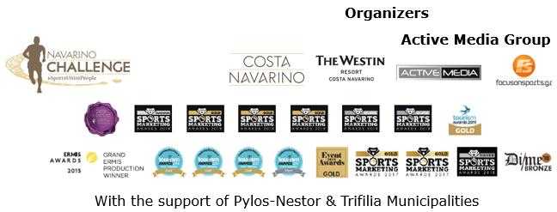

PRESS RELEASE

Navarino Challenge 2019: 2,700 participations from 40 countries in the biggest sports tourism celebration

Nick Galis guest of honour – with the presence of the Minister of Tourism & the Deputy Minister of Culture & Sports

Athens, October 17, 2019 – The award-winning Navarino Challenge, united according to its central message “Sports Unite People”, people of all ages for the 7th consecutive year from 11-13 October 2019 in Messinia and Costa Navarino.

More than 2,700 participants of all ages enjoyed, the ideal weather conditions, with a rich program of more than 30 activities. The event, hosted by The Westin Resort Costa Navarino was recently recognized as the best sports event in Greece and supported the ideals of the Olympic Movement, contributing towards the development of a peaceful and better world without any discrimination, through sports.

The wellness event promoted the benefits of exercise and raised awareness on the Mediterranean diet, towards the fight against childhood obesity. Furthermore, considering the global issue of inactivity of youth, the event exhorted young people to get involved in games and sports, through the Active Kids program, by adding even more kids’ activities. Navarino Challenge brought together athletes, families and children from 40 countries, including among others, Australia, Canada, Denmark, Finland, France, Germany, India, Italy, Lebanon, Netherlands, Moldavia, Norway, Portugal, Qatar, Russia, Spain, Sweden, United Arab Emirates, United Kingdom, Ukraine, USA.

The full schedule of the event included activities for the whole family. On Friday, October 11, Greek Hall of Fame basketball athlete Nick Galis, this year’s guest of honour, was the one to tip off the 4on4 basketball tournament by Nutramins that was held with the participation of the basketball legend Joe Arlaouckas and twice silver Olympic medalist Alexandros Nikolaidis. The day continued with many sports activities and ended with the screening of Barney Spender and Roddy Gibson’s award-winning documentary “The Road to Sparta” at the Agora, Costa Navarino.

Messinia at the center of sports tourism
On Saturday, October 12 sport action was held in the Municipality of Pylos-Nestor that supported the event for another year and helped in the smooth implementation of the activities at Navarino Bay with the assistance of local companies. For the first time in the event, participants had the opportunity to try sea kayaking and headed to the island of Sphacteria with the support of Explore Messinia.

Right after, open water swimming enthusiasts had the chance to compete in a chip-timed event at the beautiful Navarino bay from the scenic Pylos harbor, covering the unique 1 mile (1.6 km) route of the open water swimming race by Vikos. The swimming event was held with absolute safety with the approval of the Hellenic Swimming Federation, according to FINA’s regulations and the support of Pylos Hellenic Coast Guard and Pylos-Nestor Municipality.
The route was designed by the national federal technical coach, Nikos Gemelos.

Silver Olympic medalist in open water swimming Spyros Gianniotis, world champion Kelly Araouzou, European champion George Arniakos and significant athletes of the Greek National Open Water Swimming Team participated in this year’s race, in the presence of Pylos-Nestor Mayor, Takis Karvelas.
Lifeguard Patrol, Pilos Dive Center group of divers and event’s medical partner Athens Medical Group ensured the safety of the swimming race.

“Challenge The Wind” interclub sailing race of triangle course with OPTIMIST and LASER 4.7 boats was co-organized with the Maritime Athletic Pylos Association “Nestor”.
The sea actions also marked the beginning of the “Navarinia” event for the 192-year anniversary from the Battle of Navarino, which will culminate this week.

In addition, Pylos came alive with local flavors and scents. A station with traditional lalagia, loukoums, sesame seed bars and nuts with honey, created by Poseidonia and Pylos Poems welcomed visitors.
A visit to the refurbished family home of the Olympic champion, Kostis Tsiklitiras, was held with the presence of Olympic medalist Spyros Gianniotis.
All water sports were also supported by the following partners: Poseidonia, Pylos Association of Enterprises for Tourism Development, Karalis Beach Hotel, Karalis City Hotel & Spa.

On Saturday night, the official airline Qatar Airways welcomed guests on the special night “A Night to Remember by Qatar Airways”. In the presence of Minister of Tourism, Mr. Harry Theocharis and Deputy Minister of Culture and Sports, Mr. Lefteris Avgenakis, Qatar Airways honored great personalities of the sports industry. In particular, the Greek hall of famer Nick Galis was honored for his contribution in sports by Mrs. Costantza Sbokou-Constantakopoulou on behalf of TEMES, along with the Minister of Tourism, the Deputy Minister of Culture & Sports and Mrs. Theresa Cissell, Country Manager for Greece & Cyprus of Qatar Airways. The Greek-American ultramarathon runner and event’s ambassador Dean Karnazes, was awarded by the Minister of Tourism. Greek gold Paralympic medalist and world champion in boccia Grigoris Polychronidis was awarded by Mr. Byung Moo (Theofilos) Shin, President & Chief Executive Officer of Samsung Electronics Hellas. Silver Olympic medalist Spyros Gianniotis was awarded by the Deputy Minister of Culture and Sports, while journalists Minas Tsamopoulos and George Thanailakis undertook the presentation of the athlete and the award. Twice Olympic medalist in rowing, Vassilis Polymeros, was awarded by Ms. Petri Logara, Operations Manager of Ford Motor Hellas. World karate champion Eleni Chatziliadou was awarded by Country Manager for Greece & Cyprus of Qatar Airways, while bronze medalist in sailing world championship Maria Tsamopoulou was awarded by Mr. Stefanos Theodorides Managing Director of TEMES. The event was presented by Joe Arlauckas, under the rhythms of the Pylos Conservatory duet.

Qatar Airways Puzzle Challenge contest continues
Qatar Airways surprised participants with the Puzzle Challenge competition created through a special application.The contest continues until October 21st with a gift of two round-trip airline tickets to over 160 places across the globe on Qatar Airways’ global network. “A Night to Remember by Qatar Airways” was assisted by Kayak, Karoulias, Lafazanis, Nestor, while the specially designed awards of the event, were created by PHEE and Nestor Winery.

On Sunday, October 13, professional and amateur runners tested their skills on the routes of 5km by Samsung (running & dynamic walking), 10km by PlantBox and Ford Go Further Greek Half-Marathon (21.1km). The Half-Marathon route is described by runners as one of the most beautiful around the world, whereas the 5km route was the one that really impressed participants. Navarino Challenge was included in World’s Marathons world community with runners from the Sport Club with people with special needs from Kalamata, “Diaforozo”, celebrating their participation at the event one day before the International White Cane Day (October 15th). The routes were designed by the former marathon runner, holder of national best performance on the classical route, running coach and director of All About Running, Nikos Polias. During the event, all participants were timed. All running races are co-organized with Messiniakos Gymnastic Club, EAS SEGAS Peloponnese Region and the approval of the Hellenic Athletics Federation [SEGAS]. Hellenic Rescue Team – Messinia Department and the event’s medical partner, Athens Medical Group, ensured the safety of the races.

Later on, the children’s 1km race (supported by VIKOS) took place, with the dynamic presence of children from the wider region as well as clubs such as Messiniakos, GC Akritas 2016 and Pylos Maritime Sports Club.

Aiming to the protection of the environment and the adoption of a more eco-friendly strategy, the event proceeded with the following actions, among others: a) declared the start and end points of the Navarino Dunes runways as strictly smoke-free areas, b) declared the beautiful Voidokilia beach, which the runners crossed, as strictly plastic-free, c) offered participants an eco-friendly bag by Luanvi, event’s official sports supplier.

The first sports event worldwide with a medal made of seagrass
The event innovated with another surprise. This year's participants received a medal made only of seagrass from the event’s official supporter, PHEE, a company that innovates by promoting the principles of “green” entrepreneurship and the re-use of natural resources.
Moreover, the event offered each participant an olive tree by PlantBox. At the same time, all participants received high quality cosmetics be Messinian Spa.

As the official sports supplier of Navarino Challenge, LUANVI, the leading force in the field of sports apparel offered once again the official t-shirt of the event (made 100% of cotton). A special technical t-shirt for the participants, that as of last year contains elements from Messinia to enhance the feeling of remembering and unforgettable experience in order to highlight the cultural elements of the area. With this criterion in mind, the ancient symbol rodakas, found also during the Byzantine period whilst dominating Messinian life in ancient Greece, appeared on the t-shirt this year. At the same time finishers of the Ford Go Further half marathon, with great attendance and the participation of Dean Karnazes, received a special t-shirt with the design of Voidokilia.

The event innovated for yet another year alongside Samsung, official technology partner. During the running routes, participants had the chance to try the next-gen Galaxy Fit, tracking live their fitness stats, like cardiac pulse and timing in just one touch without missing a moment from their performance.
Meanwhile, Samsung assisted in achieving the zero footprint of the event, contributing to a paperless registration with the use of the innovatory Galaxy Tab S6.
During the event, Samsung created a special Samsung Βusiness Lounge providing participants of Navarino Challenge with endless entertainment, while informing them on the ultimate business solution of the company, the Samsung Dex. Participants also got to know the powerhouses of smartphones Galaxy Note10 | Note 10+, enjoyed the unparalleled picture of Samsung QLED 8K TV, the cinematic experience of Samsung 4K Smart QLED TV, the use of the QLED Gaming Monitor and browsed the multiple functions of the interactive Flip monitor.

Unique piece of art in Navarino Challenge
A special surprise from Samsung awaited participants of Navarino Challenge, with the exceptional artwork of artist Nathan Makris, that depicted top athletes, Nick Galis, Spiros Gianniotis, Alexandros Nikolaidis, Grigoris Polychronidis, Periklis Iakovakis and Dean Karnazes. Visitors had the opportunity to take a picture with them and post their photos on social media.

The three-day schedule included activities such as: taekwondo (with Olympic medalist Alexandros Nikolaidis and the numerous participations of TaeKwonDo teams from Kyparissia), basketball (with Joe Arlauckas), beachathlon (with Olympic and World Champion, Periklis Iakovakis), beach volley lessons by Samsung and King & Queen Beach Volley Tournament by Samsung (with Michalis Triantafyllidis and supported by Triantafyllidis Beach Arena), climbing and bike ride at Voidokilia by HSBC (supported by Navarino Outdoors), pilates (with physical education instructor, Mandy Persaki), golf by Qatar Airways (supported by Navarino Golf Academy and instructor Adam Kritikos), kick boxing (with champion Alexandros Nikolaidis), baby swimming (supported by Swim Academy and Red Swim Academy), group cycling (spinning challenge with trainer Tess Arlauckas from F45 The Pearl and Dimitris Moros from FitnessArt), tennis cross training (supported by Navarino Racquet Academy), boxing (with Christos Gatsis and supported by Vizantinos target sport club), high intensity training and crossfit (with Dimitris Moros and supported by FitnessArt), F45 training (from trainers Tess Arlauckas and Scott Hettermann – F45 The Pearl, Doha), beach yoga by Messinian Spa (with Katiana Priovolou and the support of FitnessArt), karate (from the coaches of Pammessiniakos Karate Sports Club and the presence of the World Karate Champion Eleni Chatziliadou) and boccia demonstration by Samsung (from Gold Paralympic athlete, Grigoris Polychronidis)

Ford Motor Hellas promoted sports and “fair play” as the event’s official sponsor and supported the efforts of the fight against childhood obesity while promoting healthy diet by participating for another year in the support team of Navarino Challenge. For the sixth consecutive year, athletes and organizers moved with the safety and efficient engines of the cars of Ford Motor Hellas, while the brand-new Ford Ranger Raptor was present too in Navarino Challenge 2019!

For another year Vikos SA as an official sponsor spread the message of sporting energy with the natural mineral water “Vikos”, offering the necessary hydration and revitalization to all participants. The natural mineral water “Vikos” offers the necessary balance, well-being and energy that the athletes need during their exercise in order to be able to continue their efforts.

More than 250 people worked in the event’s production in less than 50 hours.

“Navarino Challenge” supports: a) the Institute of Preventive Medicine, Environmental and Occupational Health, Prolepsis with a program on Food Aid and Promotion of Healthy Nutrition, DIATROFI, and through the Captain Vasilis and Carmen Konstantakopoulos Foundation: b) WWF Greece and c) Karkinaki, through the GivenGain online platform: https://bit.ly/33KTNhD

Qatar Airways was the official airline.
Samsung was the official technology partner for another year. Official sponsors of the event were Ford Motor Hellas and the Natural Mineral Water “Vikos”.
Luanvi was the official sports supplier of the event for one more year.
Nutramins was the official health supporter of the event.
Official supporters were Poseidonia, PlantBox, PHEE and Municipality of Pylos-Nestor.
HSBC was the official banking partner. Messinian Spa was the Official Beauty Partner for the first time. ON was the official shoe partner. Athens Medical Group was the event’s medical partner. Partners of the event were Pylos Poems, Fysiotek Sports Lab, Karalis Beach Hotel, Athens Easy Transfers.
Avance Rent A Car was the official rental partner.
National Geographic was the strategic partner of the event and 24MEDIA its premium media partner.
All event’s equipment transfers were made with Pilia Express.

Athletic Partners: Explore Messinia, F45 The Pearl, FitnessArt, Navarino Golf Academy, Navarino Outdoors, Navarino Racquet Academy, Pilates by Mandy, Red Swim Academy, Swim Academy, Triantafyllidis Beach Arena, Vizantinos target sport club
CSR Partners: Captain Vasilis and Carmen Konstantakopoulos Foundation, WWF Greece, Karkinaki, Institute of Preventive Medicine Environmental and Occupational Health Prolepsis
Volunteering Partner: Phaos
Assisted by: VitaNTravel, Karalis City Hotel & Spa, Lifeguard Patrol, Pylos Association of Enterprises for Tourism Development, Maritime Athletic Pylos Association “Nestor”, Target Security, Pilia Express, Kayak, Nestor, Blackmile, Epathlon, METAXA, The Blue Beetle, Fever-Tree, NoS, Southern Comfort
Discount Partners: Anazoe Spa, Armyra, Attica Selections, Bio & Pharma, Branco, Kafenio & Deli, Kessaris, Kooc Taverna Secrets, Lol the brand, Nargile, Panellinios Agora Games, Souvlakerie, The Diner, Tsamis Eyewear Boutique

“Navarino Challenge” joined the Greek actions of the #BeactiveHellas 2019 programme of the European Commission and was held under the auspices of the General Secretariat of Sports.
The event was held under the auspices of the Greek National Tourism Organization with the approval of the Hellenic Swimming Federation.
Navarino Challenge was co-organized by Costa Navarino, The Westin Resort Costa Navarino and Active Media Group with the support of the Municipalities of Pylos-Nestor and Trifilia.

Hashtags: #navarinochallenge #costanavarino #sportsunitepeople #eatwell #runwell #livewell

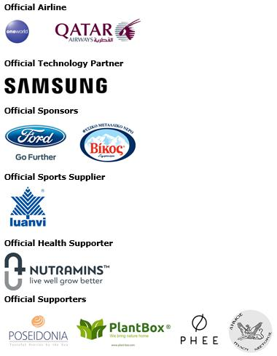
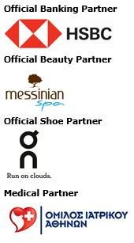
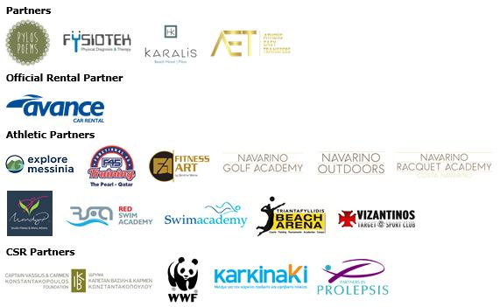
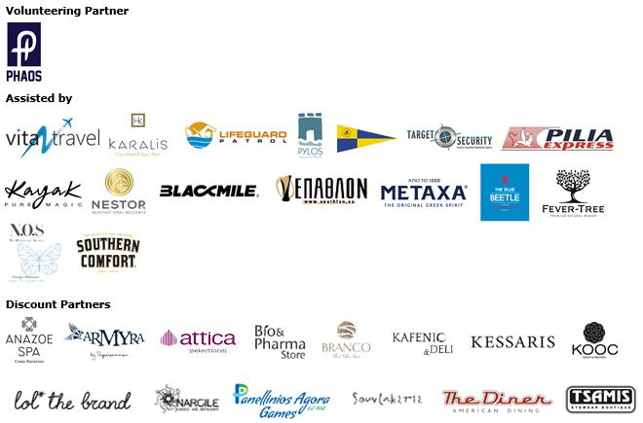

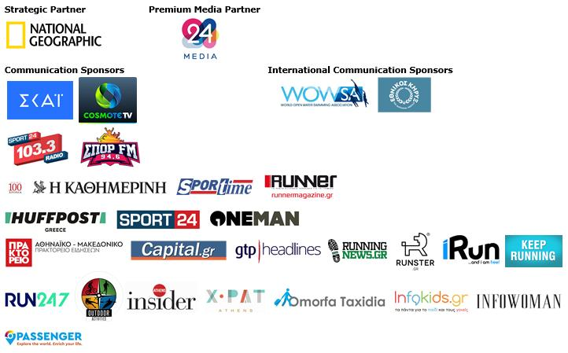

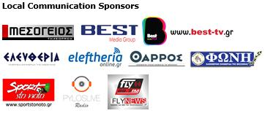

Member of:





Under the Auspices of the Greek National Tourism Organization


Approved by the Hellenic Swimming Federation
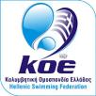

Under the Auspices of the Hellenic Rowing Federation

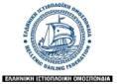

All running races are co-organized with Messiniakos Gymnastic Club, EAS SEGAS Peloponnese Region and the approval of the Hellenic Athletics Federation [SEGAS]
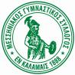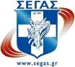

---
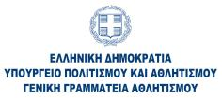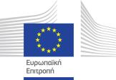

Website: www.navarinochallenge.com
Facebook Page: www.facebook.com/Navarinochallenge
Instagram Page: http://instagram.com/navarinochallenge
Twitter Account: https://twitter.com/NavarinoC
YouTube Channel: http://www.youtube.com/user/NavarinoChallenge

About Costa Navarino
Costa Navarino is the prime, sustainable destination in the Mediterranean, located in the Greek region of Messinia in the southwest Peloponnese. One of the most unspoiled and breathtaking seaside Mediterranean landscapes, this area has been shaped by 4,500 years of history. Its philosophy is driven by a genuine desire to promote Messinia, while protecting and preserving its natural beauty and heritage. It will comprise a number of distinct sites featuring 5-star deluxe hotels, luxury residences, conference facilities, spa and thalassotherapy centres, signature golf courses, as well as a wide range of unique year-round activities for adults and children. Navarino Dunes, the first area, is home to two luxury 5-star hotels, The Romanos, a Luxury Collection Resort and The Westin Resort Costa Navarino; Navarino Residences, a collection of luxury villas for private ownership; The Residences at The Westin Resort Costa Navarino, fully-furnished resort apartments for sale; the signature golf course The Dunes Course, Anazoe Spa, a 4,000m2 spa and thalassotherapy centre; the state-of-the-art conference centre House of Events; specially designed facilities for children; as well as a variety of gastronomy venues, sports, outdoor and cultural activities. Navarino Bay, the second area, is home to the signature golf course, The Bay Course. Navarino Hills, with two 18-hole golf courses, is currently under construction, and there are two further sites underway. Download high resolution photos and logos from the press section in downloads on the website www.costanavarino.com, using the password Nestor.

The Westin Resort Costa Navarino
The Westin Resort has been voted one of the best resorts in Greece and one of the foremost holiday destinations in Europe. In 2017 The Westin Resort Costa Navarino has been voted among the Best Resorts in Europe in Condé Nast Traveler Reader’s Choice Awards. It features an amazing selection of deluxe rooms, family rooms and suites in a privileged seaside location on a verdant hillside that affords an alluring mix of golf, sea and pool views. Voted “Best Family Destination” in the Mediterranean among Starwood Hotels & Resorts, this exceptional 5-star family resort in Greece allows children to choose from an enormous variety of supervised fun activities, tailored specifically for them, at the Cocoon and the SandCastle, giving parents plenty of time to indulge in their own favorite sports or simply unwind. At the Cocoon crèche, infants and toddlers from just 4 months to 3 years old are creatively engaged and encouraged to develop their skills under the supervision of qualified baby nurses and trained staff. Whilst the SandCastle, which offers both recreational and educational activities as well as overnight stay options, is aimed at children aged 4 to 7 and 8 to 12, with specially devised programs for each age group. For more information on The Westin Resort Costa Navarino, please visit www.westincostanavarino.com or follow us on Twitter.

