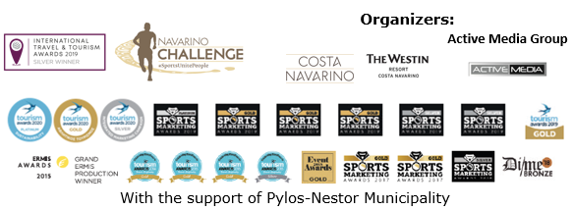
PRESS RELEASE

Navarino Challenge: Platinum at 2020 Tourism Awards

Special prices on Half Marathon registrations until 31/7

Athens, June 4, 2020 – The award-winning sports tourism event returns for the 8th consecutive year on October 16-18, 2020 in Messinia, Pylos and Costa Navarino.
Through its global message “sports unite people”, the event will offer the opportunity of discovering the magic of the Messinian landscape and the history highlighted by the top sports celebration, to people of all ages from Greece and abroad.

Participants will have a chance of running one of the top 21.1km Greek Half Marathons, along with Greek-American ultramarathon Dean Karnazes. In addition, they can choose between the 10km route or the joyful 5km route which is also suited for dynamic walking. Athletes starting from the Navarino Dunes of Costa Navarino, will run along the picturesque coast towards Pylos and cross the magnificent Voidokilia beach, while passing by the Gialova lagoon. This is one of the most significant wetlands in Europe. It is the southernmost station of migratory birds in the Balkans to and from Africa that has been designated as a Natura 2000 nature protected area. The Half Marathon is the only trail running route in Greece that combines soil, sand and asphalt. The event offers race timing for all runners. All races are co-organized with Messiniakos Gymnastic Club and EAS SEGAS Peloponnese Region.
On the same day, the 1km children’s race will be held in two groups, for children 10-14 years old & kids up to 9 years of age.
The impressive 5km route that emerges by the sea as well as all other routes, have been planned by the former marathon runner, current classic marathon course national record holder, running coach and director of All About Running, Nikos Polias.

The top sports tourism event in Greece
Navarino Challenge has remained at the forefront of the 2020 Tourism Awards, claiming the highest distinction in Greek tourism by winning the Platinum Award in the Sustainability category. The significant accolades received by the event, also include the Gold Award, once more, in the Sports Tourism category and the Silver Award in the Integrated Marketing Campaign category. The Platinum award is the first one to be received by a sports tourism event in Greece.
Distinctions do not stop for one of the top sports tourism events in Europe since it was also the first sports tourism event in Greece to win an award in the “Best In Wellness” category at the International Travel & Tourism Awards by WTM London last year.

In the context of this year’s recognition, Active Media Group Chief Executive Officer, Mr. Akis Tsolis stated: “Our most recent distinction highlights the innovative sustainability initiatives that we have implemented in a sports tourism event, for the first time in Greece. Our excellent collaboration with Costa Navarino, all cooperating bodies, the Municipality of Pylos-Nestor, businessmen from Pylos and Messinia as well as our sponsors, indicates more than ever, the importance and value of solid strategic relations. Despite the unprecedented conditions we are experiencing, sports tourism is not only an integral part of the Greek tourism product, that we all need to protect, but something even more valuable for the future. There is considerable room for growth in outdoor sporting activities, which promote economic and social development for local communities, while highlighting the unique cultural elements of each place”.

Early bird - Refund offer
Runners can act promptly and take advantage of the early bird offer on registrations until July 31. Athletes can register in the Half Marathon with a 40% discount and find out about valid early bird offers in all other routes. Children’s race is held at no cost. The event, always prioritizing the participants themselves, offers a refund of their registration costs until August 31. Entries for the award-winning sporting event are underway and interested parties can participate by completing the available form through the following link: https://www.myrace.gr/event/2409/registrations.html

More information on premium accommodation packages will be announced in the coming weeks.

Special offer from the event’s official technology partner
The event continues to innovate for another year by having Samsung Electronics Hellas as its Official Technology Partner. Following last year’s successful contribution towards the organization of a paperless event, Samsung returns with the top Galaxy S20, S20+ and S20 Ultra, which change the way videos and photos are captured through their 8K Video and the most advanced 100X Zoom, offering brand new features and impressive shots. At the same time, the Galaxy Z Flip, the first full screen folding smartphone, with flexible glass and excellent design, offers convenience and unique style.
Samsung and Navarino Challenge will offer all participants the opportunity to purchase the Galaxy S20, S20+ & Galaxy Z Flip, with a 20% discount.
Navarino Challenge is held under the auspices of the Greek National Tourism Organization and is co-organized by Costa Navarino, The Westin Resort Costa Navarino and Active Media Group with the support of Pylos-Nestor Municipality.

As every year, the event will be held, in accordance with the strict standards set by the Greek Ministry of Tourism, the General Secretariat of Sports and the relevant sports Federations.
Always having the safety and health of all participants and staff as its main priority, Navarino Challenge will be planned and delivered based on the protocol of races, which will ensure public health and safety of all parties involved. Moreover, the event is already strengthened with top consultants specialized in this area.

Official technology partner: Samsung
Official sports supplier: Luanvi
Official supporters: Poseidonia, Pylos-Nestor Municipality
Partners: Fysiotek Sports Lab, Karalis Beach Hotel
Official rental partner: Avance
Athletic partners: Explore Messinia, FitnessArt, Navarino Golf Academy, Navarino Outdoors, Navarino Racquet Academy, Pilates by Mandy, Red Swim Academy, Swim Academy, Triantafyllidis Beach Arena, Vizantinos target sport club
CSR Partner: Captain Vasilis and Carmen Konstantakopoulos Foundation
Assisted by: VitaNTravel, Karalis City Hotel & Spa, Lifeguard Patrol, Pylos Association of Enterprises for Tourism Development, Maritime Athletic Pylos Association “Nestor”, Target Security
Sports Production: Active Media Group

Hashtags: #navarinochallenge #costanavarino #sportsunitepeople #eatwell #runwell #livewell

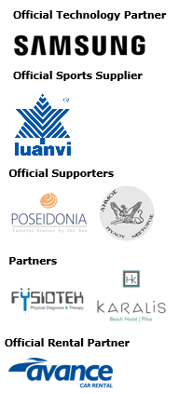
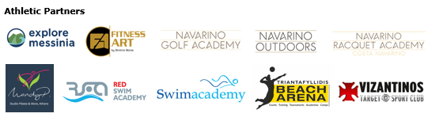
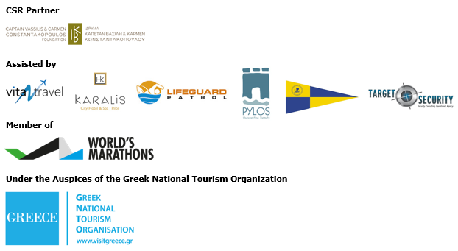
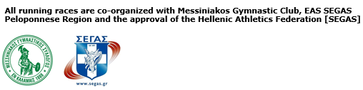


Website: www.navarinochallenge.com
Facebook Page: www.facebook.com/Navarinochallenge
Instagram Page: http://instagram.com/navarinochallenge
Twitter Account: https://twitter.com/NavarinoC
YouTube Channel: http://www.youtube.com/user/NavarinoChallenge

About Costa Navarino
Costa Navarino is the prime, sustainable destination in the Mediterranean, located in the Greek region of Messinia in the southwest Peloponnese. One of the most unspoiled and breathtaking seaside Mediterranean landscapes, this area has been shaped by 4,500 years of history.
Its philosophy is driven by a genuine desire to promote Messinia, while protecting and preserving its natural beauty and heritage. It will comprise a number of distinct sites featuring five-star deluxe hotels, luxury private residences, conference facilities, spa and thalassotherapy centres, signature golf courses, as well as a wide range of unique year-round activities for adults and children.
Navarino Dunes, the first area, is home to two luxury five-star hotels, The Romanos, a Luxury Collection Resort, and The Westin Resort Costa Navarino; Navarino Residences, a collection of luxury villas for private ownership; and The Residences at The Westin Resort Costa Navarino – fully furnished resort apartments for sale; the signature golf course The Dunes Course; Anazoe Spa, a 4,000m² spa and thalassotherapy centre; the state-of-the-art conference centre House of Events; specially designed facilities for children; and a variety of gastronomy venues, sports, outdoor and cultural activities.
Navarino Bay, the second area, is home to the signature golf course, The Bay Course and to the earth-sheltered Bay Clubhouse, while an ultra-luxury, all suite and pool villas resort is currently under construction, alongside an upscale, vibrant, lifestyle resort at the nearby site Navarino Waterfront.
At Navarino Hills, two new 18-hole signature golf courses are also being constructed.
High-resolution images of Costa Navarino may be downloaded from http://bit.ly/AZ_CN.

The Westin Resort Costa Navarino
The Westin Resort has been voted one of the best resorts in Greece and one of the foremost holiday destinations in Europe. In 2017 The Westin Resort Costa Navarino has been voted among the Best Resorts in Europe in Condé Nast Traveler Reader’s Choice Awards. It features an amazing selection of deluxe rooms, family rooms and suites in a privileged seaside location on a verdant hillside that affords an alluring mix of golf, sea and pool views. This exceptional 5-star family resort in Greece allows children to choose from an enormous variety of supervised fun activities, tailored specifically for them, at the Cocoon and the SandCastle, giving parents plenty of time to indulge in their own favorite sports or simply unwind. Families are offered countless ways to spend quality time together at the impressive Aqua Park, the pools and the beach, or can select among a wide variety of sports and outdoor activities.
For more information on The Westin Resort Costa Navarino, please visit www.westincostanavarino.com or follow us on Facebook and Instagram.

