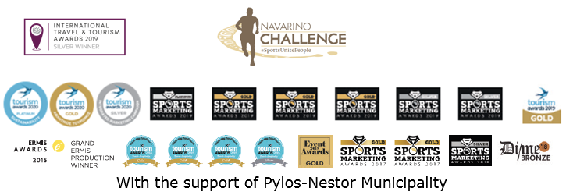
PRESS RELEASE

8th Navarino Challenge: October 16-18 2020 with the participation of Olympic Medalists & World Champions

Top Greek basketball player Evina Maltsi will be present
at this year’s sports tourism celebration

Athens, September 1, 2020 - Navarino Challenge, the award-winning sports tourism event that every year brings together people of all ages and abilities, returns for 8th consecutive year in Messinia, Pylos and Costa Navarino, on October 16-18, 2020. The top wellness event, as highlighted at the World Travel Market in London, which promotes Olympic values ​​and “fair play” will be held with the upmost safety of all participants and attendees.

Event with safety measures and health protocol
The event, taking into account the current health conditions, is organized with the strict specifications set by the Ministry of Tourism, the General Secretariat of Sports and the relevant sports federations. With the safety and health of all participants and staff as its main priority, Navarino Challenge will be conducted based on the health protocol established by experienced staff, certified by the World Health Organization, following the instructions of General Secretariat of Sports’ expert scientists-collaborators as well as the epidemiological data and suggestions of the General Secretariat of Sports’ Health Committee.

The universal value of the Greek language
Navarino Challenge promotes and supports actions that highlight the history and cultural heritage of our country and more specifically the undeniable value of the Greek language. The Greek language has been a source of inspiration and culture for many countries, since many foreign languages ​​use words deriving from ancient Greek. Words such as athlete, energy, harmony, ideals which are used around the world, are highlighted in this year’s video that presents all wellness activities of the 8th Navarino Challenge. Watch the video through the following link: https://youtu.be/XJoAr8weEmA

Navarino Challenge means wellness
Participants in this year’s Navarino Challenge will have the opportunity to enjoy exercising along with significant personalities from the wellness field, such as: the physical education instructor Mandy Persaki, the trainer of F45, Barrio Salamanca, Tess Arlauckas and the personal trainer Dimitris Moros, as well as athletic partners such as FitnessArt, Navarino Outdoors, Navarino Racquet Academy, with the experience and dynamic of the Panellinios Agora Games and the Navarino Golf Academy. In addition, the following instructors will be present: the boxing champion Christos Gatsis, with the support of the Vizantinos target sport club, the kick boxing champion Alexandros Nikolaidis, the table tennis champion and international career model Ioanna Papadimitriou as well as athletic partners such as Swim Academy and Red Swim Academy. For the first time a beach volley tournament will be held by the champion and pioneer of the sport, Michalis Triantafyllidis.

With the dynamic presence of Evina Maltsi & Joe Arlauckas
Top international female basketball player of all time Evina Maltsi meets Euroleague legend Joe Arlauckas at the Navarino Challenge 2020.
The Greek Women’s National Team all-time top scorer and former WNBA player will be an honoree guest at this year’s event. In the context of her participation, Evina Maltsi stated: “It is my honour and pleasure to participate in the 8th Navarino Challenge which is a huge sporting event in a beautiful tourism destination. I hope that this event can live on for one thousand years. What the event stands for, is completely in line with my beliefs, the dissemination of the Olympic idea. It is a wonderful place that can combine sports tourism and attract more people who will adopt the Olympic values ​​as a way of life. As a basketball player it will be my pleasure to introduce the sport that I have served for more than 25 years, to as many children as I can”.

Olympic & World Champions
Dynamic sports will also be included in this year’s award-winning event’s schedule.
Specifically, the Olympic and world champion in 400m with hurdles, Periklis Iakovakis, the two-time silver Olympic medalist Alexandros Nikolaidis, the gold Paralympic medalist and world champion of Boccia Grigoris Polychronidis, the European champion, Miltos Tentoglou, as well as the top track and field coach George Pomaski, will be present at the event.

History “lives” with the demonstration of boats in the port of Pylos
A demonstration of sailing races with OPTIMIST and LASER boats will be held in the Municipality of Pylos-Nestor at the bay of Navarino, by the Maritime Athletic Pylos Association “Nestor”. The “Forgotten Heroes” races will be held in honor of Anastasios Tsamados, Nikolaos Votsis, Stavros Sachinis, Georgios Sachtouris and the ghost sailors of the warship (brig) Aris of Tsamados. The “Aris” ship (also known as “Athena” during the period 1829–1879) is considered as one of the most glorious ships of the Greek navy in the Greek war of independence, which was owned by the fearless captain, the admiral Anastasios Tsamados. It was the last ship to break through the enemy siege, putting seven enemy ships out of battle, during the siege of the island of Sphacteria at the Battle of Sphacteria on April 26, 1825.

Sports for a good cause
This year, Navarino Challenge through its actions will support the following CSR partners: Through the “Captain Vasilis and Carmen Konstantakopoulos Foundation”, it will support a) Karkinaki and b) Dogs’ Voice, while will also directly support c) Fashion Targets Breast and Prostate Cancer.

The energy you need to start your day stronger
The favorite breakfast cereal bars FITNESS®, as the Official Breakfast Partner of Navarino Challenge, will be by the side of the participants, giving them the energy they need to meet the challenges they will encounter during this unique event! With their B-complex vitamins that helps release energy from food, they form the ideal choice for a delicious and balanced breakfast.

Accommodation Packages
Enjoy a weekend full of outdoor wellness activities for people of all ages. For more information on accommodation packages at The Westin Resort Costa Navarino you may send your email to booking(at)navarinochallenge.com or call Vita N Travel at +30 210 3249070.

Registration offers & gifts to participants
Entries for the event’s top Greek Half-marathon (21.1km), 10km, 5km by Samsung and 1km children’s races are underway and interested parties can participate by completing the available form through the following link: https://www.myrace.gr/en/event/2409/registrations.html
Take advantage of the offer by the event’s Official Technology Partner, Samsung Electronics Hellas. Samsung and Navarino Challenge will offer all participants the opportunity to purchase the Galaxy S20, S20+ & Galaxy Z Flip, with a 20% discount upon completion of their registration.

Discount on car rentals
The top Greek rental company Avance, as the event’s official car rental partner provides participants of Navarino Challenge with an opportunity to make their reservation, with a 15% discount on the official price list, for any vehicle of their choice regarding their travel to Messinia during the period of the event. In terms of bookings, participants need to send an email to reserv(at)avance.gr

Navarino Challenge is held under the auspices of the Greek National Tourism Organization with the support of Pylos-Nestor Municipality. Navarino Challenge has joined the Greek actions of the #BeactiveHellas 2020 programme of the European Commission and is held under the auspices of the General Secretariat of Sports.
All running races are co-organized with Messiniakos Gymnastic Club and EAS SEGAS Peloponnese Region.

Official Technology Partner: Samsung
Official Sponsor: Vikos Natural Mineral Water
Official Sports Supplier: Luanvi
Official Supporters: Pylos-Nestor Municipality, Poseidonia, Karalis Beach Hotel
Official Beauty Partner: Messinian Spa
Official Shoe Partner: On
Official Breakfast Partner: Nestlé FITNESS®
Partner: Fysiotek Sports Lab
Official Car Rental Partner: Avance
Premium TV Partner: SKAI
Strategic Partner: National Geographic
Premium Media Partner: 24MEDIA
Athletic Partners: Explore Messinia, FitnessArt, Navarino Golf Academy, Navarino Outdoors, Navarino Racquet Academy, Pilates by Mandy, Red Swim Academy, Swim Academy, Triantafyllidis Beach Arena, Vizantinos target sport club, Marathon Team Greece
Assisted By: VitaNTravel, Karalis City Hotel & Spa, Lifeguard Patrol, Pylos Association of Enterprises for Tourism Development, Maritime Athletic Pylos Association “Nestor”, Target Security, Pilia Express, Kayak
Discount Partner: Panellinios Agora Games
Sports Production: Active Media Group

Hashtags: #navarinochallenge #costanavarino #sportsunitepeople #eatwell #runwell #livewell

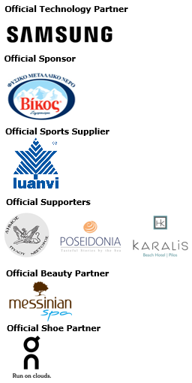
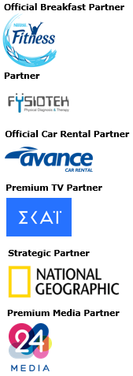
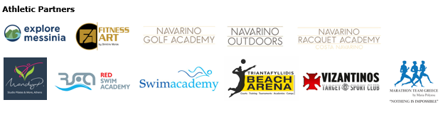
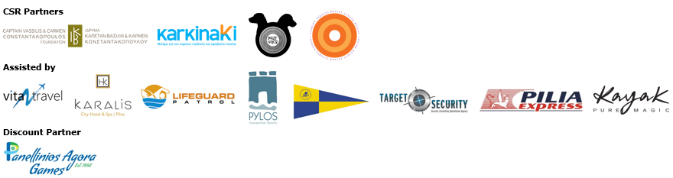
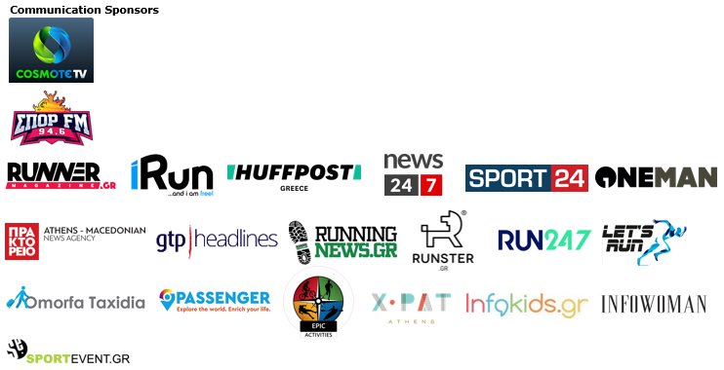
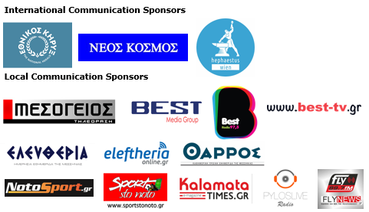

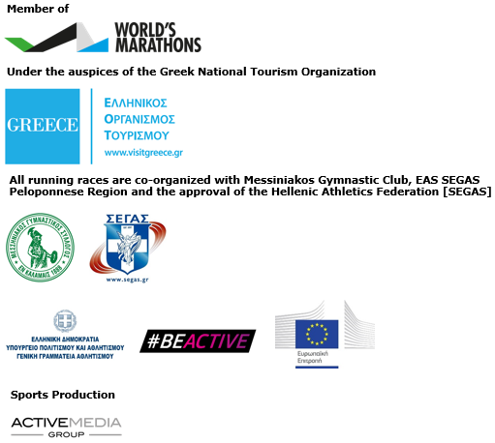

Website: www.navarinochallenge.com
Facebook Page: www.facebook.com/Navarinochallenge
Instagram Page: http://instagram.com/navarinochallenge
Twitter Account: https://twitter.com/NavarinoC
YouTube Channel: http://www.youtube.com/user/NavarinoChallenge

About Costa Navarino
Costa Navarino is the prime, sustainable destination in the Mediterranean, located in the Greek region of Messinia in the southwest Peloponnese. One of the most unspoiled and breathtaking seaside Mediterranean landscapes, this area has been shaped by 4,500 years of history.
Its philosophy is driven by a genuine desire to promote Messinia, while protecting and preserving its natural beauty and heritage. It will comprise a number of distinct sites featuring five-star deluxe hotels, luxury private residences, conference facilities, spa and thalassotherapy centres, signature golf courses, as well as a wide range of unique year-round activities for adults and children.
Navarino Dunes, the first area, is home to two luxury five-star hotels, The Romanos, a Luxury Collection Resort, and The Westin Resort Costa Navarino; Navarino Residences, a collection of luxury villas for private ownership; and The Residences at The Westin Resort Costa Navarino – fully furnished resort apartments for sale; the signature golf course The Dunes Course; Anazoe Spa, a 4,000m² spa and thalassotherapy centre; the state-of-the-art conference centre House of Events; specially designed facilities for children; and a variety of gastronomy venues, sports, outdoor and cultural activities.
Navarino Bay, the second area, is home to the signature golf course, The Bay Course and to the earth-sheltered Bay Clubhouse, while an ultra-luxury, all suite and pool villas resort is currently under construction, alongside an upscale, vibrant, lifestyle resort at the nearby site Navarino Waterfront.
At Navarino Hills, two new 18-hole signature golf courses are also being constructed.
High-resolution images of Costa Navarino may be downloaded from https://bit.ly/2BCBxxJ. Password: Nestor

The Westin Resort Costa Navarino
Voted “Top Resort” in Europe in Condé Nast Traveler Readers’ Choice Awards, The Westin Resort Costa Navarino enjoys a privileged location by the Ionian Sea. This deluxe 5* property features elegant rooms and suites with varied sea, golf or resort views, and expanded terraces or balconies to connect with the splendor of the hotel’s setting, while all ground-floor units additionally provide individual infinity pools. Families are offered countless ways to explore and play; innovative children hubs to keep the little ones creatively engaged, a state-of-the-art Aqua Park, refreshing pools and the 1 km-long sandy beach, along with a wide variety of sports and activities for all, including two signature golf courses, on-water and under-water sports, biking and hiking pursuits, a racquet academy and more. For more information please visit www.westincostanavarino.com or follow us on Facebook and Instagram.

