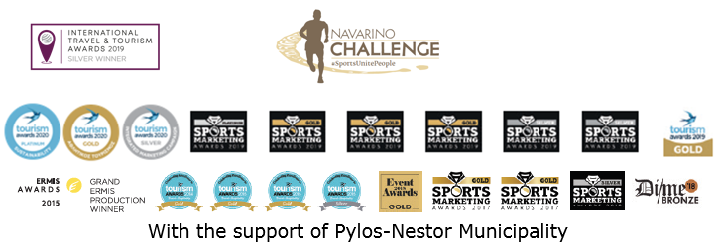

PRESS RELEASE

Navarino Challenge 2020: The top celebration of sports tourism is postponed

New appointment on October 15-17, 2021

Athens, October 9, 2020 – The award-winning sports tourism event Navarino Challenge, with a high sense of responsibility towards its participants and visitors, announces the postponement of the event to October 15-17, 2021, taking into consideration the epidemiological data and current health conditions prevailing in our country, despite designing and getting the necessary approvals for the strict health protocols.

Registered athletes and participants will receive relevant email communication from the event, whereas those interested can learn news and read all announcements directly through Navarino Challenge’s communication channels.

Navarino Challenge is held under the auspices of the Greek National Tourism Organization, with the support of Pylos-Nestor Municipality. Navarino Challenge has joined the Greek actions of the #BeactiveHellas 2020 programme of the European Commission and is held under the auspices of the General Secretariat of Sports.
All running races are co-organized with Messiniakos Gymnastic Club and EAS SEGAS Peloponnese Region.

Samsung is the Official Technology Partner.
Vikos Natural Mineral Water is the event’s Official Sponsor.
Luanvi is the Official Sports Supplier.
Pylos-Nestor Municipality, Poseidonia, Karalis Beach Hotel are Navarino Challenge’s Official Supporters.
Messinian Spa is the Official Beauty Partner.
On is the Official Shoe Partner.
Nestlé FITNESS® is the Official Breakfast Partner.
Target Security, Fysiotek Sports Lab are the event’s Partners.
Avance is the Official Car Rental Partner.
SKAI is the Premium TV Partner.
National Geographic is the Strategic Partner.
24MEDIA is the Premium Media Partner.
Deree - The American College of Greece is the Educational Partner.
Explore Messinia, FitnessArt, Navarino Golf Academy, Navarino Outdoors, Navarino Racquet Academy, Pilates by Mandy, Red Swim Academy, Swim Academy, Triantafyllidis Beach Arena, Vizantinos target sport club, Marathon Team Greece are Navarino Challenge’s Athletic Partners.
Navarino Challenge is assisted by Vita N Travel, Karalis City Hotel & Spa, Lifeguard Patrol, Pylos Association of Enterprises for Tourism Development, Maritime Athletic Pylos Association “Nestor”, Pilia Express, Kayak.
Anazoe Spa, Attica Selections, Kessaris, Nargile, Panellinios Agora Games are the Discount Partners.
Active Media Group is responsible for the event’s Sports Production.

Hashtags: #navarinochallenge #costanavarino #sportsunitepeople #eatwell #runwell #livewell

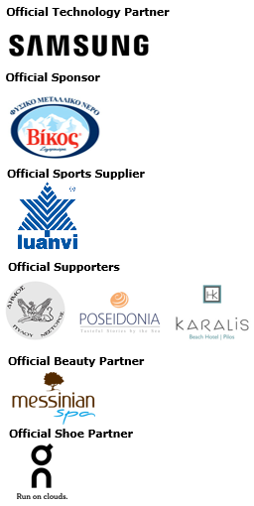

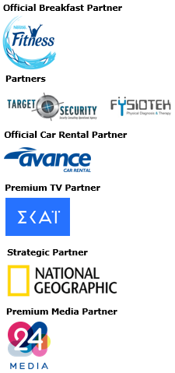
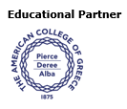
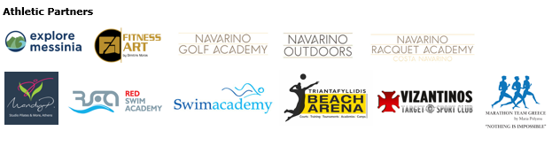
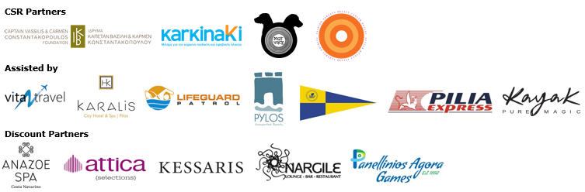



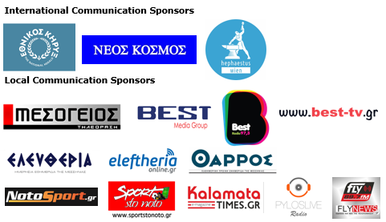

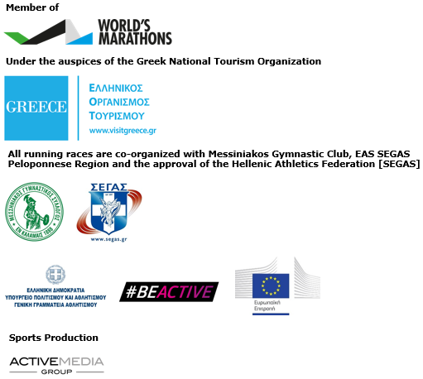

Website: www.navarinochallenge.com
Facebook Page: www.facebook.com/Navarinochallenge
Instagram Page: http://instagram.com/navarinochallenge
Twitter Account: https://twitter.com/NavarinoC
YouTube Channel: http://www.youtube.com/user/NavarinoChallenge

About Costa Navarino
Costa Navarino is the prime, sustainable destination in the Mediterranean, located in the Greek region of Messinia in the southwest Peloponnese. One of the most unspoiled and breathtaking seaside Mediterranean landscapes, this area has been shaped by 4,500 years of history.
Its philosophy is driven by a genuine desire to promote Messinia, while protecting and preserving its natural beauty and heritage. It will comprise a number of distinct sites featuring five-star deluxe hotels, luxury private residences, conference facilities, spa and thalassotherapy centres, signature golf courses, as well as a wide range of unique year-round activities for adults and children.
Navarino Dunes, the first area, is home to two luxury five-star hotels, The Romanos, a Luxury Collection Resort, and The Westin Resort Costa Navarino; Navarino Residences, a collection of luxury villas for private ownership; and The Residences at The Westin Resort Costa Navarino – fully furnished resort apartments for sale; the signature golf course The Dunes Course; Anazoe Spa, a 4,000m² spa and thalassotherapy centre; the state-of-the-art conference centre House of Events; specially designed facilities for children; and a variety of gastronomy venues, sports, outdoor and cultural activities.
Navarino Bay, the second area, is home to the signature golf course, The Bay Course and to the earth-sheltered Bay Clubhouse, while an ultra-luxury, all suite and pool villas resort is currently under construction, alongside an upscale, vibrant, lifestyle resort at the nearby site Navarino Waterfront.
At Navarino Hills, two new 18-hole signature golf courses are also being constructed.
High-resolution images of Costa Navarino may be downloaded from https://bit.ly/2BCBxxJ. Password: Nestor

The Westin Resort Costa Navarino
Voted “Top Resort” in Europe in Condé Nast Traveler Readers’ Choice Awards, The Westin Resort Costa Navarino enjoys a privileged location by the Ionian Sea. This deluxe 5* property features elegant rooms and suites with varied sea, golf or resort views, and expanded terraces or balconies to connect with the splendor of the hotel’s setting, while all ground-floor units additionally provide individual infinity pools. Families are offered countless ways to explore and play; innovative children hubs to keep the little ones creatively engaged, a state-of-the-art Aqua Park, refreshing pools and the 1 km-long sandy beach, along with a wide variety of sports and activities for all, including two signature golf courses, on-water and under-water sports, biking and hiking pursuits, a racquet academy and more. For more information please visit www.westincostanavarino.com or follow us on Facebook and Instagram.

