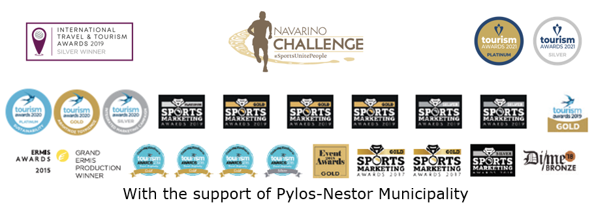

PRESS RELEASE

Navarino Challenge honors the Gold Olympic medalist
Miltos Tentoglou & his coach George Pomaski

30 sports activities in this year’s event

Athens, September 3, 2021 – Navarino Challenge, the top sports tourism celebration returns for the 9th year at Costa Navarino and Pylos, Messinia on October 15-17, uniting people of all ages and abilities, both amateurs and professionals. With its global message “sports unite people”, the event promotes the benefits of exercise, the Olympic values ​​and fair play through sports.

The world’s greatest long jumper will be honored
Navarino Challenge will honor this year the man who made Greece proud at the Tokyo Olympic Games, the gold Olympic medalist in long jump Miltos Tentoglou as well as his coach George Pomaski, who is behind all of his important achievements. The event will also pay tribute to Kostis Tsiklitiras, the world-famous legend and 1912 gold Olympic medalist who was born in Pylos, Messinia, by presenting the standing long jump activity for the first time at Costa Navarino. Tentoglou and his coach will provide people of all ages with an opportunity to try out their jumps and attempt to surpass Tsiklitiras’ world record of 3.47m.

Run in Voidokilia
Participants in Navarino Challenge 2021 will have the opportunity to run in one of the top Greek Half Marathons of 21.1km, together with the Greek-American ultramarathon runner Dean (Konstantine) Karnazes. They will also have the ability to choose between the 10km route or the fun 5km route by Samsung, which can even be completed with dynamic walking. Moreover, the 1km children’s route will be held in two groups, for children 10-14 years old and kids up to 9 years of age. Runners can act promptly and participate by completing the available form through the following link. The children’s race is held for free. It should be noted that due to the strict health & safety measures that will be in force, all running participants not staying at Costa Navarino must provide either a vaccination certificate or a COVID-19 recovery certificate (valid for 6 months after testing positive).

Sea kayaking
Book now your participation at the sea kayak tour that will take place around the island of Sphacteria with the support of Explore Messinia. For entries: welcome (at) exploremessinia.com

Beach Volleyball Tournament
Take part in the Navarino Challenge King of the Court Beach Volley Tournament by Samsung that will be held at The Dunes Beach with the former international Greek volleyball player and record holder of participations with the Greek National Team, Michalis Triantafyllidis, as its ambassador. You may also participate in the beach volleyball lessons by Samsung that will be held. All beach volleyball activities are carried out with the support of Triantafyllidis Beach Arena. For registrations and more information: info(at)beacharena.gr
In the context of this year’s activities, Michalis Triantafyllidis stated: “With great pleasure, after this difficult period, Navarino Challenge King of the Court Beach Volley Tournament returns to the event. There is already a great response and enthusiasm. Both we, as organizers and the people are looking forward to it”.

Book your room now
Enjoy a weekend full of outdoor wellness activities for all ages. Book now the event’s accommodation package which is full of sports activities and includes half board. Live the unique sports and cultural experience that is offered to you. For more information on accommodation packages at The Westin Resort Costa Navarino you may send your email to booking(at)navarinochallenge.com or call Vita N Travel at +30 210 3249070. Check the accommodation packages here.

Sharing is Caring: Online Auctions for a Good Cause
As Aesop quotes “No act of kindness, no matter how small, is ever wasted”. Navarino Challenge, like every year, will support the society as a whole. In collaboration with the Sports Management Society of Deree – The American College of Greece and the unique European agency, dealing with trading cards and memorabilia, Trace ‘n Chase, the event will organize the “Sharing is Caring” series of online auctions in December 2021. The online auctions, to be conducted through the Charity Idols platform, will include items of world-famous and renowned athletes, hall of famers and ambassadors of Navarino Challenge, while proceeds from the auctions will be given to support non-profit organizations.

You may enjoy the Navarino Challenge 2021 beach activities here.

Samsung is the Official Technology Partner.
Vikos Natural Mineral Water is the event’s Official Sponsor.
Luanvi is the Official Sports Supplier.
Costa Navarino and The Westin Resort Costa Navarino are the Official Hospitality Sponsors.
Pylos-Nestor Municipality, Poseidonia, Karalis Beach Hotel are Navarino Challenge’s Official Supporters.
Messinian Spa is the Official Beauty Partner.
Nestlé FITNESS® is the Official Breakfast Partner.
Target Security, Fysiotek Sports Lab are the event’s Partners.
Avance is the Official Car Rental Partner.
π³ (pi3) is the Sustainability Partner.
SKAI is the Premium TV Partner.
National Geographic is the Strategic Partner.
Deree - The American College of Greece is the Educational Partner.
Explore Messinia, FitnessArt, F45 Barrio Salamanca, Navarino Golf Academy, Navarino Outdoors, Navarino Racquet Academy, Pilates by Mandy, Red Swim Academy, Swim Academy, Triantafyllidis Beach Arena, Vizantinos target sport club, Marathon Team Greece are Navarino Challenge’s Athletic Partners.
Diaforozo, Karkinaki, All For Blue and Pet Partners of Hellas are the event’s nonprofit organizations CSR partners.
Navarino Challenge is assisted by Vita N Travel, Karalis City Hotel & Spa, Lifeguard Patrol, Pylos Association of Enterprises for Tourism Development, Maritime Athletic Pylos Association “Nestor”, Pilia Express, Kayak.
Anazoe Spa, Attica Selections, Kessaris, Nargile, Panellinios Agora Games are the Discount Partners.

Navarino Challenge will be held under the auspices of the Ministry of Tourism, the International Olympic Academy and the Greek National Tourism Organization, with the support of Pylos-Nestor Municipality. The event is organized by ActiveMedia Group which is also responsible for the event’s Sports Production. All running races are co-organized with Messiniakos Gymnastic Club and EAS SEGAS Peloponnese Region.

Hashtags: #navarinochallenge #costanavarino #sportsunitepeople #eatwell #runwell #livewell

Website: www.navarinochallenge.com
Facebook Page: www.facebook.com/Navarinochallenge
Instagram Page: http://instagram.com/navarinochallenge
Twitter Account: https://twitter.com/NavarinoC
YouTube Channel: http://www.youtube.com/user/NavarinoChallenge



