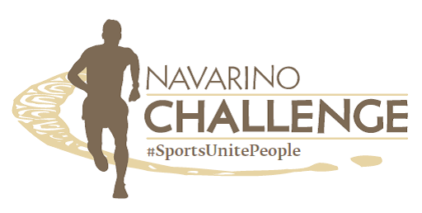

30 SPORTS ACTIVITIES!
THERE IS DEFINITELY SOMETHING FOR YOU
REGISTRATION FORM FOR ACCOMMODATION PACKAGE
15-17/10/2021

Last Name: First Name:
Company: Position:
Address: ZIP: City:
Phone.: e-mail: Mobile Phone

Second Person (for double/twin room):
ACCOMMODATION PACKAGE – COSTA NAVARINO
NAVARINO CHALLENGE, Package  3 days – 2 nights on Half Board basis  - 2 people in deluxe garden view room €654.00  - 2 people in deluxe sea view room €728.00  Including:  - Accommodation at The Westin Resort Costa Navarino, in deluxe garden view room, for two nights  - Buffet breakfast  - Two (2) dinners at Morias restaurant (no beverages included, except of water)  Free participation to the below Navarino Challenge activities at The Westin Resort:  - 1km kids running race  - 1km kids with parents running race  - Tae kwon do lessons by the two times silver Olympic medalist, Alexandros Nikolaidis  - Indoor climbing lessons supported by Navarino Outdoors (4 people/group). For entries: events@activemedia.gr  - Bike ride in Voidokilia supported by Navarino Outdoors (10 people/group). For entries: events@activemedia.gr  - Pilates lessons by Nestle Fitness by Mandy Persaki  - Basketball 4on4 tournament / Register your team  - Basketball Clinic for kids 5-17 yrs old by Euroleague legend Joe Arlauckas & the top Greek basketball player Evina Maltsi  - Golf lessons supported by Navarino Golf Academy  - Kick Boxing lessons by the champion Alexandros Nikolaidis  - Samsung King of the Court Beach Volley Tournament by Samsung with Triantafyllidis Beach Arena with international volleyball player Michalis Triantafyllidis. For entries: info@beacharena.gr | - Beach volley lessons by Samsung from Triantafyllidis Beach Arena with international volleyball player Michalis Triantafyllidis  - Tennis Cross Training for beginners supported by Navarino Racquet Academy  - High intensity training by Nestle Fitness for people of all ages by Dimitris Moros & FitnessArt  - Crossfit for adults by Dimitris Moros & FitnessArt  - Yoga Beach at The Dunes Beach (Westin Resort) by FitnessArt  - Boxing lessons by Christos Gatsis & Vizantinos Target Sport  - Sea kayaking at the historic Sphacteria island by Explore Messinia. For entries: welcome@exploremessinia.com  - Beachathlon for kids 6-13 yrs old & parents by the Olympian & World Champion Periklis Iakovakis.  - Group Cycling (Spinning Challenge) for people of all ages powered by FitnessArt  - Free access to the WestinWORKOUT® Gym. The facilities include a fully equipped gym, sauna, hamam, indoor pool, change rooms etc.  The preferential price of the package is valid only with the condition of the participation of at least one person in one of the running routes (5 km or 10 km or 21 km). You can register here: https://www.myrace.gr/en/event/2453/registrations.html  Otherwise, the regular hotel's pricelist applies.  Accommodation supplements for children:  - Child under 4 years old - FREE.  - Child 4-12 years old - €40,00 surcharge.  - Child older than 13 years old - €220,00 surcharge.
Full prepayment is requested for the confirmation of the reservation. For any cancellation, amendment or no show a 100% fee will be charged after the confirmation of the reservation.
For rates concerning other room categories and/or more nights, please contact us.
PAYMENT METHOD Total Amount: Euro
By bank transfer: PIRAEUS BANK account: 5012 -045985 - 641
IBAN: GR65 0172 0120 0050 1204 5985 641
(Please send us by e-mail a copy of the bank remittance receipt including your name on the transfer notice)
By credit card: I authorize VITA N TRAVEL to charge my credit card with the amount of € ………,00 Euro
Credit Card Details: Visa Mastercard

Owner Credit Card number

(month) (year) (month) (year)
Issuance Date /_ Expiration Date / 3-CODE/CVC No.

Signature
(Please attach photocopy of your credit card & your passport or you ID)
One form per room – Please fill in with CAPITAL letters
DATE __/__/__ Please send the form via email to booking@navarinochallenge.com

