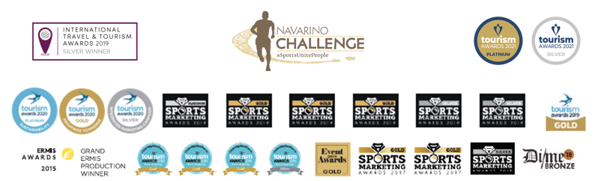

PRESS RELEASE

Navarino Challenge 2021: The Greek Language unites through Sports

Athens, October 11, 2021 – Just a few days before the 9th year of Navarino Challenge, people of all ages and abilities are preparing to participate and be a part of the top sports tourism fest at Costa Navarino and Pylos, Messinia, on October 15 -17, 2021.

Showcasing the global value of the Greek language
Navarino Challenge promotes and supports actions that highlight the history and cultural heritage of Greece and more specifically the indisputable value of the Greek language. The Greek language is one of the most important ones in the world and has been the basis for countless cultures. Most alphabets derive from Greek. This year’s Navarino Challenge campaign has a Greek “color”, and the participants will have the opportunity to find this out both in the event’s commemorative T-shirt, which is designed by Luanvi, as well as in the event’s medal which are both dedicated to the Greek language and will include many Greek words in various foreign languages ​​that have the exact same meaning. You may watch the video at the following link.

The event, having decided to promote and highlight the work and life of the great Greek Olympic medalist from Pylos, Konstantinos Tsiklitiras reminds everyone the worldwide importance of the Greek language, on the occasion of the 1912 Olympic Games poster in Stockholm which is in Greek. In fact, on Saturday, October 16 at noon, the standing long jump activity in honor of Tsiklitiras will be presented in the presence of Gold Olympic medalist Miltos Tentoglou and his coach, George Pomaski at The Dunes Beach, in Costa Navarino.

Register at the 5km Powered by Samsung & win the Galaxy Fit2 Tracker Watch
A unique gift awaits all participants who will finish the 5km Powered by Samsung running route. Register now and get the Galaxy Fit2 Tracker Watch from Samsung Electronics Hellas, the event’s Grand Sponsor, while maintaining your racing rhythm and athletic style in the beautiful Messinian landscape.
Run now in one of the top Greek Half Marathons of 21.1km, together with the Greek-American ultramarathon runner Dean (Konstantine) Karnazes, in the 10km route by Caterpy or the fun 5km route Powered by Samsung. Runners can participate by completing the available form through the following link. Moreover, the 1km children’s route will be held in two groups, for children 10-14 years old and kids up to 9 years of age. The children’s race is held for free.

The schedule of Navarino Challenge 2021
With its message “sport unites people”, the event awaits you with more than 30 sports activities and 15 Olympic sports. You may find the event’s detailed schedule here.

You may find the Discount Partners’ offers, which are valid throughout the 2021 Navarino Challenge for all participants here.

The event will be held based on the strict health protocols approved by the Health Scientific Committee of the General Secretariat of Sports. You may find the protocols here.

Samsung is the event’s Grand Sponsor.
Vikos Natural Mineral Water is the Official Sponsor.
Luanvi is the Official Sports Supplier.
Costa Navarino and The Westin Resort Costa Navarino are the Official Hospitality Sponsors.
Poseidonia and Karalis Beach Hotel are Navarino Challenge’s Official Supporters.
Nestlé FITNESS® is the Official Breakfast Partner.
Messinian Spa is the Official Beauty Partner.
The North Face is the Outdoor Partner.
Athens Medical Group is the event’s Medical Partner.
Target Security, Caterpy and Fysiotek Sports Lab are the event’s Partners.
Avance is the Official Car Rental Partner.
π³ (pi3) is the Sustainability Partner.
SKAI is the Premium TV Partner.
National Geographic is the Strategic Partner.
Deree - The American College of Greece is the Educational Partner.
Explore Messinia, FitnessArt, F45 Barrio Salamanca, Mouratoglou Tennis Center – Costa Navarino, Navarino Golf Academy, Navarino Outdoors, Pilates by Mandy, Red Swim Academy, Swim Academy, Triantafyllidis Beach Arena, Vizantinos target sport club, Marathon Team Greece are Navarino Challenge’s Athletic Partners.
A Little Shelter, All For Blue, ANIMA, Diaforozo, Karkinaki, The Other Human, Pet Partners of Hellas are the event’s nonprofit organizations CSR partners.
Navarino Challenge is assisted by Vita N Travel, Karalis City Hotel & Spa, Lifeguard Patrol, Pylos Association of Enterprises for Tourism Development, Maritime Athletic Pylos Association “Nestor”, Pilia Express, Kayak, Nestor.
Anazoe Spa, Armyra, Attica Selections, Bio & Pharma Store, Kessaris, Nargile, Panellinios Agora Games are the Discount Partners.

Navarino Challenge will be held under the auspices of the Ministry of Tourism, the General Secretariat of Sport of the Ministry of Culture & Sport, the International Olympic Academy and the Greek National Tourism Organization.
The event has joined the Greek actions of the #BeactiveHellas 2021 programme of the European Commission and is held under the auspices of the General Secretariat of Sports. The event is organized by ActiveMedia Group which is also responsible for the event’s Sports Production. All running races are co-organized with Messiniakos Gymnastic Club and EAS SEGAS Peloponnese Region.

Hashtags: #navarinochallenge #costanavarino #sportsunitepeople #eatwell #runwell #livewell

Website: www.navarinochallenge.com
Facebook Page: www.facebook.com/Navarinochallenge
Instagram Page: http://instagram.com/navarinochallenge
Twitter Account: https://twitter.com/NavarinoC
YouTube Channel: http://www.youtube.com/user/NavarinoChallenge

