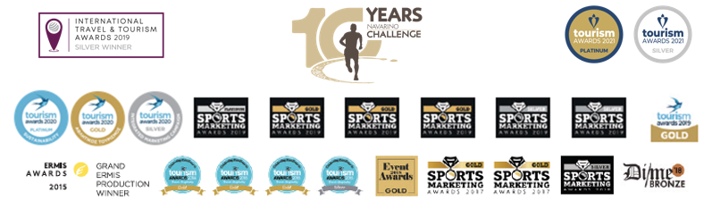
PRESS RELEASE

Navarino Challenge
Outdoor activities for the whole family

Book your room in magical Messinia

Athens, May 4, 2022 – The award-winning sports tourism event Navarino Challenge celebrates its 10th year by uniting people of all ages and abilities through sports. Amateur and professional athletes from Greece and abroad will visit Costa Navarino and Pylos, Messinia, on October 21-23, 2022.

Follow the footsteps of Telemachus
Participants in Navarino Challenge, have the opportunity to run in one of the top Half Marathons 21.1km in Greece, together with the Greek-American ultramarathon runner Konstantinos Dean Karnazes, and to cross the beautiful beach of Voidokilia while tracing history beneath their feet in King Nestor’s land. They will follow the trail mapped out in the Homeric era by Telemachus, Ulysses’ son, trying to find his missing father. Moreover, they can choose between the 10km route or the fun 5km route, which can even be completed with dynamic walking. On the same day, the 1km children’s route will be held in two groups, for children 10-14 years old and kids up to 9 years of age.
Runners can act promptly and take advantage of the early bird offers, which are valid until July 31, featuring discounts higher than 50% on registrations. The children’s race is held with free participation. The event, always having the participants as a top priority, offers a refund on their registration costs until September 1. Entries for Navarino Challenge are underway and interested parties can participate by completing the available form through the following link.

Enjoy here the video with Navarino Challenge 2022’s outdoor activities.

Sea kayaking at Pylos Bay
Starting from the Poseidonia Restaurant known for its traditional Greek cuisine and local delicacies in the port of Pylos, on Saturday, October 22, a sea kayak tour around the island of Sphacteria will take place, with the support of Explore Messinia. Participants will paddle towards the Navarino Bay exploring the coastline of Sphacteria. For entries: welcome(at)exploremessinia.com

Take part in the Beach Volleyball Tournament with a view of the Ionian Sea
Overlooking the sand dunes and crystal-clear waters of the Ionian Sea, The Dunes Beach at Navarino Dunes, Costa Navarino, will host the Navarino Challenge King of the Court Beach Volleyball Tournament. The Olympic sport of beach volleyball returns with the former international Greek volleyball player and record holder of participations with the Greek National Team, Michalis Triantafyllidis, as its ambassador. On Saturday, October 22, the tournament will include separate categories for men and women, whereas on Sunday, October 23, the tournament will be mixed. All beach volleyball activities are carried out with the support of Triantafyllidis Beach Arena. For registrations and more information: info(at)beacharena.gr

Tennis at the Mouratoglou Tennis Center Costa Navarino
Participants in Navarino Challenge will have the opportunity to attend tennis clinics for children 6-9 years old and 10-13 years old as well as to participate in the Round Robbin tennis tournaments for men and women, which will be held with the support of Mouratoglou Tennis Center Costa Navarino under the guidance of elite coaches. Costa Navarino is the first European location for a Mouratoglou Tennis Center, while the brand-new state-of-the-art facilities feature a total of 16 tennis courts at Navarino Dunes with breathtaking views of the Ionian Sea. For registrations and more information: tennis(at)costanavarino.com

Track and field, pilates, cycling, golf for everyone!
The schedule of Navarino Challenge offers you the opportunity to come closer to sports and their benefits, alongside top instructors. More specifically, you can take part in activities such as beachathlon for parents & children 6 to 13 years old with the Olympian and European champion Periklis Iakovakis, pilates lessons with the team of physical education instructor, Mandy Persaki, bike ride to Voidokilia with the support of Navarino Outdoors and golf lessons for 2 days, with the support of Navarino Golf Academy.

Book your room now
Enjoy a weekend full of outdoor wellness activities for people of all ages. Book now the event’s accommodation package which is full of sports activities and includes half board. Live the unique sports and cultural experience that is offered to you. For more information on accommodation packages at The Westin Resort Costa Navarino you may send your email to booking(at)navarinochallenge.com or call Vita N Travel at +30 210 3249070. Check the accommodation packages here.

Samsung Electronics Hellas supports the event for a 6th consecutive year as its Official Technology Partner.
Costa Navarino and The Westin Resort Costa Navarino are the Official Hospitality Sponsors.
The event is assisted by Vita N Travel and Kayak.
Navarino Challenge will take place under the auspices of the Ministry of Tourism, whose mission is the formulation of the tourism policy and the executive planning of the tourist development of Greece.
The event is organized by ActiveMedia Group which is also responsible for the event’s Sports Production.

Hashtags: #navarinochallenge #costanavarino #sportsunitespeople #10yearsNavarinoChallenge #eatwell #runwell #livewell
Website: www.navarinochallenge.com
Facebook: www.facebook.com/Navarinochallenge
Instagram: http://instagram.com/navarinochallenge
Twitter: https://twitter.com/NavarinoC
YouTube: http://www.youtube.com/user/NavarinoChallenge
TikTok: https://www.tiktok.com/@navarino_challenge

