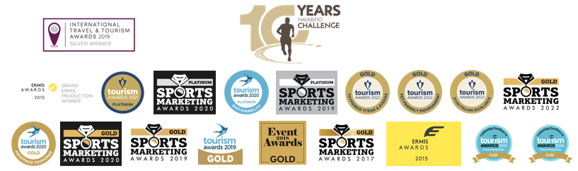

PRESS RELEASE

Navarino Challenge
Awarded as “Best Health & Wellness Event in Greece”

Significant distinction as
“Pet-friendly Environment” sports tourism event

Athens, June 2, 2022 - Amateur and professional athletes of all ages and abilities from Greece and abroad will participate in the top sports tourism event Navarino Challenge and celebrate its 10 years, on October 21-23, 2022, at Costa Navarino and Pylos.

Once again at the top of the 2022 Tourism Awards – with 45 awards in total!
With the recent addition of 3 more awards, Navarino Challenge reached 45 awards in total in its history. The event, in collaboration with Costa Navarino and the Municipality of Pylos-Nestor, won 3 Gold Awards at the leading institution in Greece which highlights the best and most innovative practices in tourism, the Tourism Awards 2022. At the same time, it remained as the only event that continues to be distinguished in this institution from its very first year. Navarino Challenge won the Gold Award in the “Health & Wellness Tourism” category for the implementation of top wellness activities in its program, the “Pet-friendly Environment” category for the pet-friendly strategy followed and implemented throughout last year’s event, enabling all people to take part with their pets in all activities and the “Storytelling Excellence” category for the successful dissemination of the event’s message “Sports Unites People” and the promotion of the region’s sports tourism around the world.

Watch here the video with the best highlights from last year and come this year to celebrate with us the 10 years of Navarino Challenge.

Run at the beach of Voidokilia
The most famous beach of Messinia -with its unique shape outlining the Greek letter omega (Ω)- and one of the most beautiful in the world, Voidokilia is the ideal destination for anyone who wants to test his strength in running. Navarino Challenge gives participants the opportunity to run in the top Greek Half-Marathon 21.1km, together with the Greek-American ultramarathon runner Konstantinos Dean Karnazes and cross the beautiful beach of Voidokilia. This is the only trail run that combines soil, sand and asphalt. At the same time, they can run the 10km route, or the fun 5km route Powered by Samsung, which can even be completed with dynamic walking. On the same day, the 1km children’s route will be held in two groups, for children 10-14 years old and kids up to 9 years of age.

Register in the running activities
Runners can take advantage of the early bird offers, which are valid until July 31st, featuring discounts higher than 50% on registrations. The children’s race is held with free participation. Register now by completing the available form through the following link.

Play in tennis, beach volley tournaments and golf and stay at Costa Navarino
Enjoy a weekend full of outdoor wellness activities for people of all ages. Book now the event’s accommodation package which is full of sports activities and includes half board. Live this year’s unique sports and cultural experience. For more information on accommodation packages at The Westin Resort Costa Navarino you may send your email to booking(at)navarinochallenge.com or call Vita N Travel at +30 210 3249070. Check the accommodation packages here.

Samsung Electronics Hellas supports the event for a 6th consecutive year as its Official Technology Partner.
Luanvi is the Official Sports Supplier.
Costa Navarino and The Westin Resort Costa Navarino are the Official Hospitality Sponsors.
Poseidonia Restaurant and Karalis Beach Hotel are Navarino Challenge’s Official Supporters.
Pilia Express is the event’s Partner.
The event is assisted by Vita N Travel and Kayak.
Explore Messinia, FitnessArt, F45 Barrio Salamanca, Mouratoglou Tennis Center – Costa Navarino, Navarino Golf Academy, Navarino Outdoors, Pilates by Mandy, Red Swim Academy, Swim O’ Clock, Triantafyllidis Beach Arena, Vizantinos target sport club are Navarino Challenge’s Athletic Partners.

Navarino Challenge will take place under the auspices of the Ministry of Tourism, whose mission is the formulation of the tourism policy and the executive planning of the tourist development of Greece.
The event has joined the Greek actions of the #BeactiveHellas 2022 program of the European Commission and is held under the auspices of the General Secretariat of Sports.
The event is organized by ActiveMedia Group which is also responsible for the event’s Sports Production.

Hashtags: #navarinochallenge #costanavarino #sportsunitespeople #10yearsNavarinoChallenge #eatwell #runwell #livewell
Website: www.navarinochallenge.com
Facebook: www.facebook.com/Navarinochallenge
Instagram: http://instagram.com/navarinochallenge
Twitter: https://twitter.com/NavarinoC
YouTube: http://www.youtube.com/user/NavarinoChallenge
TikTok: https://www.tiktok.com/@navarino_challenge

