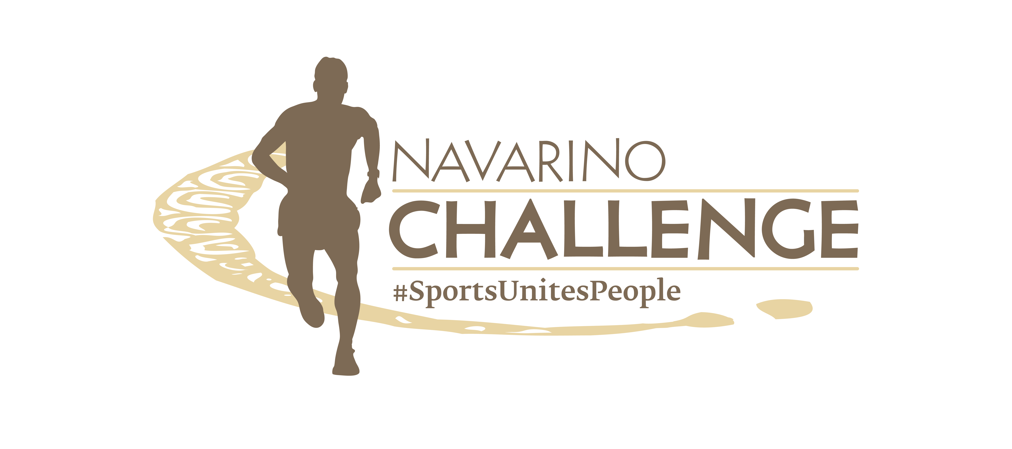

PRESS RELEASE

Registration is now open for the Navarino Challenge 2023

Book your accommodation package at Costa Navarino

Athens, July 20, 2023 – Navarino Challenge returns for its 11th year, on October 13-15, 2023, at Costa Navarino and Pylos. This year, more than 40 sports activities will take place within three days at the hotels W Costa Navarino and The Westin Resort Costa Navarino.

Navarino Challenge Marathon by That Gorilla Brand for the first time
For the first time in the event’s history, the Navarino Challenge Marathon by That Gorilla Brand will be held, with participants having the opportunity to cross the beach of Voidokilia. At the same time, the participants in the Navarino Challenge Half Marathon by That Gorilla Brand will also have the chance to cross the most famous beach of Messinia and one of the most beautiful in the world. With its unique shape outlining the Greek letter omega (Ω), Voidokilia is the ideal destination for anyone who wants to test his strength in running. The peculiar name of this enchanting location, Voidokoilia (lit. ‘ox-belly’), can be traced back to an ancient myth about Hermes, who stole the oxen of his brother, Apollo, and hid them in a cave above the beach. Feeling remorse, Hermes gave Apollo a lyre made from a sea turtle’s shell, which lays its eggs in the bay to this day. The event offers participants the opportunity to run the 42km Marathon and the top Greek Half-Marathon of 21.1km, together with the Greek-American ambassador of Greek Tourism, the ultramarathoner Constantine “Dean” Karnazes. These are the only trail running races that combine sand, soil, and asphalt.

At the same time, participants can run the magnificent 10km route powered by Miele, next to the sea, or the 5km route, among centuries-old olive trees, which can even be completed with dynamic walking. On the same day, a 1km route will be held for young people 9 to 14 years old and a 1km route for children up to 8 years old.

Register for the running activities
Runners can now participate in the 42km, 21.1km, 10km, 5km, and 1km routes. The children’s race is held with free participation. Register through the special form available at the following link.

We run for a good cause
All the proceeds from the Marathon race, as well as 50% of the proceeds from all the other running routes, will be donated through the initiative “That Gorilla Brand's Adventures For A Cause”, by the Grand Sponsor That Gorilla Brand, the world's biggest lifestyle brand dedicated to the protection of mountain gorillas, to improve sanitation facilities in Uganda. Out of a total of 16 schools located around the edges of the Bwindi Impenetrable National Park (BNIP) and close to habitats of mountain gorillas, only three meet the hygiene standards for children and teachers. The remaining 13 schools require significant financial and humanitarian aid.

Watch the video with some highlights from the Navarino Challenge running activities here: https://youtu.be/enAd28vVfA8

The hospitality of Messinia
Messinia will host for one more year the top sports tourism celebration. After all, Messinians are renowned for their hospitality (‘filoxenia’ in Greek). Homer tells the story thus: searching for his father Odysseus, Telemachus, accompanied by the Goddess Athina in mortal guise, came ashore at night in Voidokilia, which was also the port of ancient Pylos, to ask King Nestor of his father Ulysses' whereabouts. The King was holding a feast with his sons on the sand and gave the travelers the best cuts of meat and his best wine. Only after they were fed and rested did he ask them who they were and what was the purpose of their visit. This is the first written account of hospitality in the Western world, and it’s in Homer’s Odyssey.

Book your accommodation package now
Enjoy a weekend full of outdoor wellness activities for people of all ages. Book now the event’s accommodation package with breakfast and live this year’s unique sports and cultural experience. For more information on accommodation packages at the full of energy W Costa Navarino and the luxurious The Westin Resort Costa Navarino, you may send your email to the booking(at)navarinochallenge.com or call Vita N Travel at +30 210 3249070. Check the accommodation packages here.

The event’s schedule includes more than 40 sports activities that will take place at the hotels W Costa Navarino and The Westin Resort Costa Navarino.
This year, in addition to running, you will find activities such as: a basketball clinic and 4on4 basketball tournament, beach volleyball tournaments, tennis (tournaments, clinic, and demonstration), beachathlon, pilates, climbing, bike tour at Voidokolia, golf, boxing, CrossFit, yoga, high-intensity training, spinning, water sports and others that will be announced in the coming days.

That Gorilla Brand is the event’s Grand Sponsor.
Miele is the Official Sponsor.
Europa is the Official Supporter.
Luanvi is the Official Sports Supplier.
SIXT, member of the MOTODYNAMICS Group, is the Premium Mobility Partner.
Costa Navarino and the hotels W Costa Navarino, The Westin Resort Costa Navarino, and The Romanos, a Luxury Collection Resort, are the Official Hospitality Sponsors.
Poseidonia Restaurant, Karalis Beach Hotel, Pilia Express, Phee, Karalis City Hotel & Spa, and Zoe Seaside Resort are the event’s Partners.
Trace ‘n Chase is the Sports Memorabilia Partner.
Kois Optics are the event’s Official Optics Partner.
Messinian Spa is the Official Beauty Partner.
SKAI is the Premium TV Partner.
Deree - The American College of Greece is the Educational Partner.
FitnessArt, F45 Barrio Salamanca, Moraitis Watersports, Mouratoglou Tennis Center – Costa Navarino, Navarino Golf Academy, Navarino Outdoors, Pilates by Mandy, Red Swim Academy, Swim O’ Clock, Triantafyllidis Beach Arena are the event’s Athletic Partners.
Navarino Challenge is Assisted by Vita N Travel and Pylos Association of Enterprises for Tourism Development.

The event has joined the Greek actions of the #BeactiveHellas 2023 program of the European Commission and is held under the auspices of the General Secretariat of Sports.
The event is organized by ActiveMedia Group, which is also responsible for the event’s Sports Production.

More information on this year’s activities will be announced in the coming weeks.

#navarinochallenge #costanavarino #sportsunitespeople #eatwell #runwell #livewell

Website: www.navarinochallenge.com
Facebook: www.facebook.com/Navarinochallenge
Instagram: http://instagram.com/navarinochallenge
Twitter: https://twitter.com/NavarinoC
YouTube: http://www.youtube.com/user/NavarinoChallenge
TikTok: https://www.tiktok.com/@navarino_challenge

