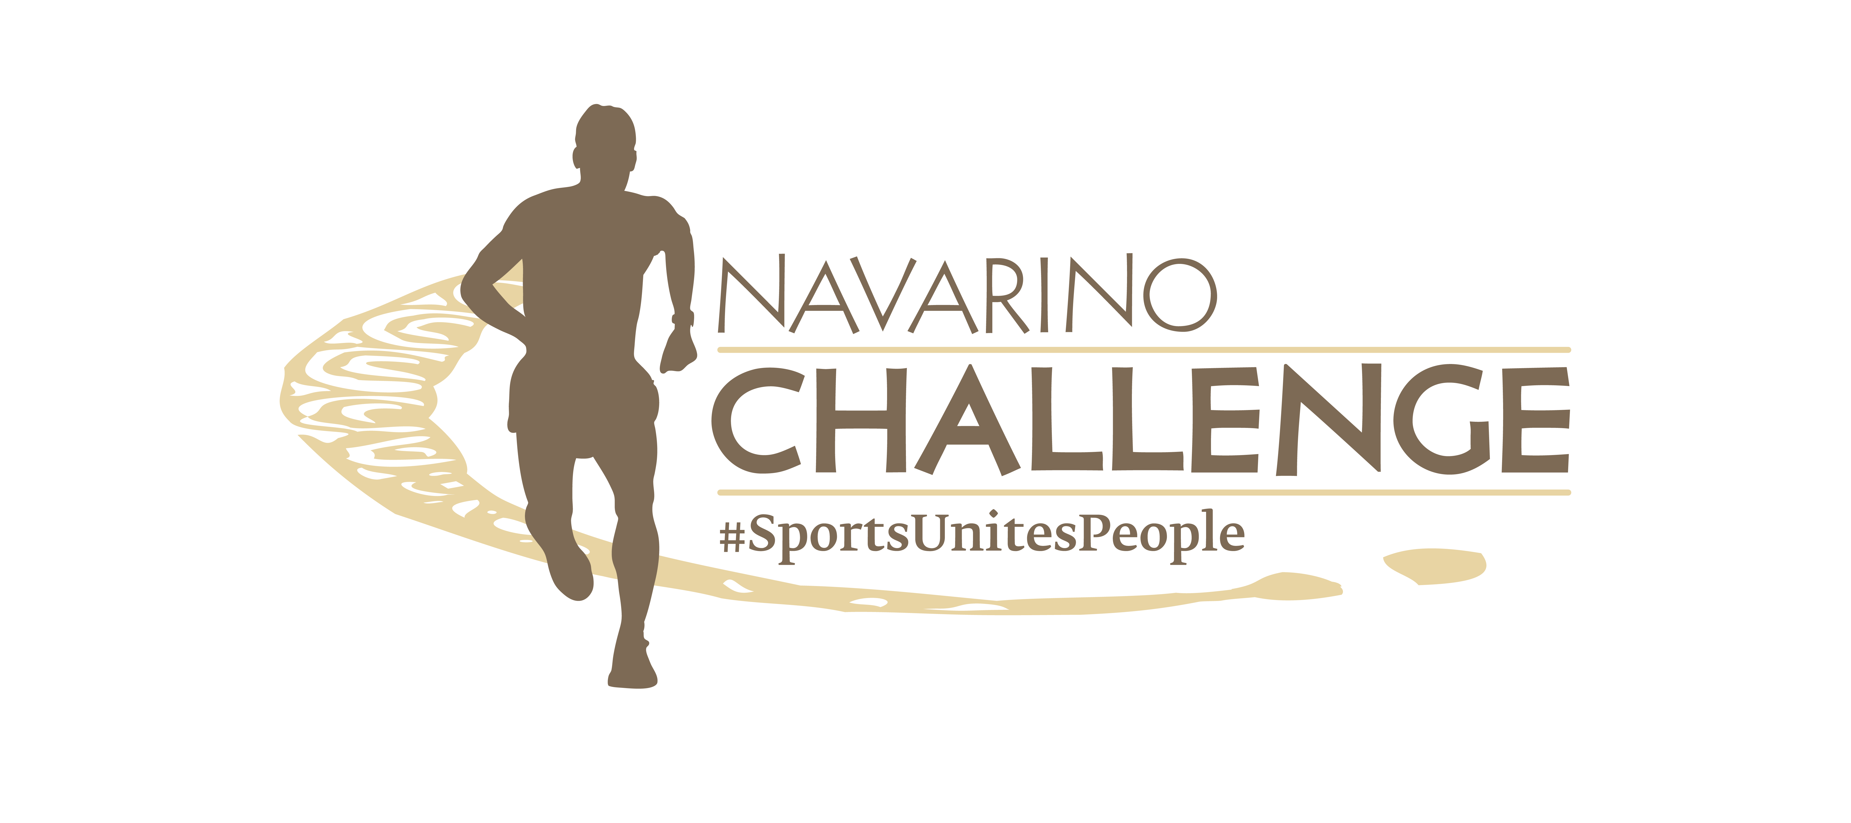

PRESS RELEASE

The European Champion Giorgos Karagounis
in Navarino Challenge 2023

Sunset Beach Pilates, Yoga, Pickleball & more than 40 activities

Athens, August 31, 2023 – The top sports tourism event in Greece, Navarino Challenge, returns renewed for the 11th year, on October 13-15, 2023, at Costa Navarino and Pylos. With the message “sport unites people”, brings young people and amateurs together with Olympians and top names close to sports, presenting more than 40 sports activities at the W Costa Navarino and The Westin Resort Costa Navarino hotels.

Football Clinics with the Greek Football Legend
Navarino Challenge welcomes for the first time in the event, the Greek football legend and European champion with the Greek national team at Euro 2004, Giorgos Karagounis. The former international midfielder, with a record number of appearances with the Greek national team and appearances for top European clubs such as Inter, Benfica, and Fulham, will be this year’s guest of honor. At the same time, this year’s Navarino Challenge schedule will include Football Clinics powered by Hellmann’s under his supervision, for children 13 to 17 years old.

Basketball for all ages
This year’s basketball action will be supported by Trace ‘n Chase, the Sports Memorabilia Partner of Navarino Challenge.
More specifically, the established 4on4 basketball tournament and the basketball demonstration with wheelchair athletes will be “powered by Trace 'n Chase”. But of course, the surprises don't stop here!
All participants, amateurs, and VIP guests will also take part in an extremely fun and fast “Knock out Challenge” by Trace 'n Chase, with unique gifts for all contestants.

Action with Pickleball Induction & Game Play
In collaboration with the former international volleyball player and record holder of participation with the Greek national team, Michalis Triantafyllidis, the Triantafyllidis Beach Arena and the Mouratoglou Tennis Center Costa Navarino, Navarino Challenge presents for the first time the fast-growing and beloved American sport of pickleball in the destination’s two new courts.

Tennis & Padel with rich gifts at Mouratoglou Tennis Center Costa Navarino
Participants in the Navarino Challenge will have the opportunity for another year to attend free of charge the tennis induction powered by Miele for kids 6 to 9 and 10 to 13 years old as well as to participate in the Round Robbin tennis tournaments for men and women powered by Miele, which will be held with the support of the Mouratoglou Tennis Center Costa Navarino under the guidance of top coaches. The schedule also includes a tennis demonstration powered by Miele with the Greek champion in wheelchair tennis and member of the Greek national team George Lazaridis and a padel tournament on the destination’s three new courts. For entries and more information: tennis(at)costanavarino.com
The winners in the padel tournament will receive rich gifts such as padel rackets and shirts from the leading company Dunlop, while the winners of the tennis tournaments will be given luxuriant gift bags and tennis balls, courtesy of the leading sports company Panellinios Agora Games and the Drakatos family that leads and guides the company to the top, with more than 130 years of history in the field.

E-bike ride to Flamingos
In addition to everyone’s favorite bike ride to Voidokilia, this year’s schedule will also include an e-bike ride to flamingos for the first time, at the area of Navarino Bay, in collaboration with Navarino Outdoors. Fans of outdoor activities will have the opportunity to discover the unique Messinian land, to admire the impressive migratory birds, and, above all, take care of the environment by leaving behind a zero footprint on their ride.

Beachathlon with a view of the Ionian Sea
Navarino Challenge continues this year with the successful and fun action of the Beachathlon powered by That Gorilla Brand, which includes athletics games for parents and children from 6 to 13 years old with the Olympian and European Champion Periklis Iakovakis. The action will take place on the unique The Dunes Beach.

Climbing lessons
Another great activity that exercises the whole body and excites the little friends of Navarino Challenge are the climbing lessons powered by That Gorilla Brand which will take place again this year at the Navarino Rocks indoor climbing wall with the support of Navarino Outdoors.

Exercise with Dimitris Moros
In collaboration with the top physical education instructor Dimitris Moros and FitnessArt, Navarino Challenge will once again this year carry out the activities of crossfit, high-intensity training, and the spinning challenge powered by Vikos, taking care of the participants’ muscle strengthening. At the same time, the activity of the F45 Barrio Salamanca Heavy Cardio Workout will be implemented by the dynamic team of F45 together with Dimitris Moros.

Sunset Beach Pilates by Mandy Persaki
The beloved physical education instructor Mandy Persaki is back in action this year, presenting for the first time the Sunset Beach Pilates, which increases flexibility, strength, and muscle endurance, on the beach at W Costa Navarino. Also, this year’s schedule includes Pilates at The Westin Resort Costa Navarino.

Sunset Beach Yoga
The yoga activity that improves flexibility and mental health will be held this year by Angelic Yoga Arts and will include Sunset Beach Yoga powered by Messinian Spa on the beach at W Costa Navarino as well as Yoga powered by Messinian Spa at The Westin Resort Costa Navarino.

Watch the event’s teaser video here: https://youtu.be/oFjbd--zWD8

Run at Navarino Challenge
For the first time in the event’s history, the Navarino Challenge Marathon by That Gorilla Brand will be held with the participation of the Greek-American ambassador of Greek Tourism, the ultramarathon runner Constantine “Dean” Karnazes. In addition, participants will have the opportunity to run the Navarino Challenge Half Marathon by That Gorilla Brand crossing the beach of Voidokilia, to run the magnificent 10km route, next to the sea, or the 5km route powered by Miele, among centuries-old olive trees, which can even be completed with dynamic walking. On the same day, a 1km route will be held for young people 9 to 14 years old powered by Europa and a 1km route for children up to 8 years old powered by Vikos.
Register through the special form available at the following link. The children’s race is held with free participation. All running races are co-organized with Messiniakos Gymnastic Club and EAS SEGAS Peloponnese Region.

We run for a good cause
All the proceeds from the Marathon race, as well as 50% of the proceeds from all the other running routes, will be donated through the initiative “That Gorilla Brand's Adventures For A Cause”, by the Grand Sponsor That Gorilla Brand, the world's biggest lifestyle brand dedicated to the protection of mountain gorillas, to improve sanitation facilities in Uganda.

Book your accommodation package now
Enjoy a weekend full of outdoor wellness activities for people of all ages. Book now the event’s accommodation package with breakfast and live this year’s unique sports experience. For more information on accommodation packages at the full of energy W Costa Navarino and luxury The Westin Resort Costa Navarino, you may send your email to the booking(at)navarinochallenge.com or call Vita N Travel at +30 210 3249070. Check the accommodation packages here.

That Gorilla Brand is the event’s Grand Sponsor.
Miele is the Official Sponsor.
Europa, Knorr, Hellmann’s, The Vegetarian Butcher are the Official Supporters.
Novo Nordisk is the Strategic Healthcare Sponsor.
Vikos Natural Mineral Water is the Official Water.
Luanvi is the Official Sports Supplier.
SIXT, member of the MOTODYNAMICS Group, is the Premium Mobility Partner.
Costa Navarino and the hotels W Costa Navarino, The Westin Resort Costa Navarino, and The Romanos, a Luxury Collection Resort, are the Official Hospitality Sponsors.
Poseidonia Restaurant, Karalis Beach Hotel, Pilia Express, Municipality of Pylos-Nestor, Phee, Karalis City Hotel & Spa, and Zoe Seaside Resort are the event’s Partners.
Trace ‘n Chase is the Sports Memorabilia Partner.
Kois Optics are the event’s Official Optics Partner.
Messinian Spa is the Official Beauty Partner.
SKAI is the Premium TV Partner.
Liquid Media is the Premium Media Partner.
Deree - The American College of Greece is the Educational Partner.
Angelic Yoga Arts, FitnessArt, F45 Barrio Salamanca, Moraitis Watersports, Mouratoglou Tennis Center Costa Navarino, Navarino Golf Academy, Navarino Outdoors, Pilates by Mandy, Red Swim Academy, Swim O’ Clock, Triantafyllidis Beach Arena are the event’s Athletic Partners.
Navarino Challenge is Assisted by Vita N Travel and Pylos Association of Enterprises for Tourism Development.
Anazoe Spa, Away Spa, Mouratoglou Tennis Center Costa Navarino, Panellinios Agora Games are the Discount Partners.

Navarino Challenge is held Under the Auspices of the Greek Ministry of Tourism and the Greek National Tourism Organization.
The event has joined the Greek actions of the #BeactiveHellas 2023 program of the European Commission and is held under the auspices of the General Secretariat of Sports.
The event is organized by ActiveMedia Group, which is also responsible for the event’s Sports Production.

More information on this year’s additional activities will be announced in the coming weeks.

#navarinochallenge #costanavarino #sportsunitespeople #eatwell #runwell #livewell

Website: www.navarinochallenge.com
Facebook: www.facebook.com/Navarinochallenge
Instagram: http://instagram.com/navarinochallenge
Twitter: https://twitter.com/NavarinoC
YouTube: http://www.youtube.com/user/NavarinoChallenge
TikTok: https://www.tiktok.com/@navarino_challenge

