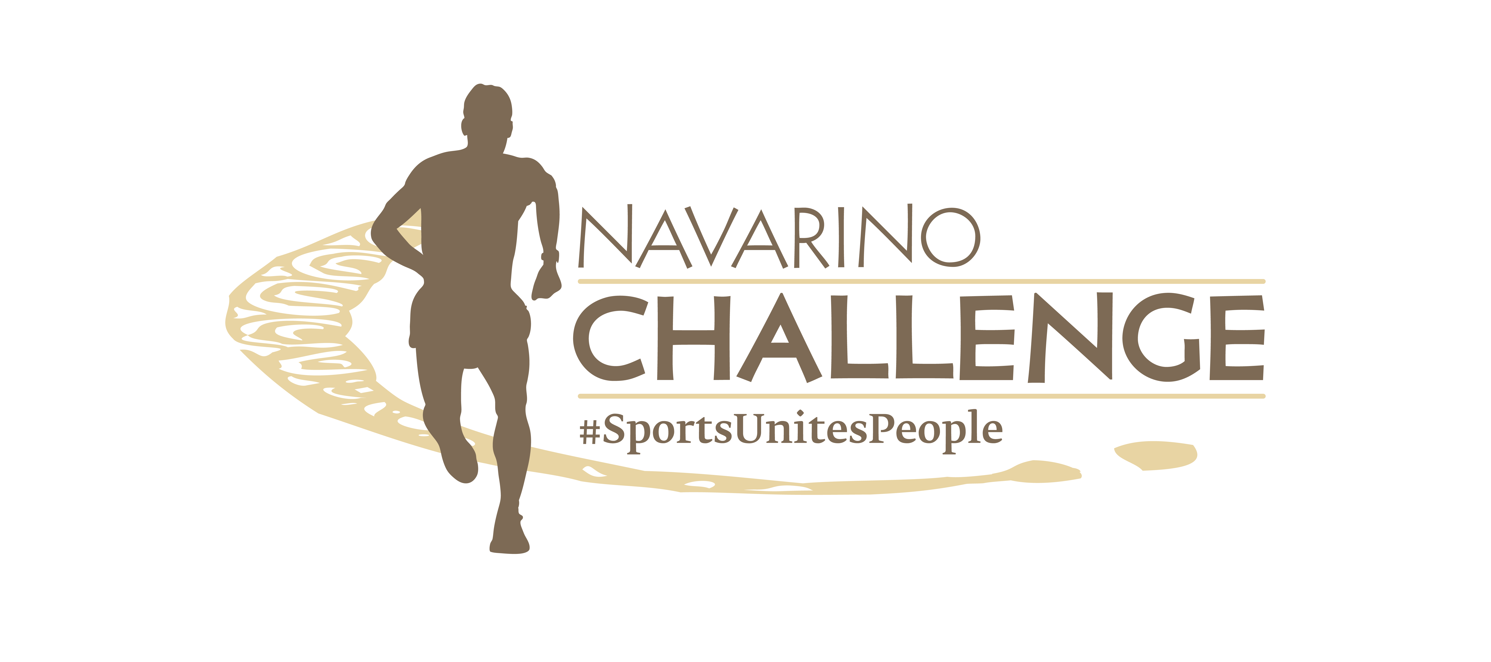

PRESS RELEASE

Ntrismpioti and Mouroutsos in this year’s
Navarino Challenge celebration

The schedule is enriched with 2 masterclasses
of the famous chef Panos Ioannidis

Athens, September 19, 2023 – The most prestigious and prominent multi-sport event in Europe, Navarino Challenge, which will take place on October 13-15, 2023, at Costa Navarino and Pylos, continues to enrich its activities. More than 40 sports activities and many surprises await this year’s participants at the W Costa Navarino and The Westin Resort Costa Navarino.

The event honors the top race-walking athlete, Antigoni Ntrismpioti
The best Greek racewalker of all time, two-time European gold medalist, bronze medalist in world athletics championships, and Olympian Antigoni Ntrismpioti, will be present at this year’s Navarino Challenge event. The great athlete and ambassador of SIXT, a member of the MOTODYNAMICS Group, who is a role model for everyone and proves every year that age is just a number, will be next to young athletes and amateurs and will be honored by the event for her overall contribution to sports.

Miele Masterclasses with Panos Ioannidis
The surprises of Navarino Challenge do not stop here. Miele, the event’s Official Sponsor, innovates and presents for the first time in the event, which stands for exercise and proper nutrition, the magical world of gastronomy, with 2 masterclasses that will bear the signature of the great Greek chef Panos Ioannidis. With the message “eat well, run well, live well”, participants will have the opportunity to meet him at the Miele Open House and learn the “little secrets” behind his magical recipes.

More than 17 children’s activities
With the message “sport unites people”, Navarino Challenge presents more than 17 sports activities bringing young people and amateurs closer to healthy sports again, alongside Olympians and world-class names. The event follows the purpose of the Olympic Movement, which is to contribute to building a peaceful and better world, without discrimination through sport and promotes the benefits of information and exercise. At the same time, it encourages young people, through the Active Kids program, to play and do sports, enriching its program with more children’s activities.

Taekwondo lessons with the Olympic gold medalist Michalis Mouroutsos
As part of this year’s Navarino Challenge, the event brings the top taekwondo athlete, the Olympic gold medalist Michalis Mouroutsos. The European champion will implement a taekwondo workshop in memory of the two-time Olympic silver medalist Alexandros Nikolaidis, with the participation of children from the region of Messinia, who will learn alongside him the discipline and concentration that this great Olympic sport requires.

This year's schedule includes also activities for children such as: football clinics powered by Hellmann’s with European champion Giorgos Karagounis (for registration click here), basketball clinic powered by Hellmann’s with the Olympian Evina Maltsi and EuroLeague legend Joe Arlauckas, beachathlon powered by That Gorilla Brand with Olympian and European champion Periklis Iakovakis, climbing powered by That Gorilla Brand, golf clinic powered by Miele, e-bike tour to Gialova lagoon to watch the flamingos, bike ride to Voidokilia, tennis induction powered by Miele (ages 6 to 9 years and 10 to 13), baby swimming up to 3 years old, pilates lessons, spinning challenge for all ages powered by Vikos, pickleball, padel tournament powered by Miele, yoga powered by Messinian Spa and of course a 1km running route, for young people 10-14 years old powered by Europa and a 1km running route for children up to 9 years old powered by Vikos.
In the activity of the 1km powered by Europa, the event will bring with the assistance of Europa, children from all over Messinia, who will have the opportunity to meet the Greek and world champions, to run with them but above all, their role-models will introduce them to the secrets of their favorite activities.

But the actions do not stop here as the children will also be introduced to the principles of sustainability. The individual bottles of the athletes will be offered by Europa in a recyclable bag, applying a zero-waste policy. The company’s goal is to guide people to make lifestyle changes that imitate sustainable natural cycles.

Watch here a video with some of this year’s children’s activities.

Seminar & 2km walking powered by Novo Nordisk
As part of this year’s event, the global pharmaceutical company Novo Nordisk, as a Strategic Healthcare Sponsor, will organize a seminar to inform and raise public awareness about the prevention and treatment of chronic diseases. The keynote speaker will be the Doctor of Oxford University Dr. Konstantinos Manolopoulos.
Moreover, Novo Nordisk will give the opportunity to Navarino Challenge participants to take part in a 2km walk, which will take place in the Municipality of Pylos-Nestor and the beautiful Messinia, overlooking the Navarino Bay, starting from the residence of the Olympian Kostis Tsiklitiras in Pylos and finishing at the imposing castle - fortress Niokastro.

Vikos S.A. which is consistently close to sports events that promote fair play and the value of healthy competition, will stand alongside the athletes as an official hydration sponsor with Vikos natural mineral water and natural mineral soft drinks. The company has prioritized offering to society with an integrated multidimensional and extensive program of actions, under the title “V-oikos of our life” (“V-oikos tis zois mas”).

Register now at the running activities
Run for the first time in the Navarino Challenge Marathon by That Gorilla Brand with the ultramarathon runner Constantine “Dean” Karnazes, the Navarino Challenge Half Marathon by That Gorilla Brand, the 10km route, or the 5km route powered by Miele. Register through the special form available at the following link. The children’s race is held with free participation. All running races are co-organized with Messiniakos Gymnastic Club and EAS SEGAS Peloponnese Region.

Click here to find more information about the running routes.

We run for a good cause
All the proceeds from the Marathon race, as well as 50% of the proceeds from all the other running routes, will be donated through the initiative “That Gorilla Brand's Adventures For A Cause”, by the Grand Sponsor That Gorilla Brand, the world's biggest lifestyle brand dedicated to the protection of mountain gorillas, to improve sanitation facilities in Uganda.

Book your accommodation package now
Enjoy a weekend full of outdoor wellness activities for people of all ages. Book now the event’s accommodation package with breakfast and live this year’s unique sports experience. For more information on accommodation packages at the full of energy W Costa Navarino and luxury The Westin Resort Costa Navarino, you may send your email to the booking(at)navarinochallenge.com or call Vita N Travel at +30 210 3249070. Check the accommodation packages here.

That Gorilla Brand is the event’s Grand Sponsor.
Miele and Europa are the Official Sponsors.
Novo Nordisk is the Strategic Healthcare Sponsor.
Knorr, Hellmann’s, The Vegetarian Butcher are the Official Supporters.
Vikos Natural Mineral Water is the Official Water.
Luanvi is the Official Sports Supplier.
SIXT, member of the MOTODYNAMICS Group, is the Premium Mobility Partner.
Costa Navarino and the hotels W Costa Navarino, The Westin Resort Costa Navarino, and The Romanos, a Luxury Collection Resort, are the Official Hospitality Sponsors.
DHL is the Logistics Partner.
Athens Medical Group is the Medical Partner.
Trace ‘n Chase is the Sports Memorabilia Partner.
Kois Optics are the event’s Official Optics Partner.
Messinian Spa is the Official Beauty Partner.
SKAI is the Premium TV Partner.
Liquid Media is the Premium Media Partner.
Vlaha, Poseidonia Restaurant, Karalis Beach Hotel, Municipality of Pylos-Nestor, Phee, Karalis City Hotel & Spa, Zoe Seaside Resort, Fysiotek, Bombay Sapphire, Trata, and Pilia Express are the event’s Partners.
Angelic Yoga Arts, FitnessArt, F45 Barrio Salamanca, Moraitis Watersports, Mouratoglou Tennis Center Costa Navarino, Navarino Golf Academy, Navarino Outdoors, Pilates by Mandy, Red Swim Academy, Swim O’ Clock, Triantafyllidis Beach Arena are the event’s Athletic Partners.
Navarino Challenge is Assisted by Vita N Travel, Pylos Association of Enterprises for Tourism Development, and Rania's Flower.
Anazoe Spa, Away Spa, Moraitis Watersports, Mouratoglou Tennis Center Costa Navarino, Navarino Outdoors, Panellinios Agora Games are the Discount Partners.

Navarino Challenge is held Under the Auspices of the Greek Ministry of Tourism and the Greek National Tourism Organization.
The event has joined the Greek actions of the #BeactiveHellas 2023 program of the European Commission and is held under the auspices of the General Secretariat of Sports.
The event is organized by ActiveMedia Group, which is also responsible for the event’s Sports Production.

More information on this year’s additional activities will be announced in the coming weeks.

#navarinochallenge #costanavarino #sportsunitespeople #eatwell #runwell #livewell

Website: www.navarinochallenge.com
Facebook: www.facebook.com/Navarinochallenge
Instagram: http://instagram.com/navarinochallenge
Twitter: https://twitter.com/NavarinoC
YouTube: http://www.youtube.com/user/NavarinoChallenge
TikTok: https://www.tiktok.com/@navarino_challenge

